Spring Framework

What is spring framework

Spring is a dependency injection framework.

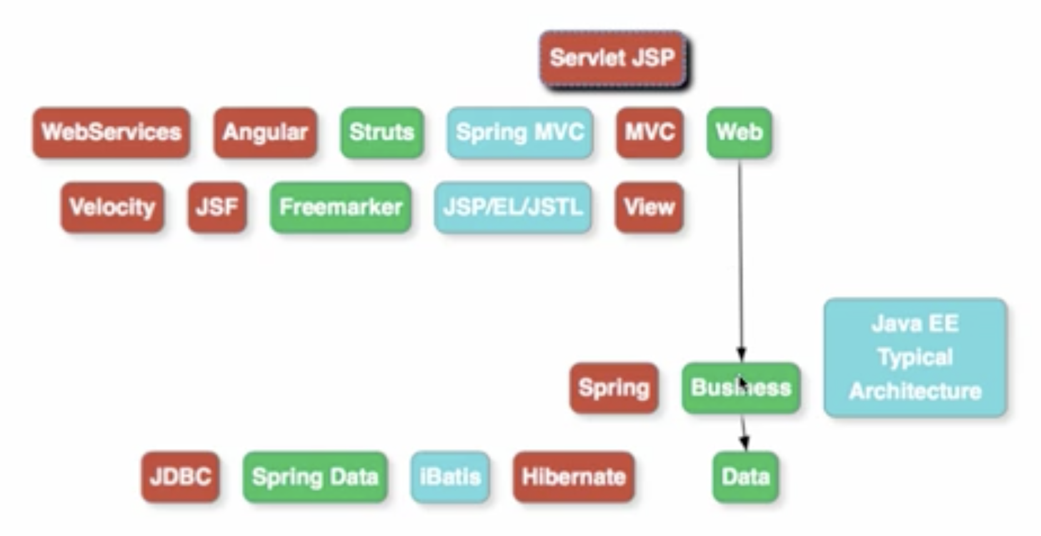

Web layer is typically concerned with the UI of the application.

The business logic is present inside your business layer.

The data layer takes care of talking to the external interfaces as well as with your database

If business layer need some data it calls some class which is present inside the data layer. So the business layer is dependent on the data layer.

If you want to show something on the UI or if you want to save some data from the user to the database the UI layer first calls business class.

So the web layer is dependent on some class which is present inside the business layer.

This is how we build web applications.

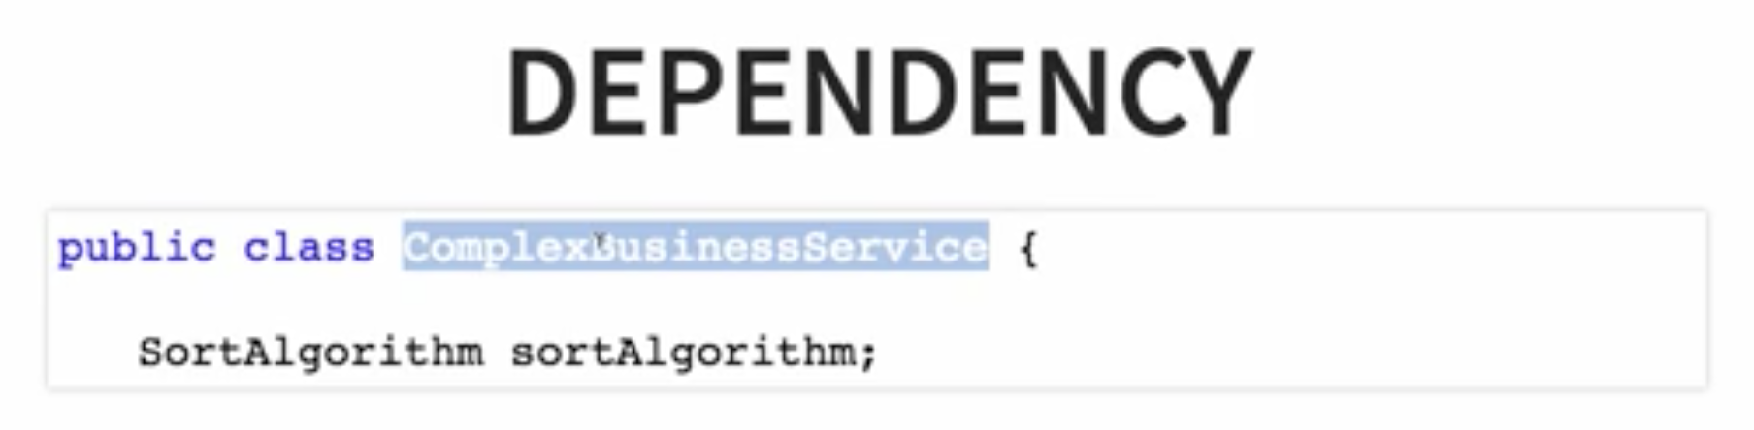

SortAlgorithm is dependency of the Business Logic class.

Meaning ComplexBusinessService is dependent on SortAlogorithm

Dependency of a class is basically what are allthe things it needs to be able to perform its functionality.

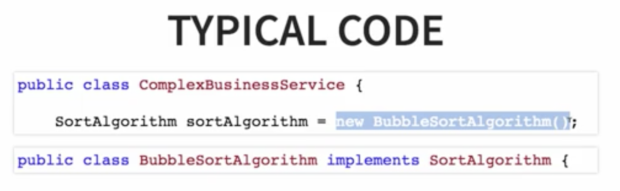

This is how we used to write code before Spring. ComplexBusinessService depends on SortAlgorithm and instantiates or uses BubbleSortAlgorithm

Now what if we want to use InsertionSortAlgorithm class instead. Then we have to modify the code to use InsertionSortAlgorithm instead of Bubble. This kind of code will be complex. Business servies is directly instantiating dependency here.

This is called Tight coupling

Complex business service is tightly coupled with the bubble sort algorithm.

Tight coupling is not considered to be good.

Good code has loose coupling. How do we make this code loosely coupled. We remove tight coupling by removing instantiation of the dependency.

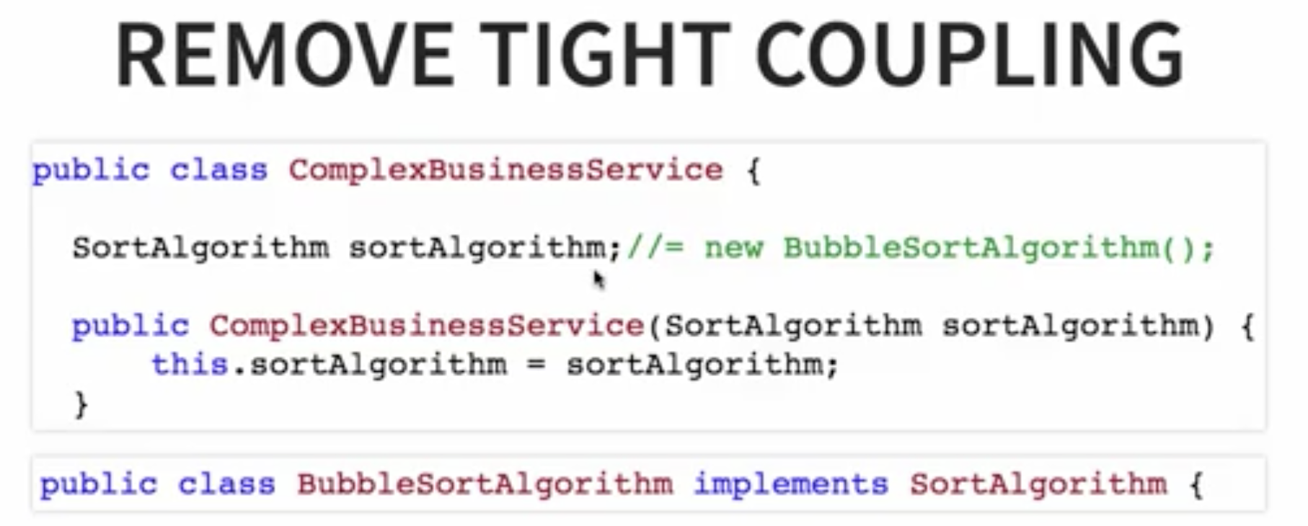

We are not creating an instance of this sort algorithm directly in here.

What we are doing is creating a constructor.

Whoever wants to make use of the complex business service can provide which sort algorithm they want to use.

How to use it with above code?

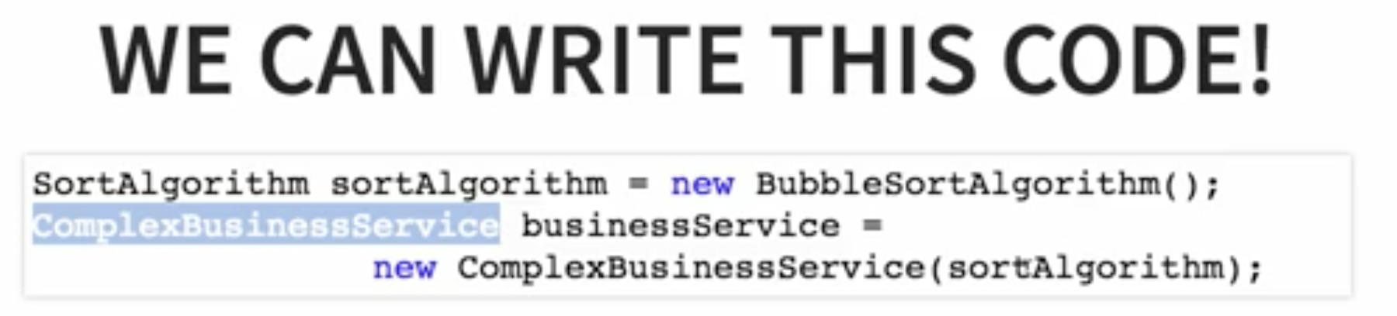

Who wants to use the business class, can instantiate this sort algorithm. They would create a complex business service, passing this sort algorithm to it. If you don't want to use the bubble sort algorithm, You can create a different sort algorithm and replace it in here.

This code is good because this is loosely coupled programming.

The complex business service is not dependent on the sort algorithm.

You can provide it with any sort and it can use it.

Who does this? Where would you you write this logic?

Think about this. What is the code doing?

It is creating a new instance of the bubble sort and createing a new instance of the complex business service after populating the right dependencies.

So all that it's doing is creating objects and populating dependencies.

This is where this Spring Framework comes in. Spring Framework does exactly the job you're seeing in the code.

It instantiate objects and populate the dependencies.

It is your job as a programmer to tell the Spring framework - What are the objects it would need to manage and what are the dependencies of each class?

How does spring know that it needs to create an instance of the bubble sort algorithm? How does spring know that it needs to create an instance of the complex business service and populate the instance it created earlier of the bubble sort algorithm.

So the question is basically - How does Spring know how to do this?

Given this code Spring needs to be able to do this. How does Spring do this magic?

The thing is you as a programmer need to help spring frame work identify what are the objects it needs to manage? what are its dependencies?

There are two important annotations that are present using which you can tell this to Spring Framework.

What are the objects it needs to manage? and what are the dependencies of your particular class?

1. The first annotation is @component.

We are putting an @component on top of the complex business service and the bubble sort algorithm.

This is where we are telling spring - OK you need to start managing instances of the complexbusinessservice and the bubblesort.

Spring knows it needs to manage the instances of these two classes but how do you tell that this sortalgorithm is a dependency of the complex business service.

The way you do that is by using another annotation @Autowired.  
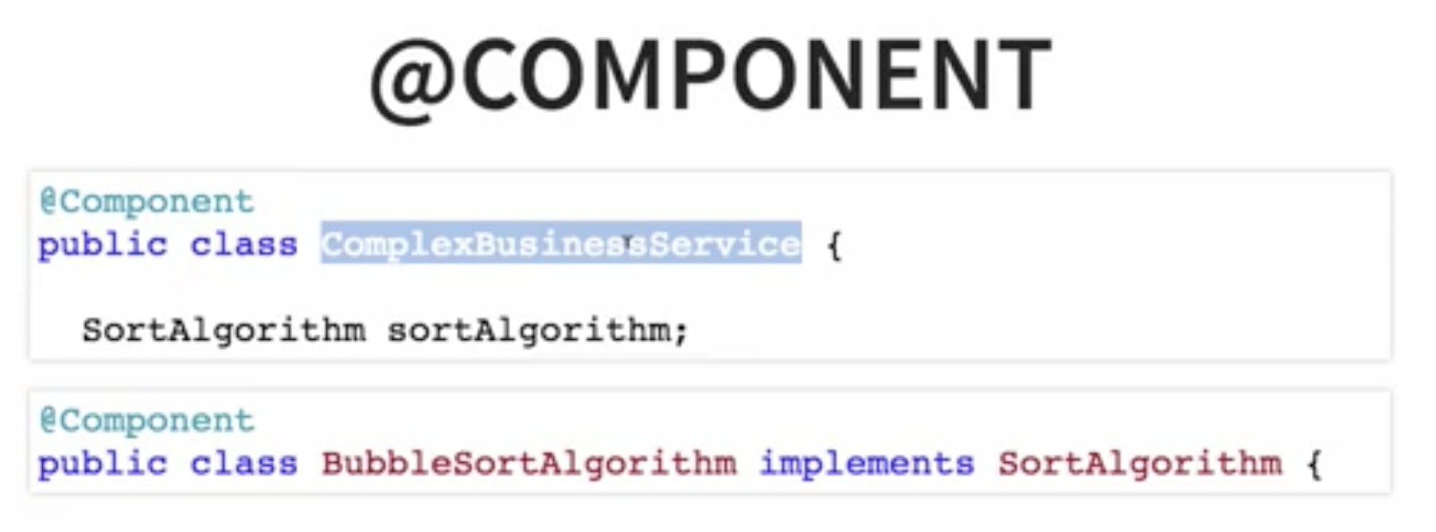

2)Autowired

So as soon as you put @Component, it means that Spring starts to manage instances of that class.

Spring would create the instances of that class for you.

And as soon as you put @Autowired - that means spring would start looking for this dependency It would start looking among the component it manages to find a matching thing for this sortAlgorithm.

So Spring would internally do this.

It would create an instance of the bubble sort algorithm and it would pass it to the constructor of the complex business service to create an instance of the complex business service.

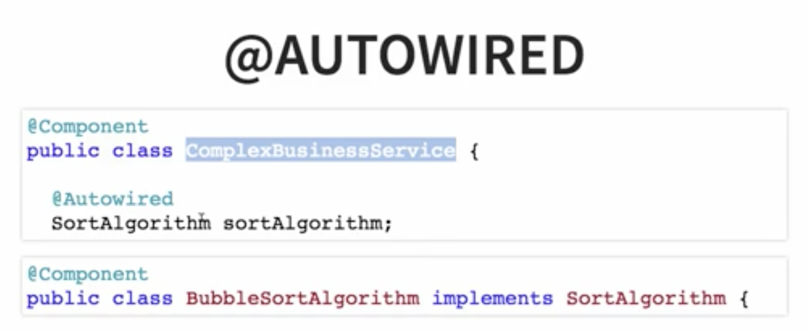

The spring framework understands the different annotations that you are putting on top of your classes.

It knows that you'd want to create an instance of this class you'd want to create an instance of this class and you would want to bring framework to manage it.

It also understands that this sort algorithm is a dependency of the complex business service.

It would make sure that the instances of all the objects it manages are created with the dependencies properly populated.

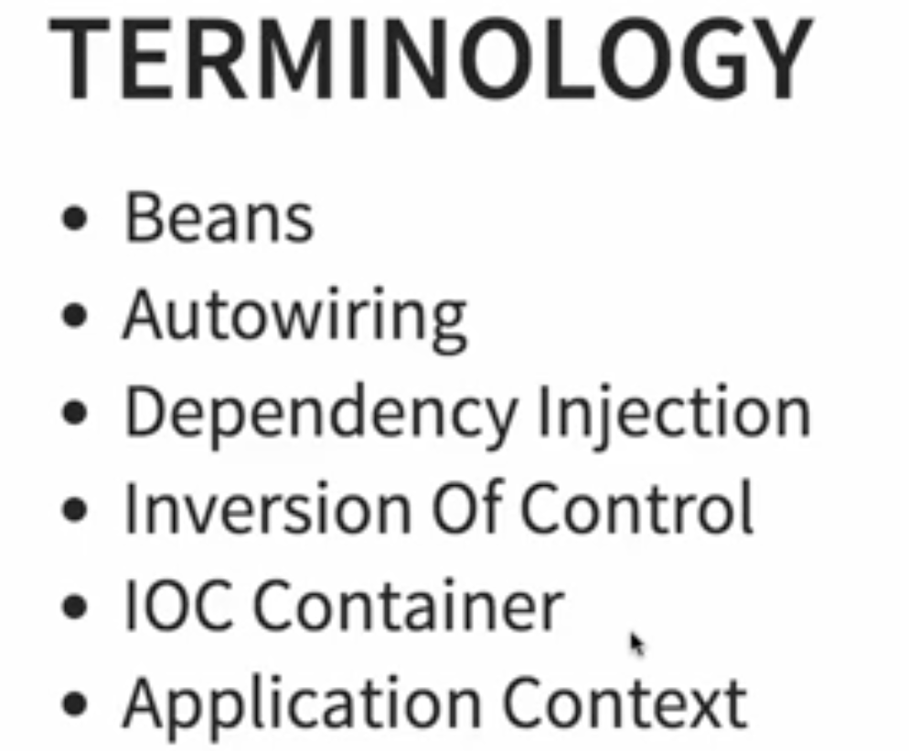

1. Beans  
   By giving @Component, We are telling spring framework to create instances of the complexBusinessService and BubbleSort.

These instances that Spring manages. These are called beans.

Beans are different objects that are managed by this Spring framework.

1. Autowiring

The process where spring identifies the dependences, identifies the matches for the dependencies and

populates them.

That process is called auto wiring.

So basically spring finds the right sort algorithm. It finds the bubble sort algorithm and creates an

instance of the complex business service by populating the right sort algorithm.

This is what is called Auto wiring.

1. Dependency injection  
   We are injecting this algorithm as a dependency into the complex business
2. IOC  
   When we started of this example - we were writing the first code - who is creating the instance of the bubbleSort? The Class which needs it i.e, ComplexBusinessService. So the class which needs the dependency creates an instance of the dependency.

Who is creating the instance of dependency in the second code example?

The spring framework is creating the instance in here . We are taking the control from the class that needs the dependency and giving the control to the framework to the spring framework.

And this is called inversion of control and that leads us nicely into the next terminology. IOC Container is a generic terminology to represent anything that is implementing inversion of control.

In the case of Spring framework the typical IOC container is the application context.

5) Application context  
So the application context is the one where all the beans are created and managed. Application context is the most important part of the Spring Framework.

That's where all the Core Logic of spring frame work happens.

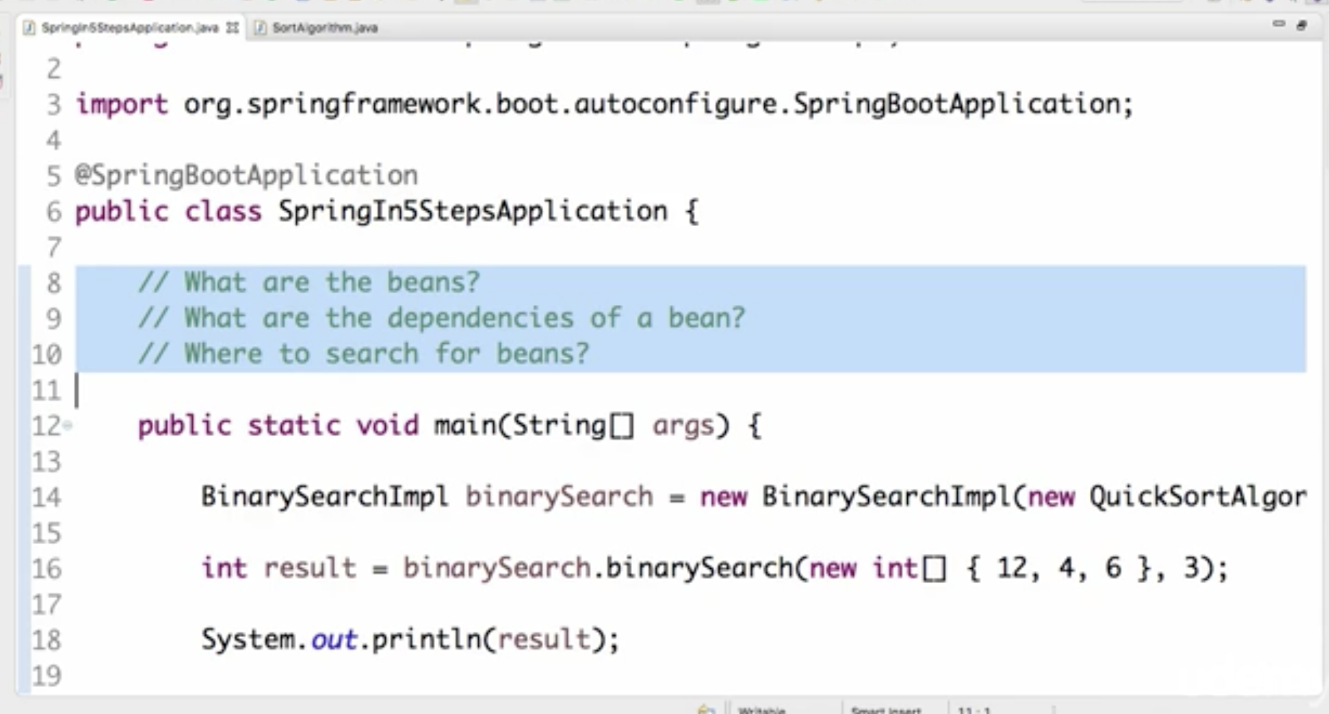

How to tell spring usually is where to search for beans?

Using ComponentScan

So we would want Spring do a component scan in this particular package. We are using Spring Boot. Spring Boot would automatically scan the package where the main application class is present.

Spring application context is the one which would maintain all the beans.

So what we would need to do is we would need to get the bean from the application context.

SpringApplication is the class which helps us get that

The run method actually returns the application context back.So I would want to take the application context and do things with it.

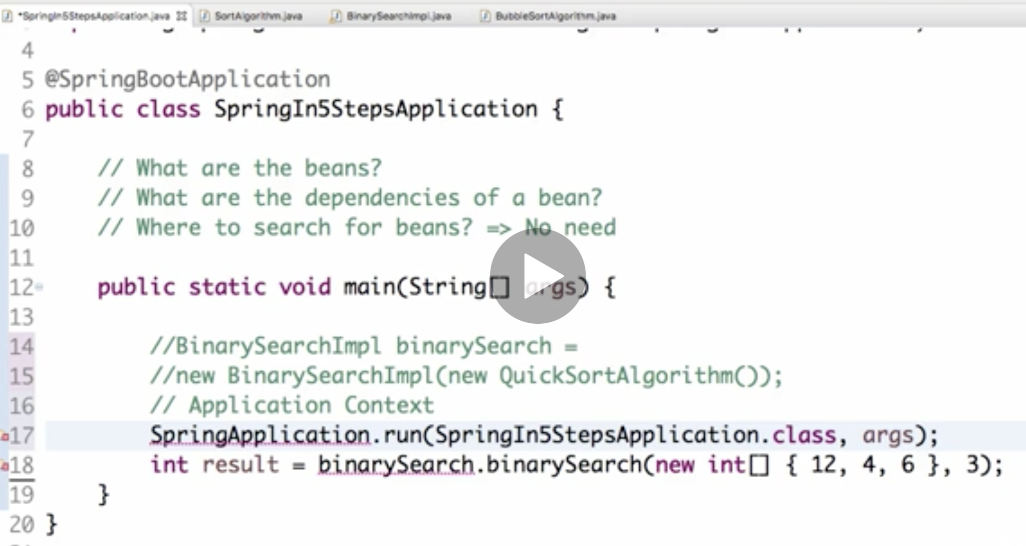

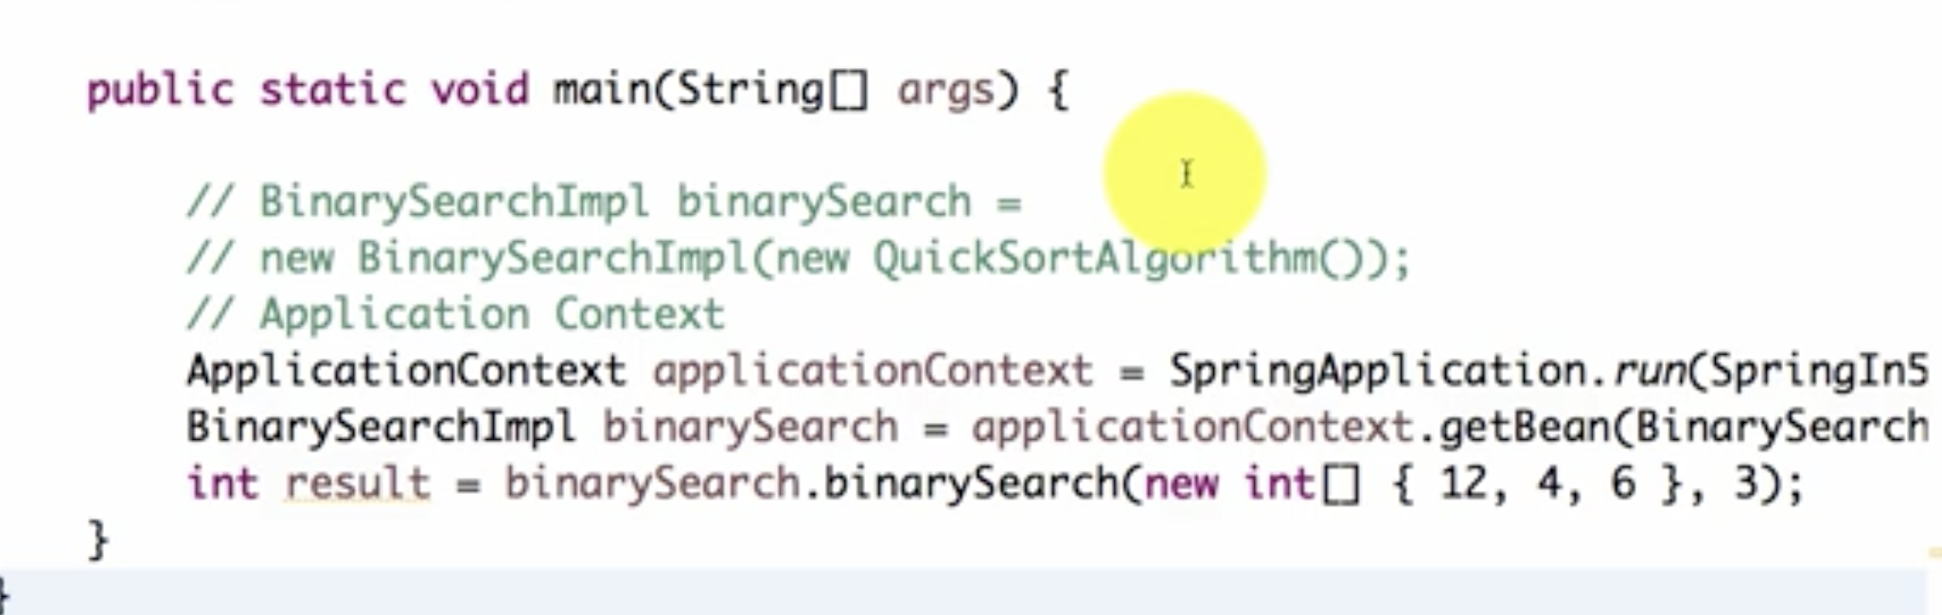

Take applicationContext and get your bean by doing .getBean(BinarySearchImpl.class);

Spring is managing the beans for us. Spring is managing dependencies. So Spring manages the dependences, injects the dependencies where ever they are needed and it manages the entire lifecycle of these beans.

That's what is called dependency management.

What is happening in background when spring app is running?

1. Component scan happens – which is searching for classes with annotations eg@Component in the package



1. The classes with annotation eg@Component are identified

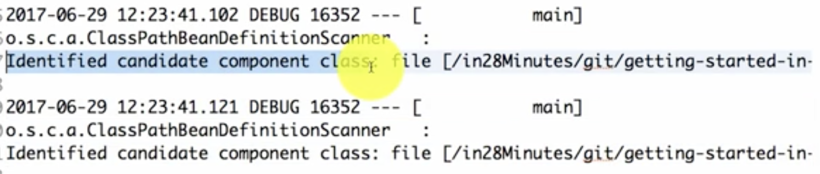

1. Starts trying to create instances of these classes



1. But while trying to create instance , it get to know that it has dependency using @Autowired, so it will go ahead and tries to create instance of that dependency class , then auto wire it previous clas which was dependent on it

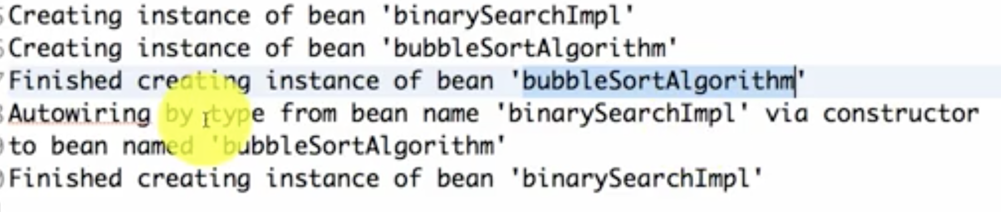

Autowiring takes place via Constructor => hence called Constructor injection

=========

What happens if SortAlgorithm is implemented by BubbleSortAlgo and QuickSortAlgo classes, then how will spring know which dependency to use ? If you application like this, it will give below error saying class needs 1 single bean but 2 found

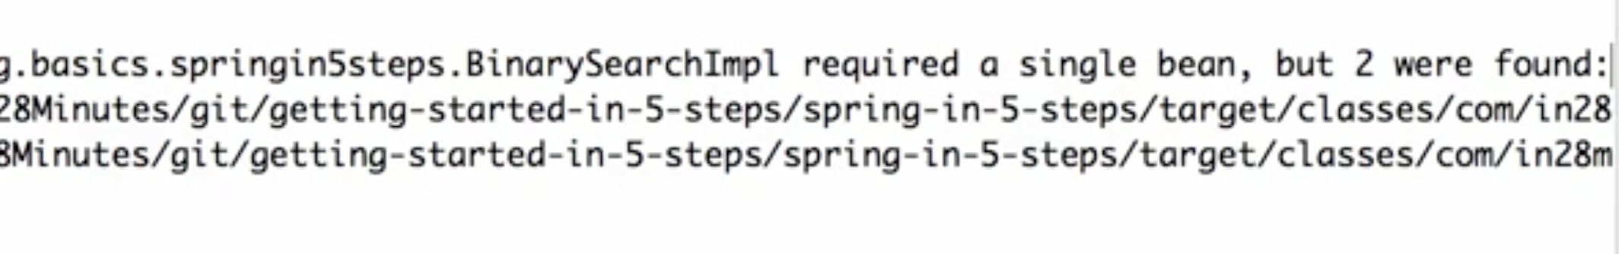

Solution:

Is to use @Primary to whichever class you want to make primary dependency

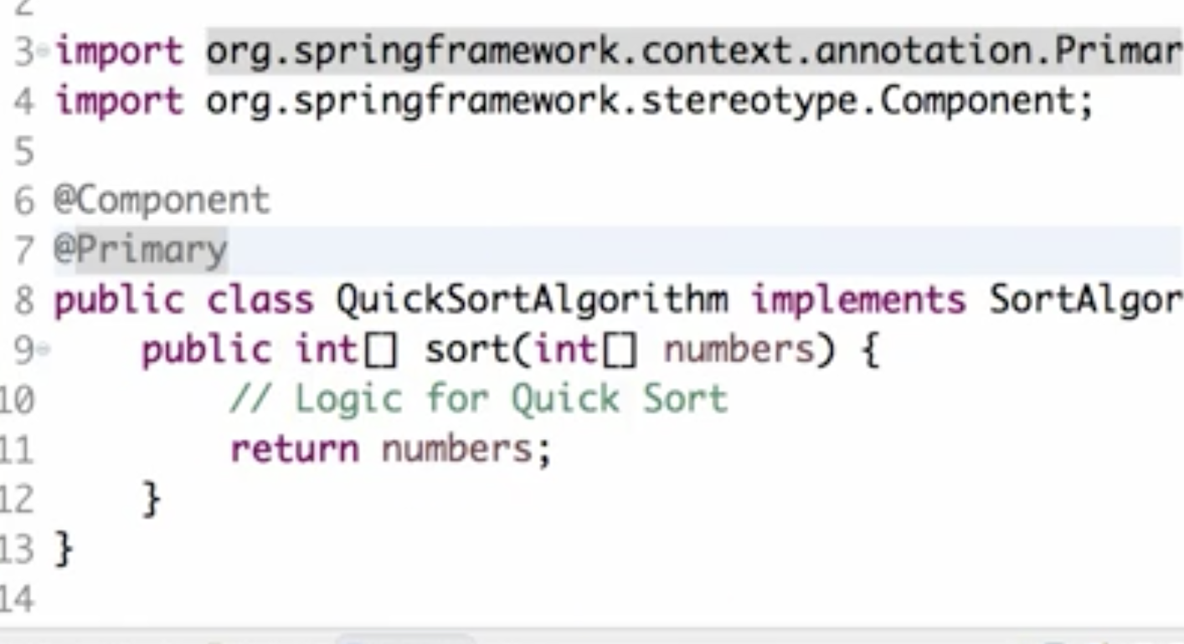

Now run your application, it will run properly and use QuickSortAlgo as we have defined it as primary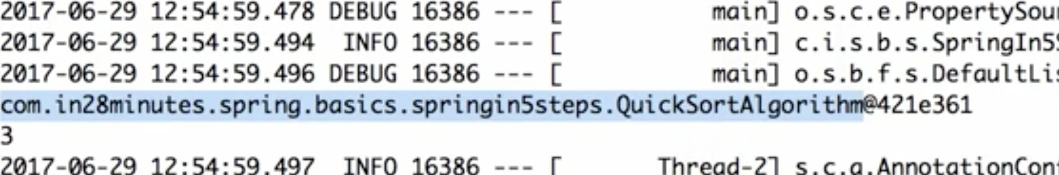

If none of the algos have @Component, it will give error saying no classes found and hence no beans will be created

Whenever you have any problems of the type a bean is not found or multiple beans are found, See if you have used the right combination of at component, at auto wired and at primary.

Fastest Approach to Solve All Your Exceptions

If you are using **Intellij** or **Java 9** or facing a **ClassNotFoundException**, our troubleshooting guide is here to help all the time!

This 50 page troubleshooting guide and faq is our way of thanking you for choosing to learn from in28Minutes. It provides solutions for 200 FAQ and Frequently faced Problems.

**Here's the Quick Start with Top 10 FAQ**

<https://github.com/in28minutes/in28minutes-initiatives/blob/master/The-in28Minutes-TroubleshootingGuide-And-FAQ/quick-start.md>

=====================================  
1) Constructor injection

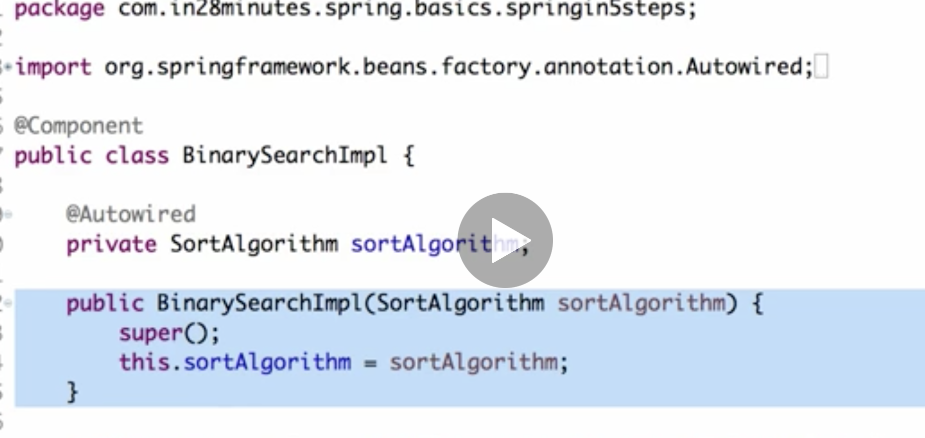

1. Setter injection

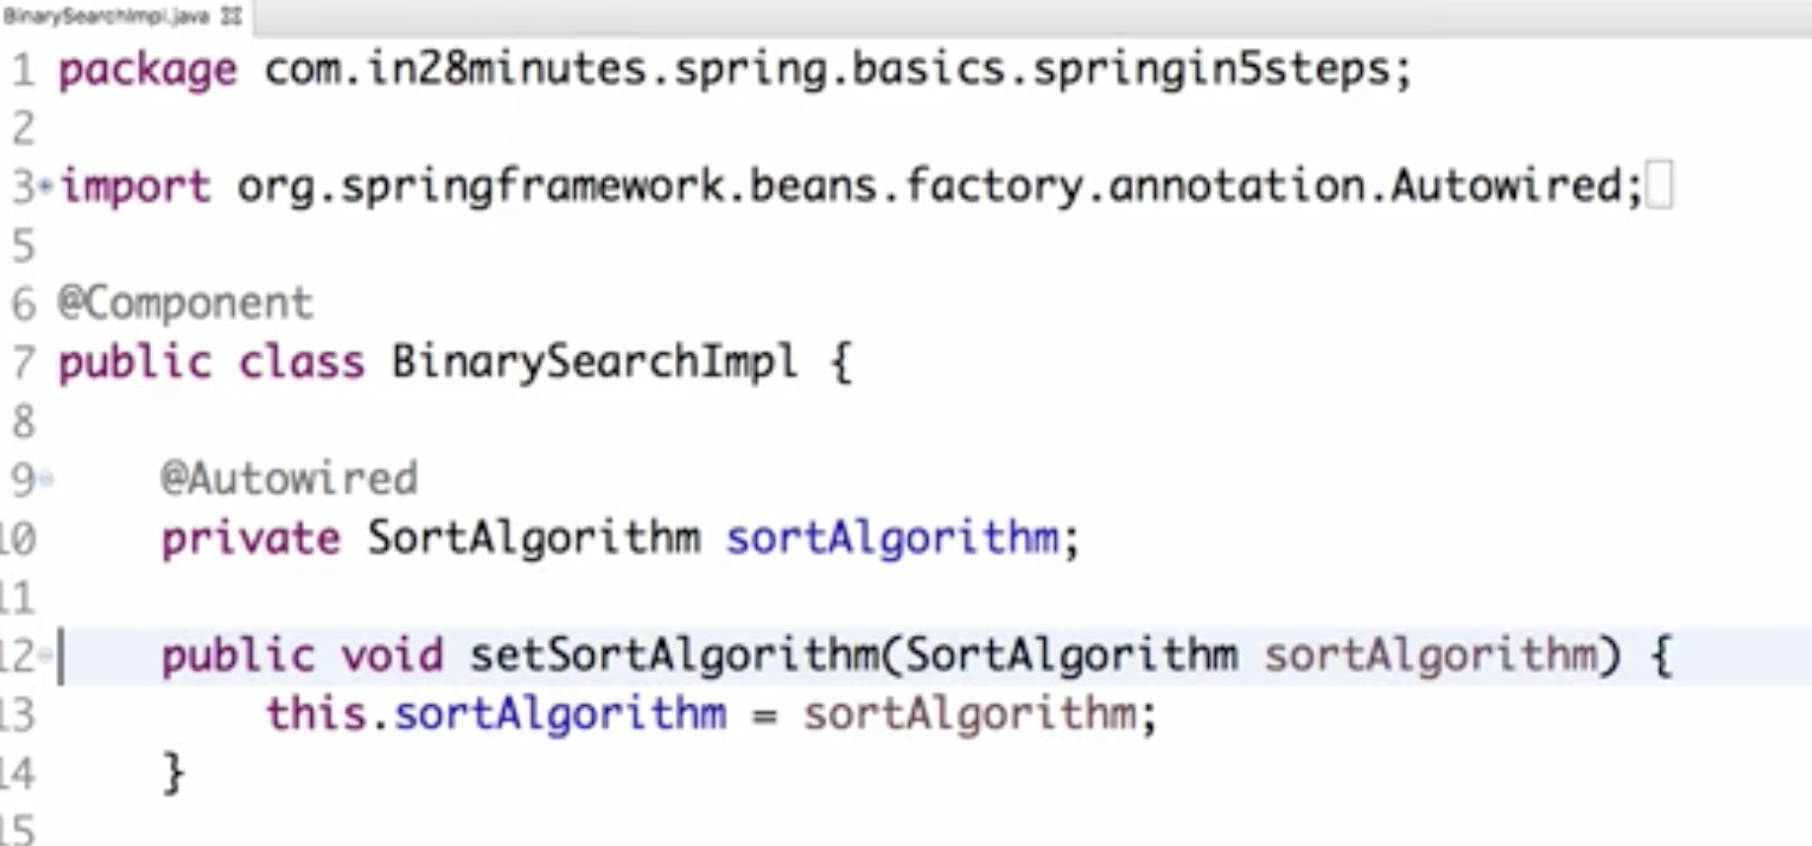



1. No setter or No constructor injection

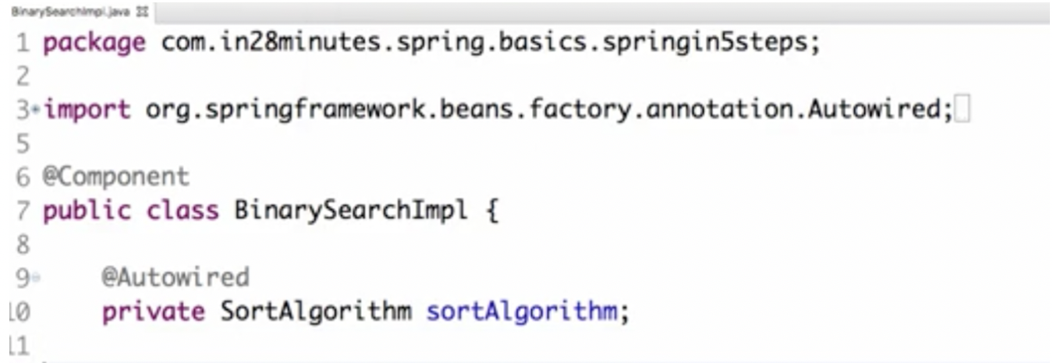



==================================================================

So we can see that autowiring log for option 2 and 3 are are same. So, One thing you need to remember is the fact that these two are really the same. So whether you're creating a setter or not, the way Spring the autowiring is the same. So when people say setter injection they would be either referring to any of these. You can even call this to be using setter injection.

So if I just put out at autowire here and remove the setter, this is kind of also termed to be setter injection, even though there is no setter in there.

Basically we have two options, right? So how do you choose between constructor and setter injection?

In newer version of Spring, you can use any of these injections

====================  
  
Spring Modules:

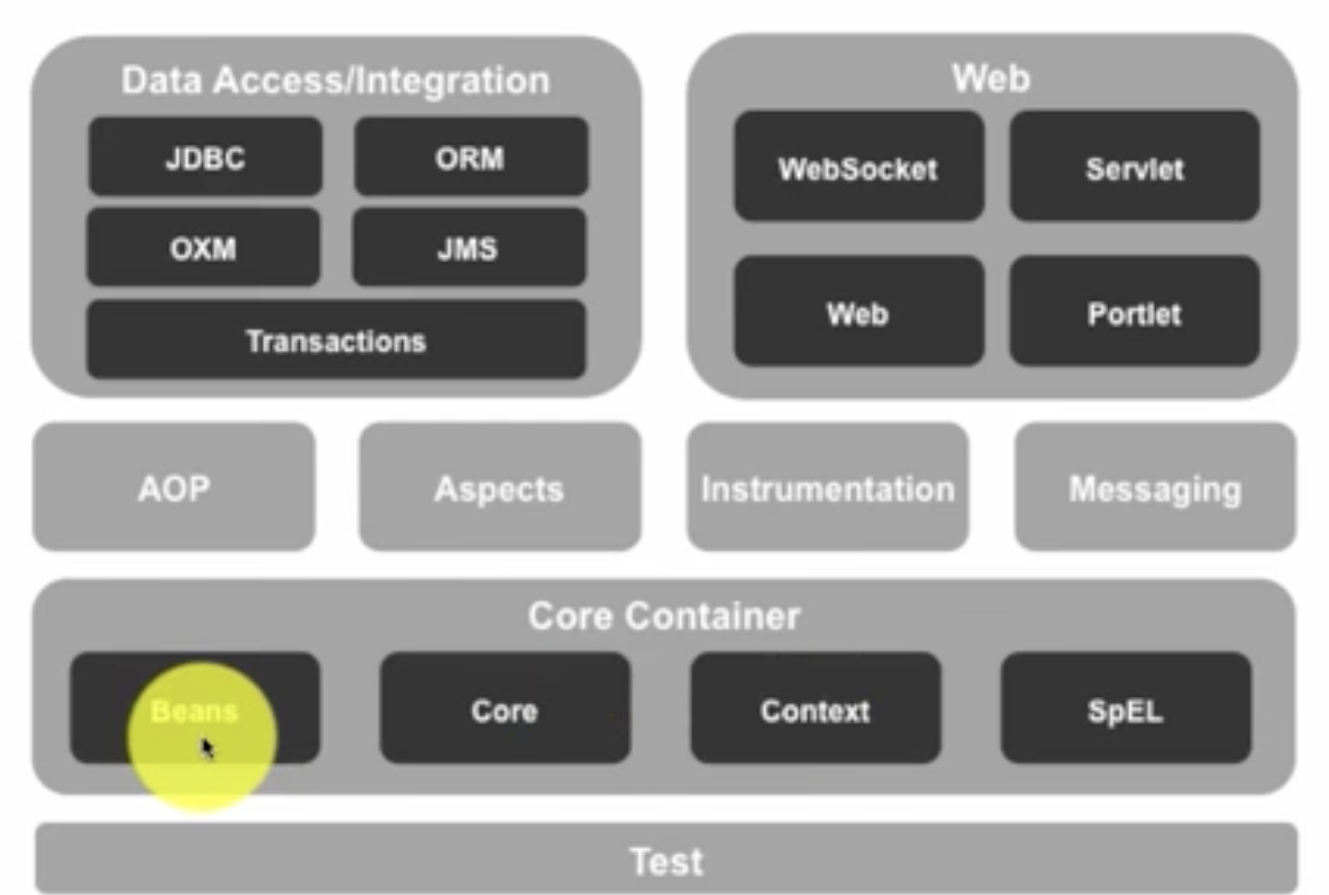

* Spring also has a very good integration with data and integration layers. What do you mean by a data layer? Data layer is something which talks to a database, Right? One of the important data access models is Spring JDBC which makes JDBC much more easier. Spring JDBC makes it easier.
* The other thing Spring is good integration with all ORM frameworks. Object relational mapping frameworks. Some of the important object relational mapping frameworks are hibernate and myBatis.
* Spring has good integration with JMS. So you want to talk to some other application over the queue then through Spring JMS you'd be

able to talk to the other application. You can put messages on the queue

* wherever object to XML transformation is needed in those kind of scenarios Spring OXM provides a lot of useful features.
* One of the important things with the data access or integration is the transaction management, right? You'd want all the steps in a transaction to be successful or you would want all of them to be rolled back.
* The other important Spring modules are inside the web space. So Spring has really good connections with web frameworks like Struts. Spring also offers a web framework of its own. It's called Spring MVC
* Spring has good support for web sockets also
* So we looked at things in the web layer. We looked at things in the data layer. There are things which are applicable to more than one layer. Those are called crosscutting concerns. One of the crosscutting concept is unit testing You would want to be able to unit test things in the web layer, in the business layer and the data layer as well.Those kind of things are called crosscutting concern. Spring has good support for unit testing through the Spring test framework.
* Spring also enables implementation of things like security, logging, through aspect oriented programming. So Spring has a module of its own called Spring AOP to do basic aspect oriented programming.
* If you want to do advanced aspect oriented programming with a framework AspectJ, Spring provides really good integration with it as well.

Spring Projects

There are other things Spring does other then the Spring Framework and it's modules. These are called Spring projects.

These Spring projects provide solutions for different problems faced by enterprise applications

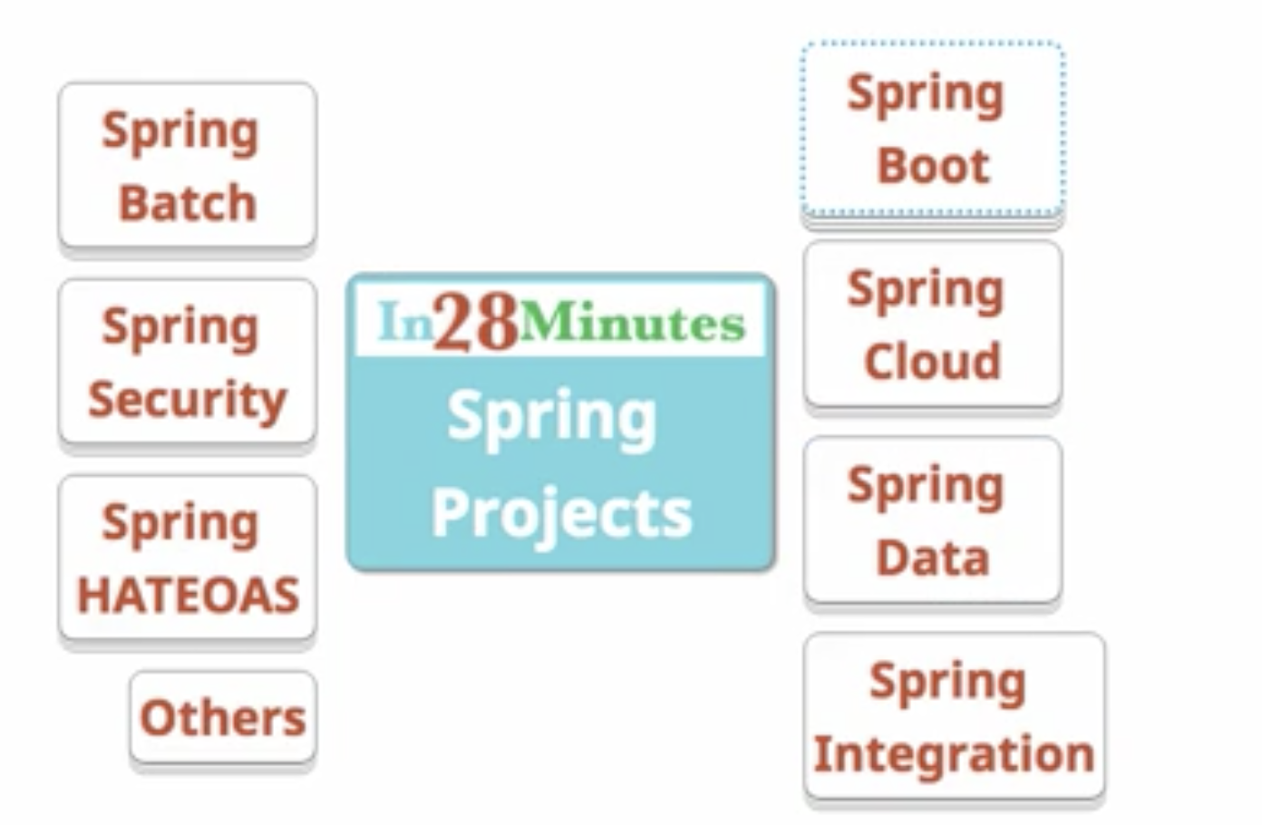

1. Spring Boot has become the most popular framework used for developing mico services. Spring Boot makes it very very easy to develop applications quickly. With features like start up projects, auto configuration, actuator Spring Boot makes developing applications especially micro service a cakewalk.
2. The other important Spring project is Spring Cloud. We have to develop Cloud native applications. We would want to be able to dynamically configure applications, we would be able to dynamically connect them. We would want to be able to dynamically deploy applications. Cloud native applications need a lot of different features. So if you have a micro service which is developed using Spring Boot, you can use Spring Cloud to cloud enable the micro service.
3. Spring data provides a consistent data access. Today there are abundant of NoSQL databases. We have a mix of data sources, so we have NoSQL..and SQL DBs How do you ensure that the way I'm accessing data from all these stuff is remaining consistent.
4. Spring integration, on the other hand, addresses problems with application integration There is something called enterprise application integration patterns. It's a very famous book. Spring integration implements the patterns which are recommended in there. Spring integration helps us in connecting enterprise applications very very easily.
5. Not all processing is done online. Some of the processing is also done in batch applications. Batch applications have their own requirements.

Like, for example, I would want to be able to restart a bad job from where it failed or I would want to be able to track down exactly what's happening in a batch in much much more minute detail.

Spring Batch provides those kinds of features. It enables developing batch applications very easily.

1. Security is one of the important parts of developing applications. You'd want your applications to be secure whether you are developing a web application whether you're developing a REST service or anything that you develop, you’d want to protect it.

So Spring Security provides solutions for securing your applications. Whether it's a web application or whether it's a REST service, Spring has support for multiple security…Spring Security has support for multiple security options like basic authentication, Oauth authentication, Oauth two for example.

1. Spring HATEOAS enables you to develop HATEOAS compatible services. In REST it’s not sufficient to just return the data. You'd also want to return the related links that would help the consumer to understand where to go from here. Spring HATEOAS would help you to do that very easily
2. There are a lot of those Spring projects like Spring webservices, Spring session, Spring social, Spring mobile and Spring Android which are solving problems in various different spaces.

Spring Popularity

1. It enables writing testable code  
   The core feature of Spring is dependency injection. And if we use Dependency Injection properly then we would be able to write unit tests for our code very easily. Spring has a really good integration frameworks like Junit and Mockito and it enables us to write good unit tests very quickly.
2. there is no plumbing code at all.

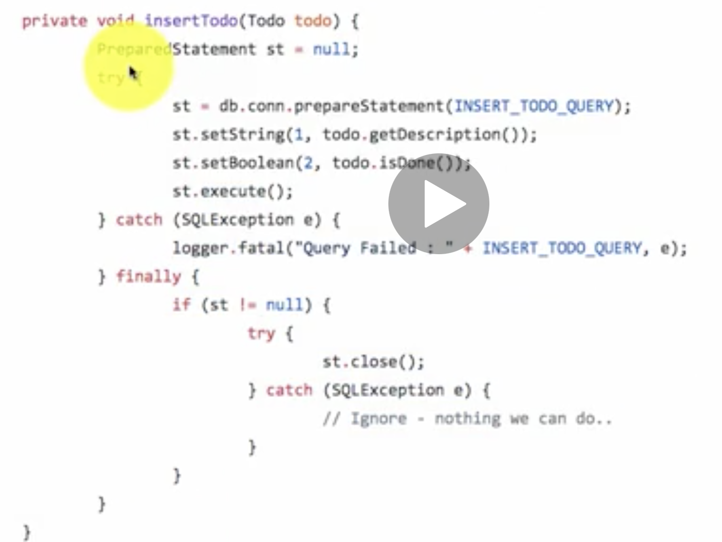

This is code written without using Spring

Same code in Spring would be below. With Spring the amount of code that you need to write becomes almost next to nothing. Because Spring makes all its exceptions unchecked.

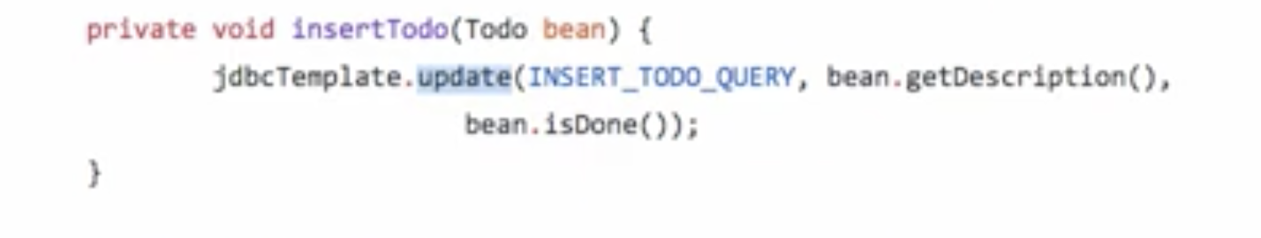

This code which you've seen in first pic is the plumbing code

1. Flexibility it brings in  
   There are Spring modules and Spring projects for very specific purposes. And I can use a specific Spring module without using all others.  
   And if I choose to use Spring in my project, I still have the flexibility to choose other frameworks. And that's very important
2. it is able to stay with the trend

And Spring is able to come up with projects which helps it to stay relevant. Spring has introduced the new project called Spring Cloud. There’s Spring Boot as well which help you to develop micro services very quickly.

Spring in-depth

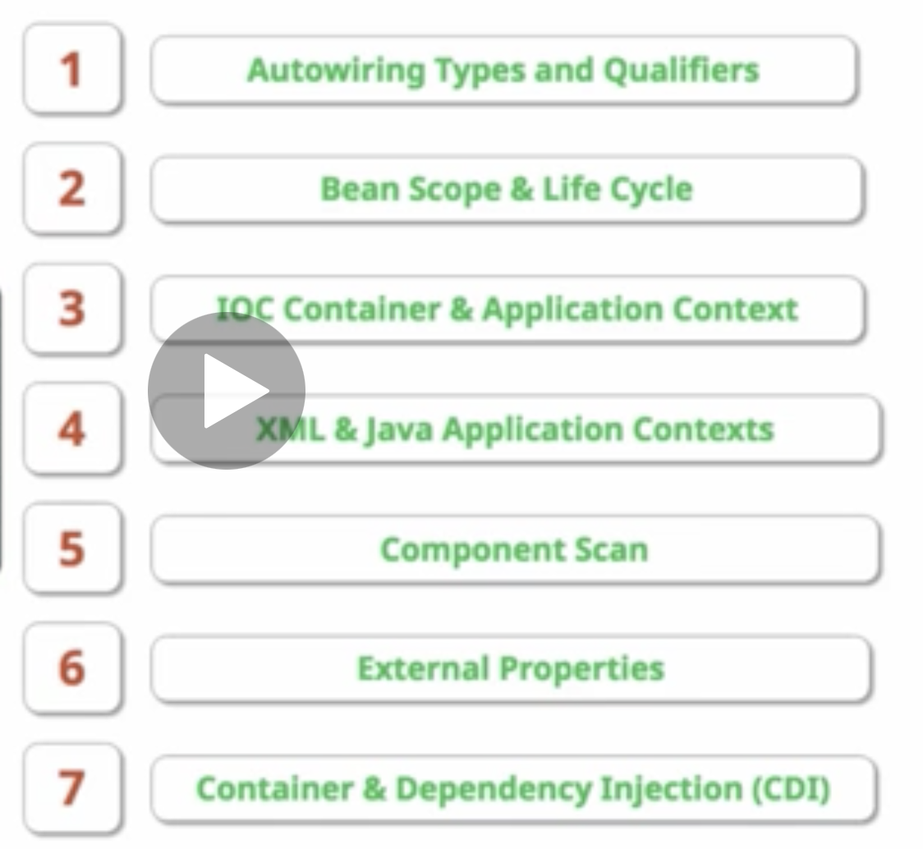

Dependencies -

Data layer is a dependency for Business layer, Business layer is a dependency for Web layer.

Whatever we looked at as a simple concept of @Autowired, actually when it comes to enterprise applications, you would see that it's very frequently used.

The enterprise web applications are full of dependencies.

Eg:

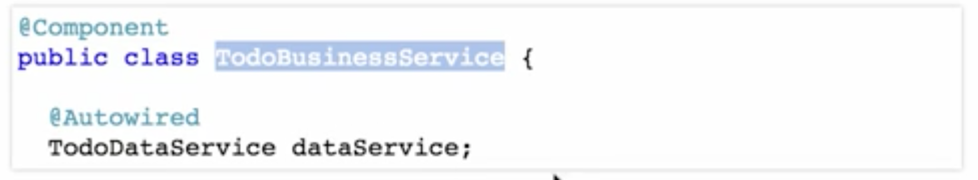

The TodoBusinessService is a dependency of TodoController.

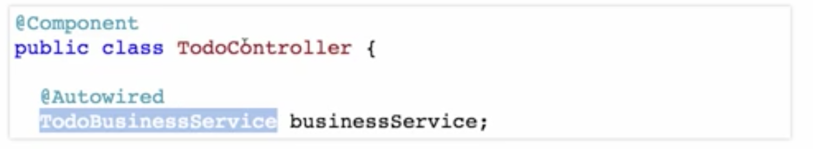

The TodoDataService either dependency of TodoBusinessService.

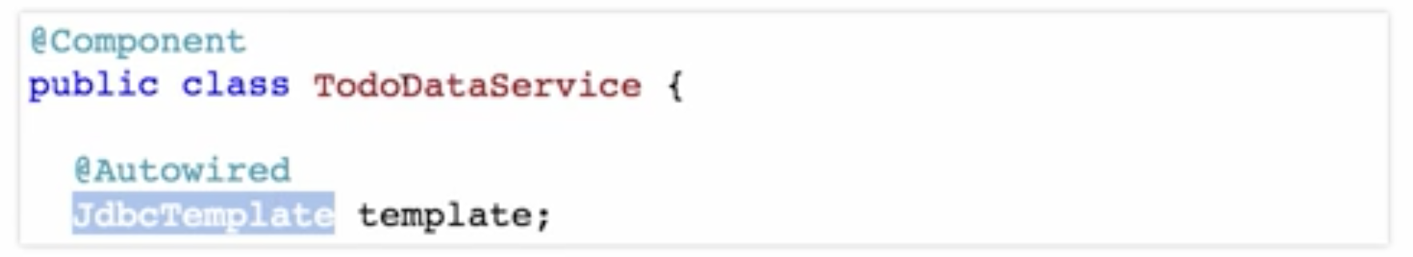

The JdbcTemplate is a dependency of the TodoDataService.

Autowiring-

Say there are two implementations of SortAlgorithm available in the component scan, bubbleSortAlgorithm and quickSortAlgorithm.Start spring application. It fails as two classes are present and Spring doesn’t know which one to use. How to solve this

1. Use @Primary on the class which you want to be autowired by default  
   
2. You can do auto wiring by name.

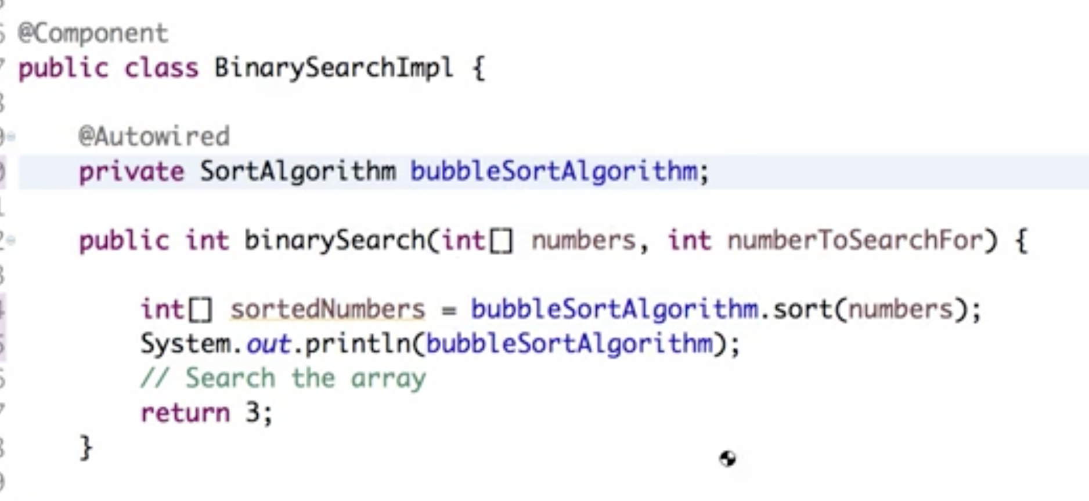

The advantage of using this way of auto wiring is I'm not changing the algorithms at all.

So I'm not putting @Primary on either of these. Where we are using it, we can decide which one to use.

So if there is another component, where I want to use the quickSortAlgorithm in there, I can rename the variable as QuickSortAlgorithm.

1. Using @Qualifier

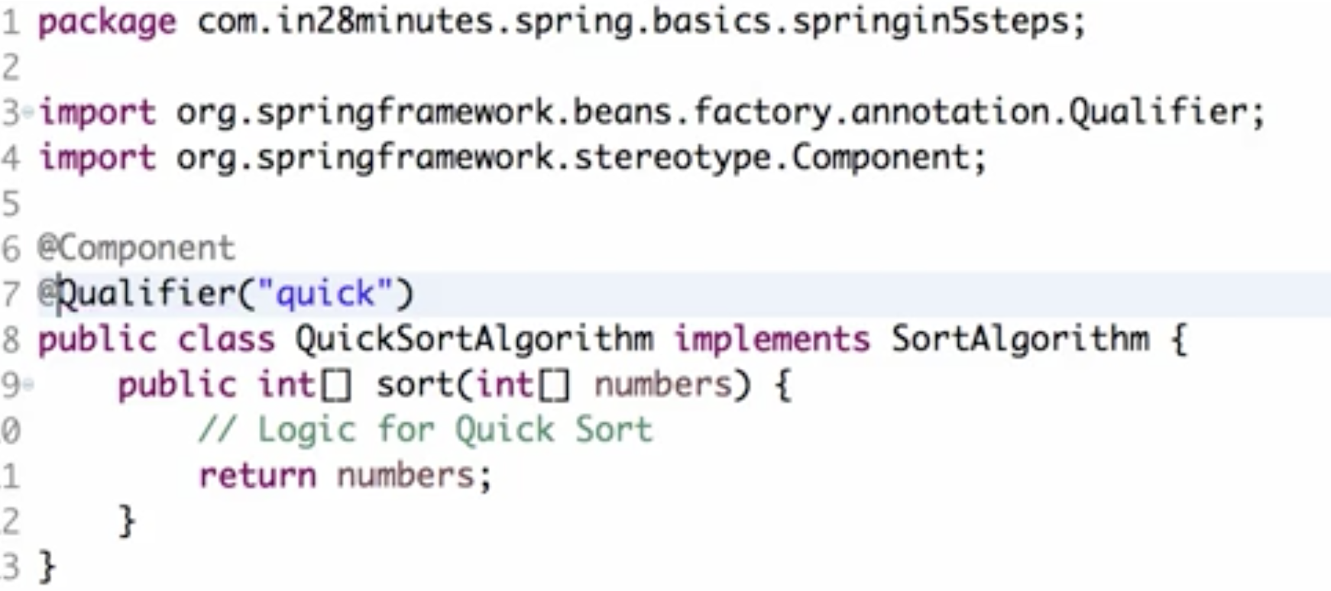

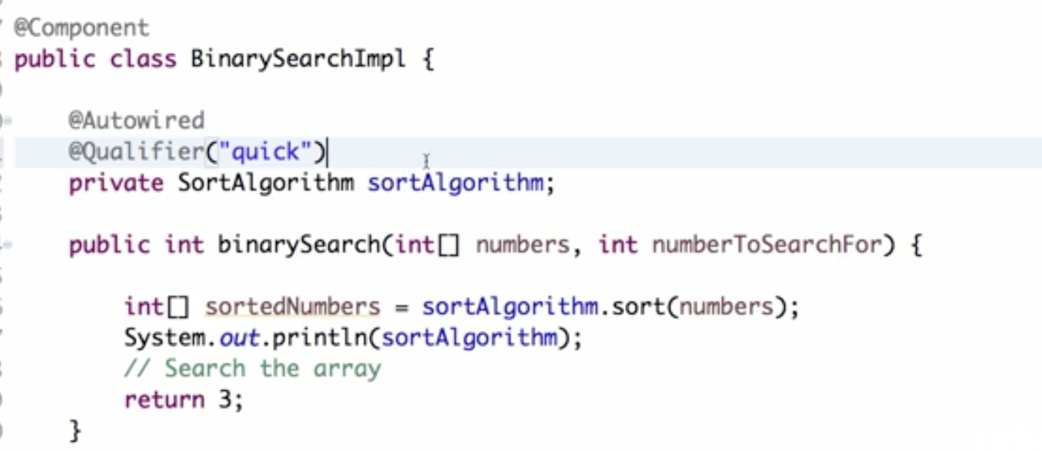

Now its using QucikSort as we gave Qualifier with name quick

Some situations:

If both are made @Primary, it gives error "I cannot find a 'primary' bean among the components" because two of them are declared as primary beans.

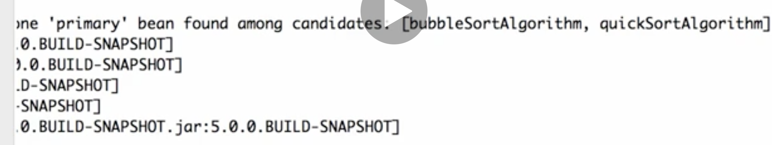

Which takes precedence - @Primary or by name? – By name has higher precedence

Meaning, use private SortAlgoirthm bubbleSortAlgorithm and make QuickSort @Primary, when you run, it will use BubbleSort

===========  
  
Scope of bean

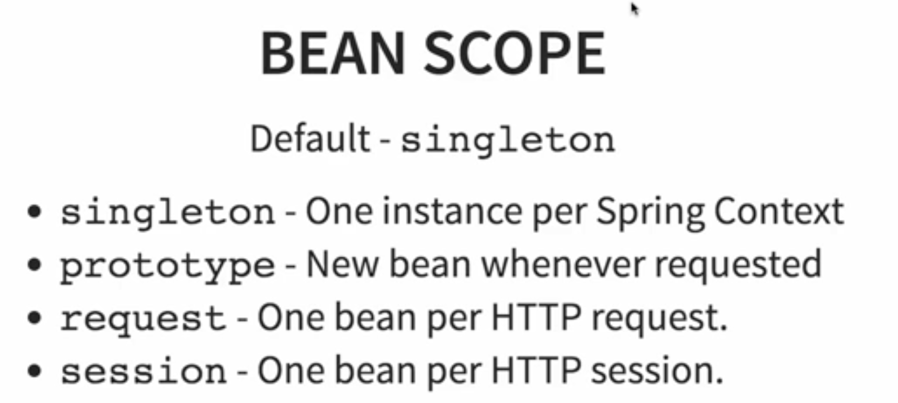

1. singleton

Let's take the example of of BinarySearchImpl. I have the BinarySearchImpl which is creating, which has a sortAlgorithm as dependency.

The container is creating an instance of the bean sortAlgorithm

It is creating an instance of the bean BinarySearchImpl as well.

Over here we are trying to get that bean from the container or the applicationContext.

For now, let's consider the idea where here we are trying to get a bean from the applicationContext using ApplicationContext.getBean.

If I do that again, if I say binarySearch1 and get the bean again, will I get the same bean or will I get a different bean?

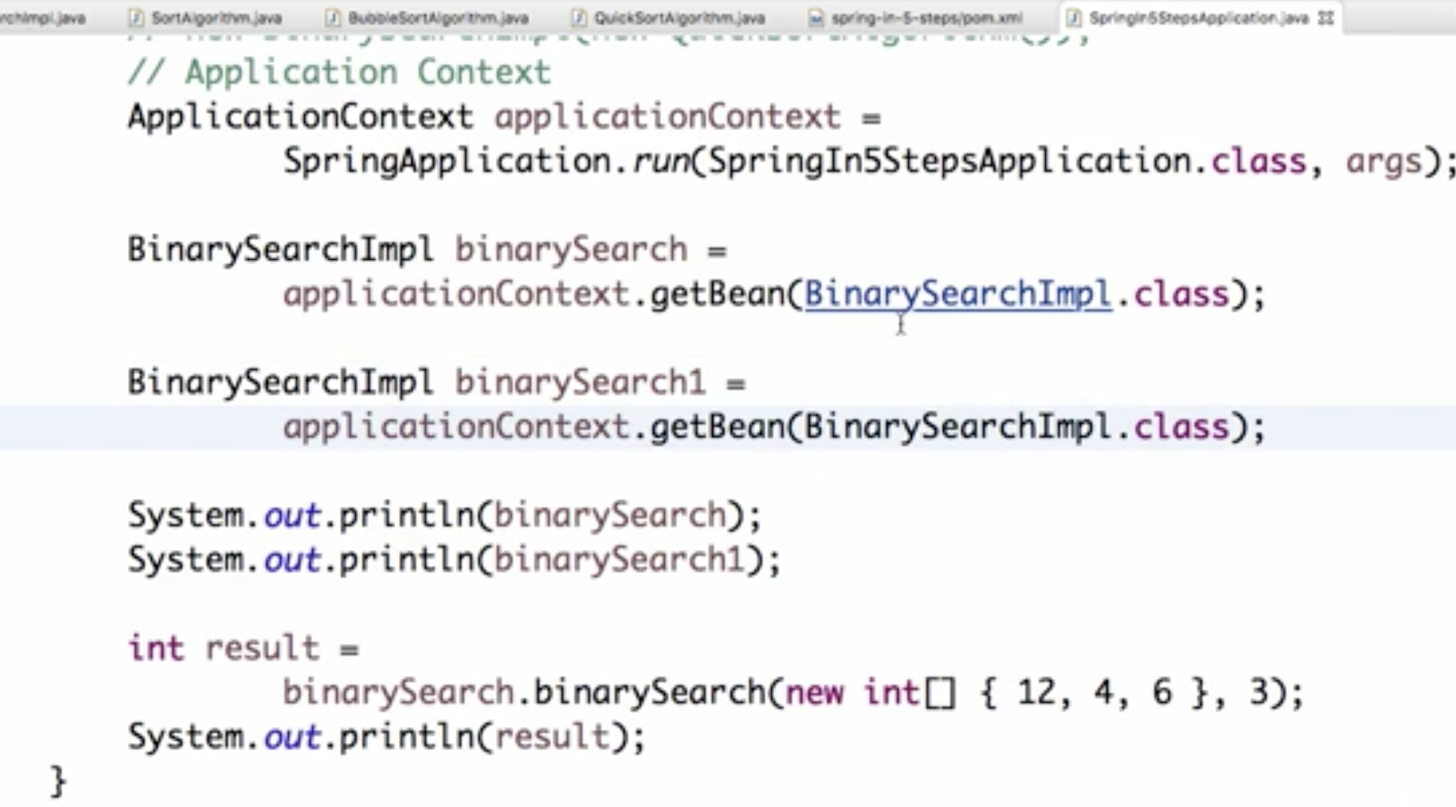

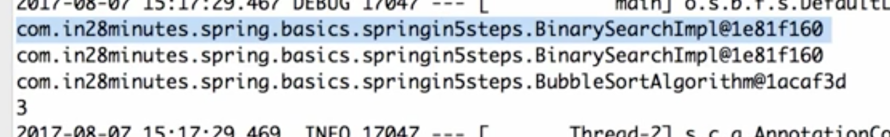

You can see that the hashCode is the same. This here we are referring to the same object. When you're trying to get different instances of binarySearch from the applicationContext, what we are getting is the same bean.

When we are requesting the applicationContext for the same bean twice we are getting the same instance of it back. These kind of beans are called singleton beans.

In Spring, by default, any bean is a singleton.

2) prototype  
In the case of a prototype, you'd get a new bean whenever it is requested.

Whenever you're requesting a prototype bean twice, you get two different instances of that same bean.

3) request and session

These are really useful in case of a web application.

In a web application, there is separate thing called a HTTP request.

One flow of a request from the browser to the server processed on the server and response comes back to the browser. This is called a request.

When you have a scope of request, then one bean is created per HTTP request.

In the case of session, one bean is created for a specific user session.

How to specify scope of bean

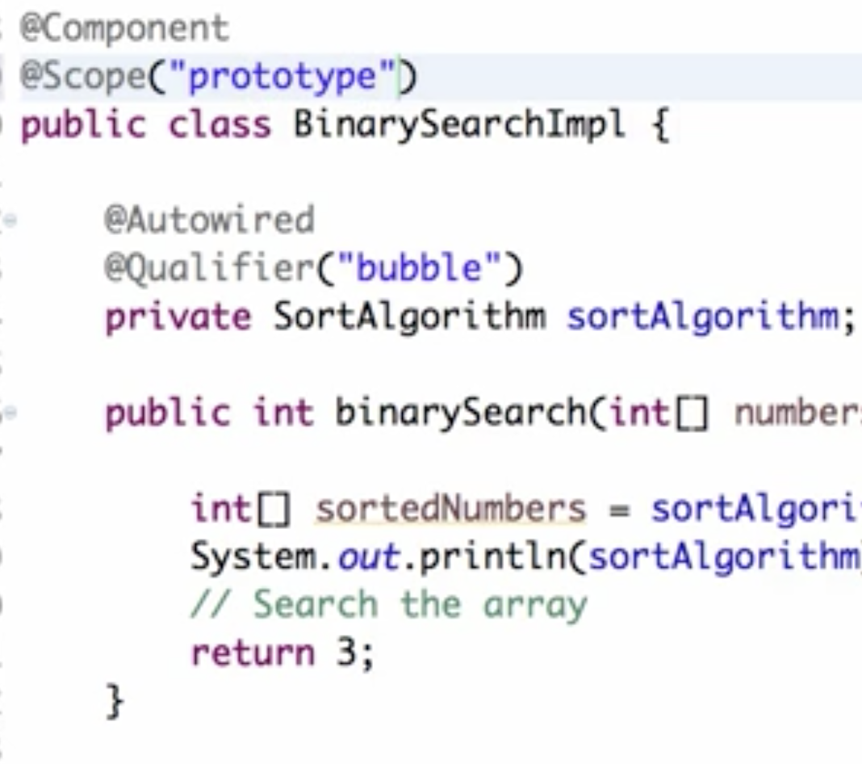

O/p – we can see different hash codes of BinarySearchImpl beans

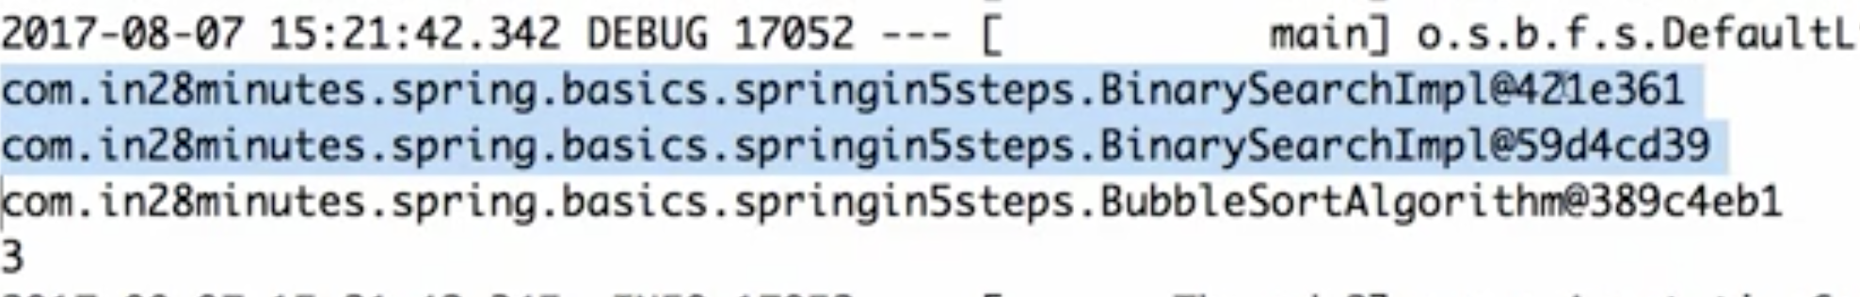

Do not hardcode the scope. Spring already gives a constant. Use it like below

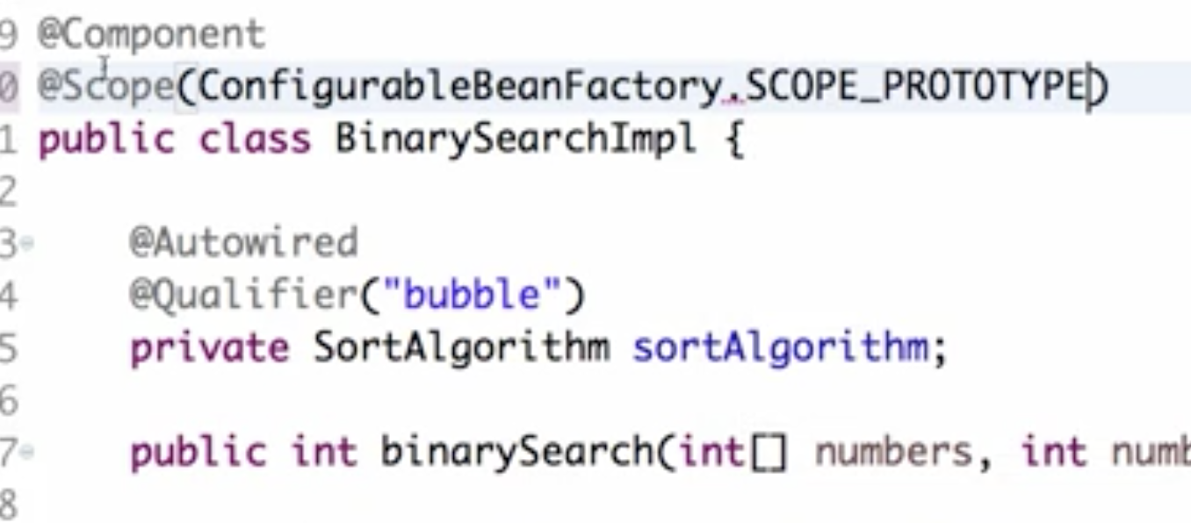

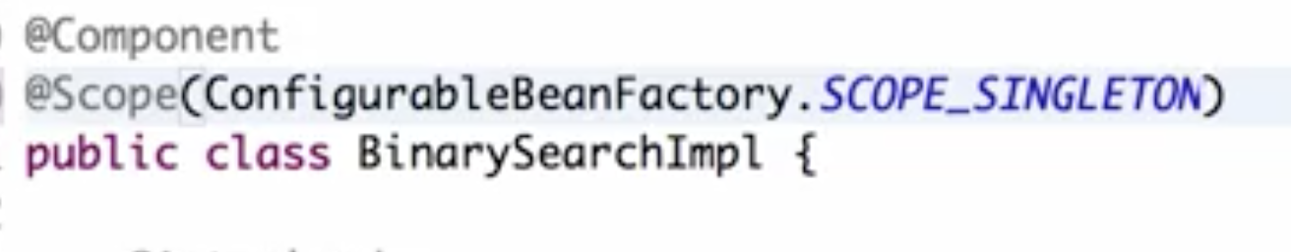

If you don't specify anything it's singleton. You can see that the same instance is being used. The ID is the same.

@Proxy

Whenever you are trying to get a bean and one of its dependencies is a prototype, then on the dependency, we should use a proxy. So we should use a proxy, so that whenever we try to get a bean and try to get the dependency, we would get a new instance of the dependency.

Eg to show and why use proxy:

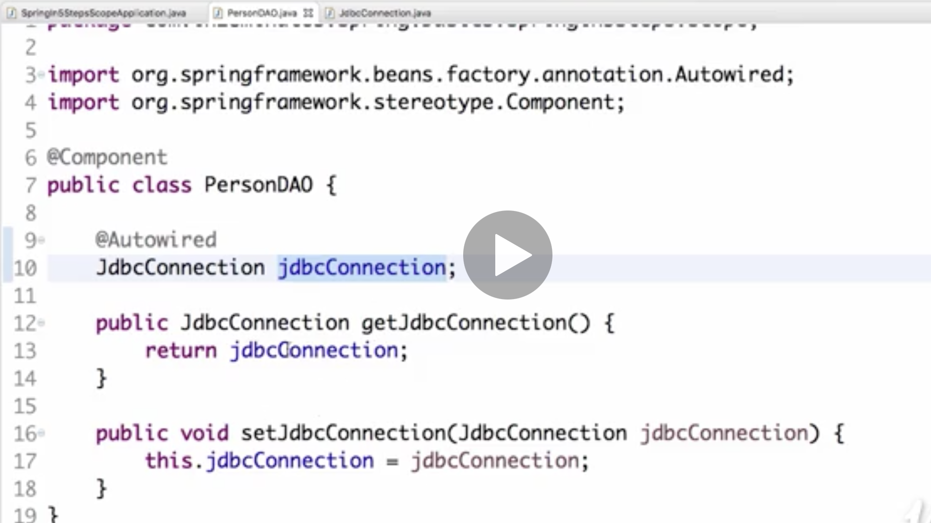

Say we have above class PersonDao which is dependent on JdbcConnection class shown below.

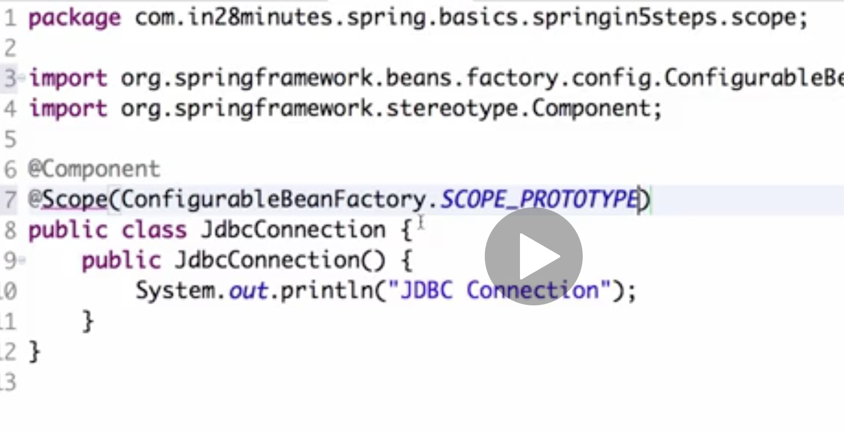

But this JdbcConnection is of scope prototype. Meaning we want new instance of Jdbc connection everywhere personDao tries to get Jdbc bean

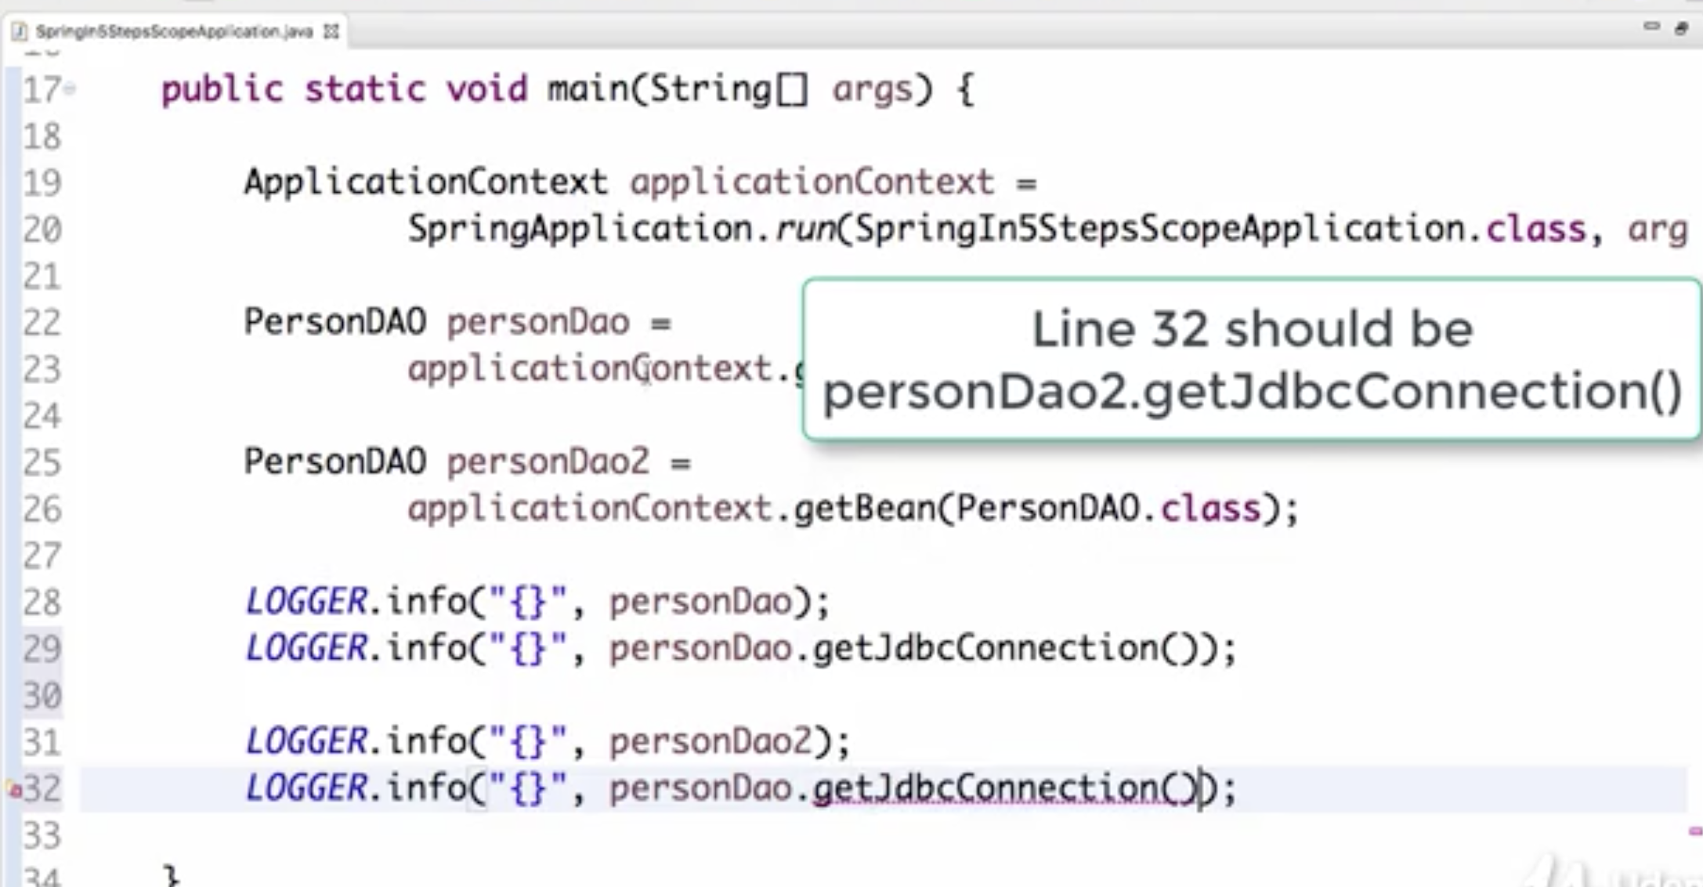

Now run the applicaition, What we see is we have same personDao which is correct as its singleton scope but we have same JdbcConnection bean also although its scope id prototype

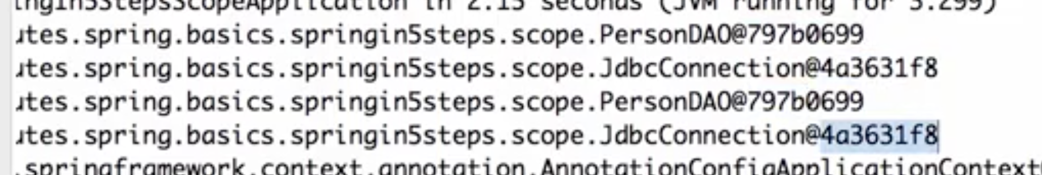

This is where @Proxy comes into picture. So whenever we have class which is dependent on another class with scope prototype, we need to use @Proxy with class ScopedProxyMode.TARGET_CLASS. So what it does is, wherever JdbcConnection is ised, it will use a proxy and hence different isntances will be created everytime

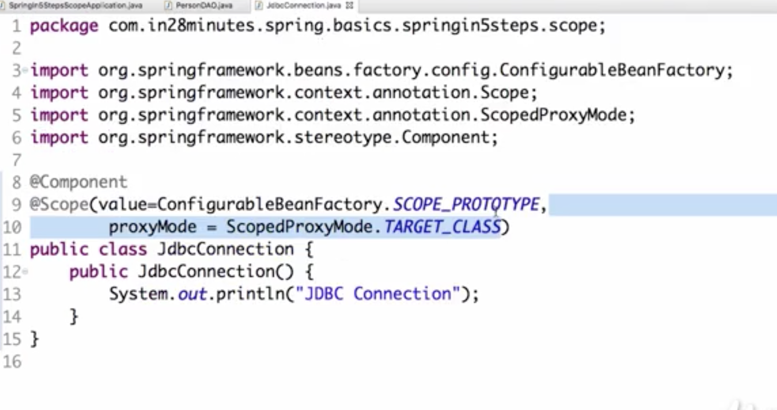

With this, o/p =>

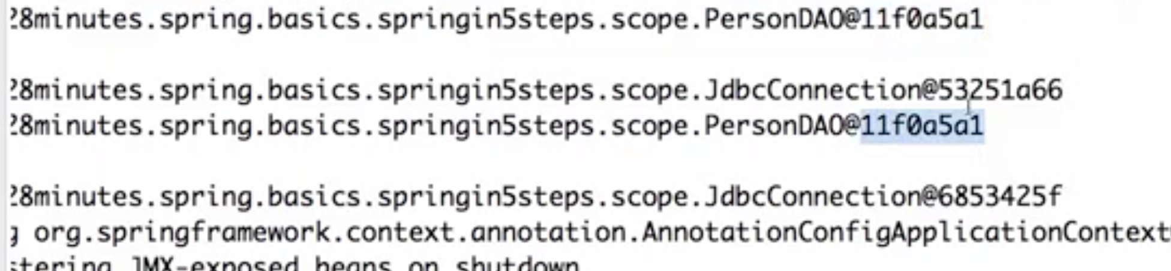

If we do getJdbcConnection() on same personDao instance also, we still get different instance of JdbcConnection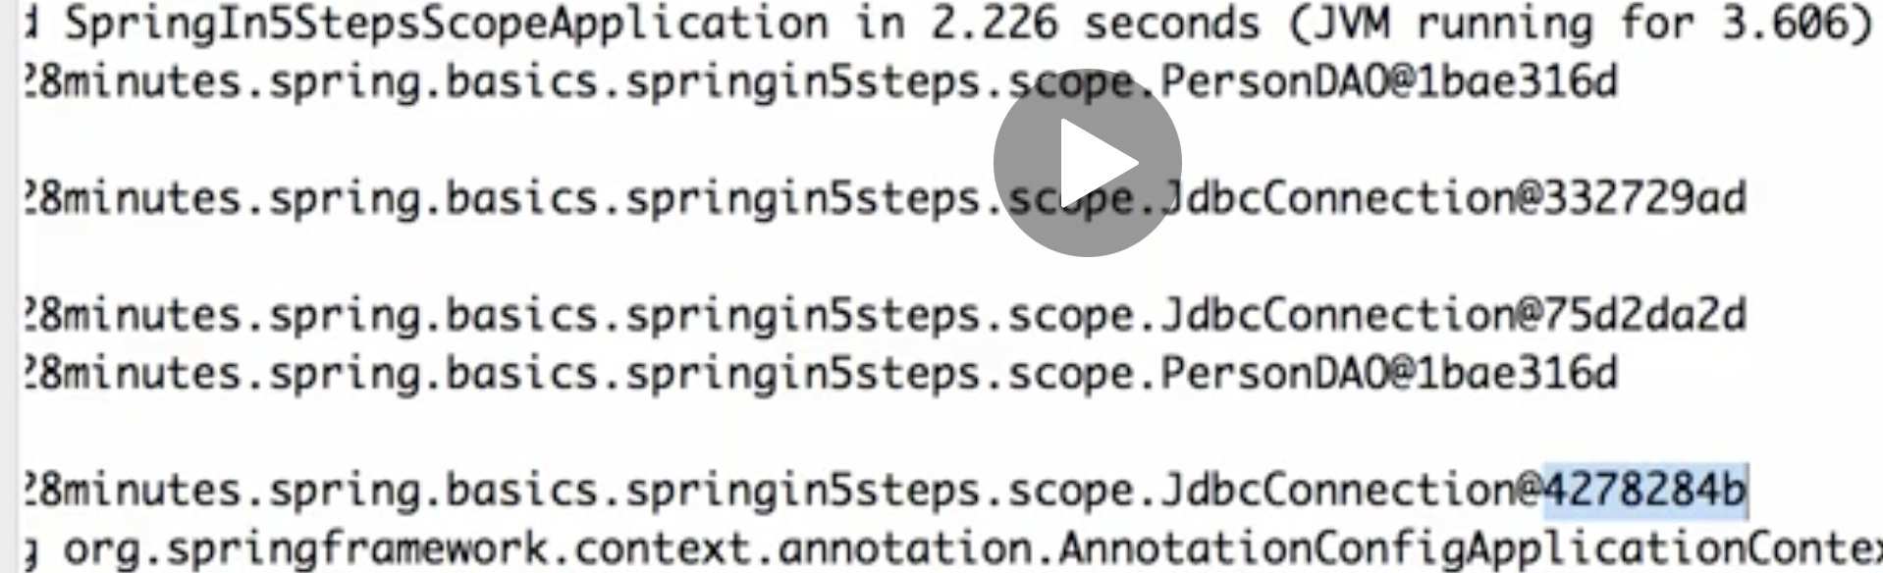

That is the reason why a proxy becomes very important.

What would happen is,instead of the JdbcConnection getting autowired into the personDao, what would be autowired in, is something called a proxy.

So a proxy gets autowired in here, and whenever you call the getJdbcConnection, the proxy would make sure that it would return the new JdbcConnection back.

Difference between bean scope singleton and Singleton pattern

* In the Gang of Four design patterns, whenever they say singleton, it basically means one singleton per JVM. Per Java Virtual Machine you have one instance of that bean.
* when we talk about singleton in Spring, it's one instance per application context.
* By Gang of Four definition, even if multiple application contexts are running in the same JVM, you should just have one instance of that specific class.
* However, when we talk about Spring singleton, there can be one instance of that class per one application context.

=======  
  
ComponentScan –

to tell Spring where to search for components

Put above classes PersonDao into another package sub folder namely componentscan other than the one in which main class is present and rename it to CompoenntDao

Run the app. We get this exception

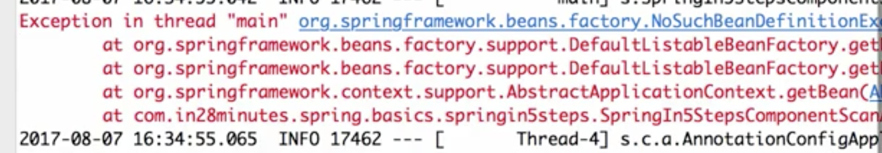



Why is it not able to find the component for us?

The reason why this is not being picked up is because this package which of well where it is present in, is not part of the componentscan.

Whenever we say something is a SpringBootApplication it automatically defines a ComponentScan on this package and these are packages off it. So everything in this package and its sub-packages will be picked up by that ComponentScan.

However, the things in other packages are not picked up. So if I want other packages to be picked up then I would need to add a ComponentScan on them as well as shown below.

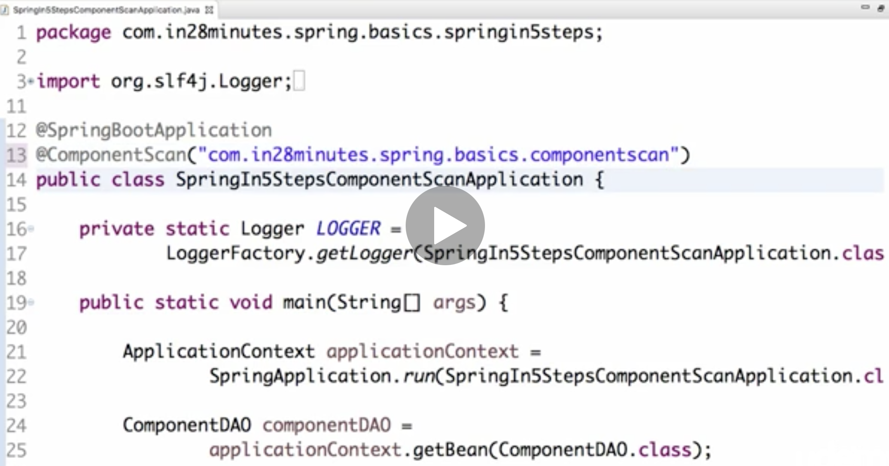

Now what would happen is we would now scan this package for component.

Now it runs properly

===========

Life cycle of bean

when we put a component on a bean, the entire life cycle of this bean will be managed by Spring. So the Spring IoC container will create a new set of this bean, and it will also make sure that this is destroyed once it's no longer needed.

Say I want to do certain things at the creation of this particular bean, or I would want to do certain things before the bean is destroyed.

How do I do that?

1)So you want to be sure that all the dependencies are populated, and only then, you would want to do certain actions. Those kind of things can be performed in something called PostConstruct.

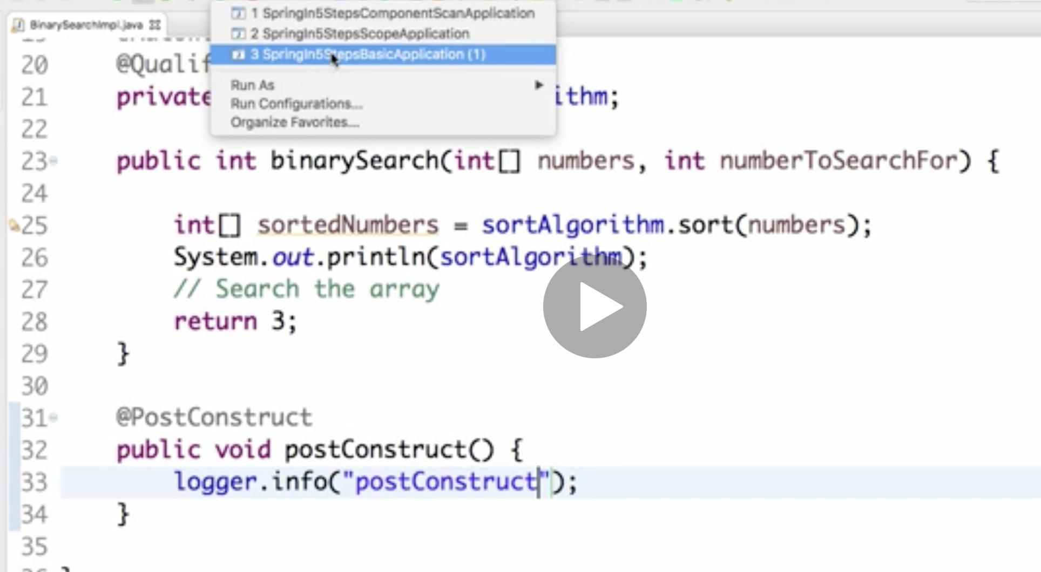

So as soon as the bean is created and initialized with the dependencies, the PostConstruct method would be called.

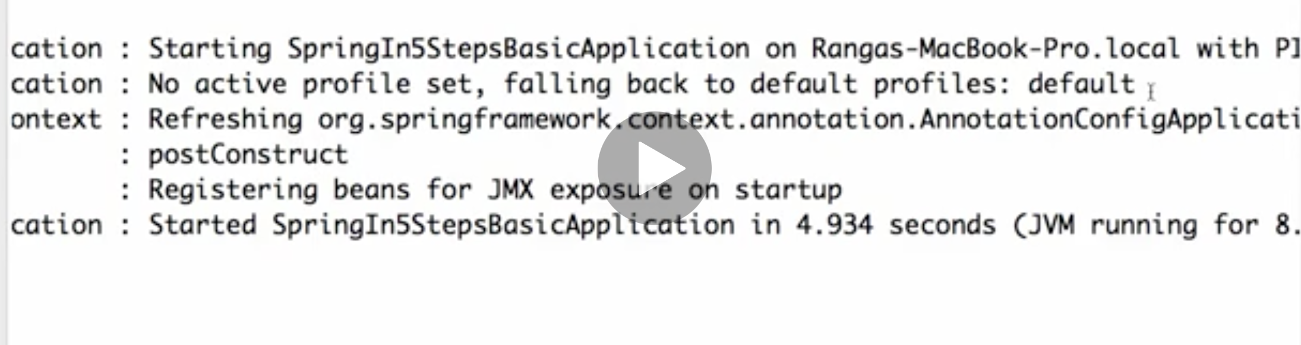

So even before any of the methods are called on the beans, so even before the bean is printed or something of that kind, as soon as the dependencies are populated, you'd see that the PostConstruct method is called.

So if you want to do something to initialize the content of the bean, as soon as the dependencies are available, then you can use the PostConstruct method

1. A similar method, which is present just before destroying, so this is called PreDestroy.

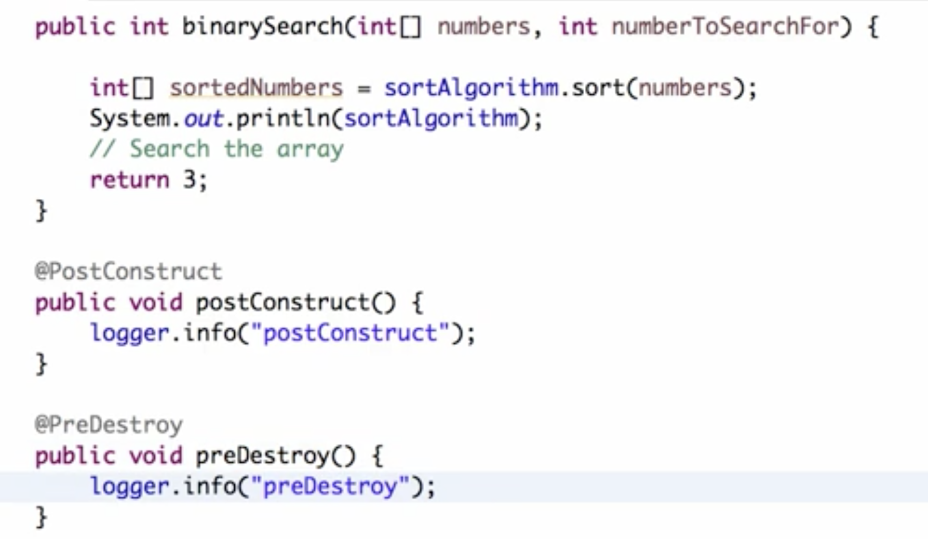

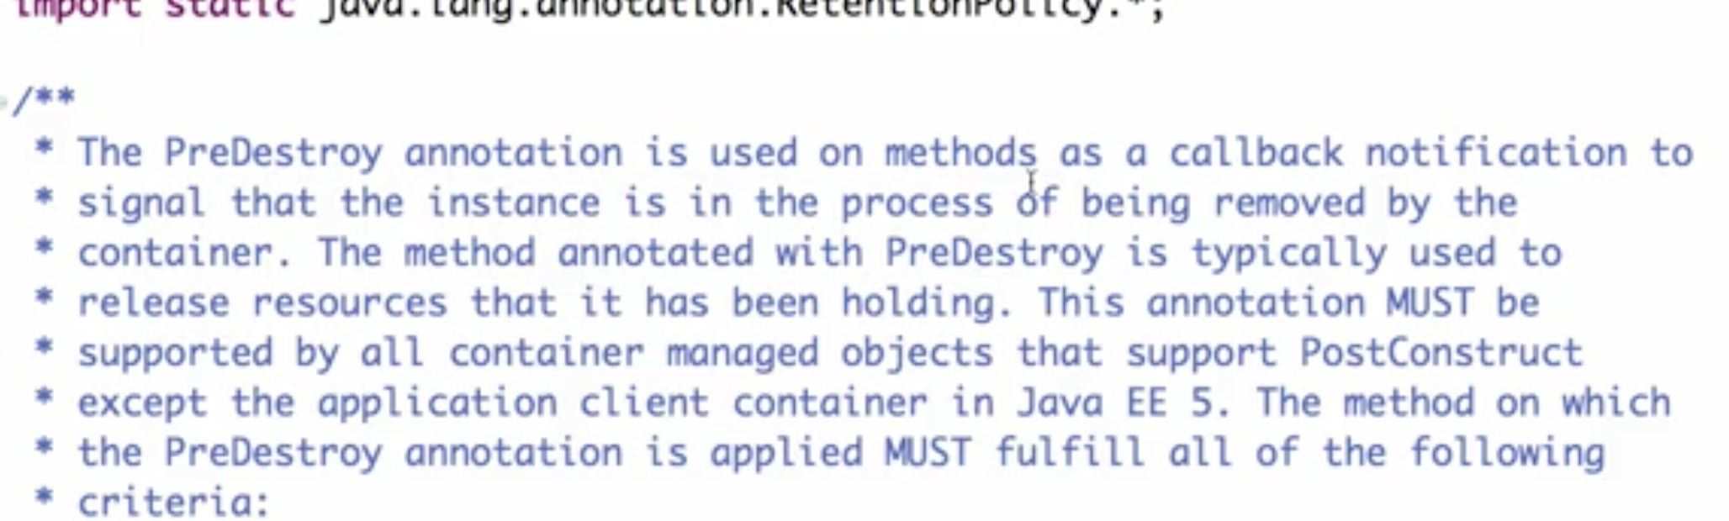

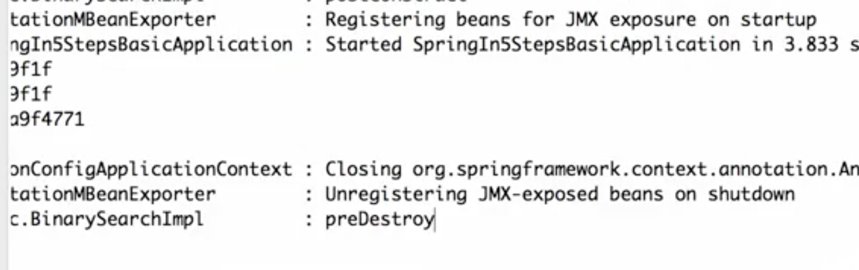

preDestroy is last one to be called when we stop application

CDI – Context and Dependency Injection.

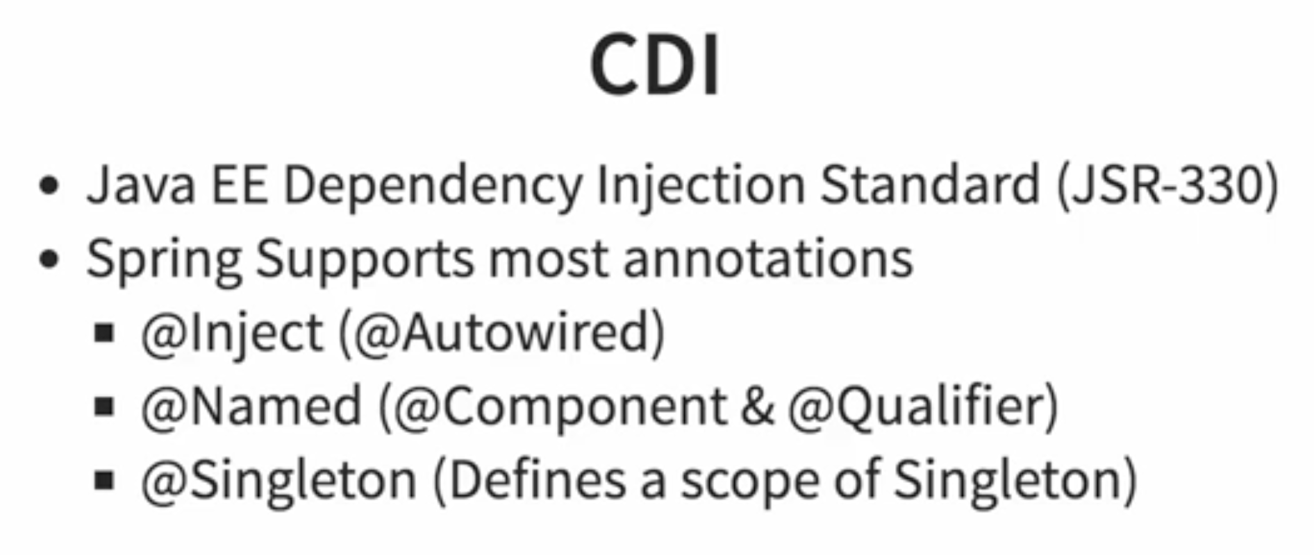

Spring framework introduced this concept called Dependency Injection. And also, it introduced something called IoC container, Inversion of Control container.

So, CDI tries to standardize this as part of the Java EE. So, CDI is like the interface. It defines the different annotations. So, it says @Inject, @Named, @Singleton. These are the different annotations, which needs to be used.

And this CDI implementation frameworks would provide the functionality.

A comparable thing would be JPA and Hibernate. So, JPA is a interface. Java Persistence API defines the API, and Hibernate understands the API, which is defined by JPA and provides the implementation for that.

Similar to that, CDI is a interface defining how to do Dependency Injection. It says, if I want to auto-wire something in, then you'd need to use @Inject. If you'd want to do @Named, that means you are defining a component. So, the comparable Spring annotation for CDI @Named, is @Component and the comparable for @Inject is @Autowired. So, CDI tried to define common annotations to use with Dependency Injection.

Spring supports almost all the features of containers and Dependency Injection. So, instead of using this Spring annotations @Autowired, you can use the annotation @Inject. Instead of using @Component, I can use @Named.

Eg on using CDI:

To use CDI, we need to add dependency javax.inject

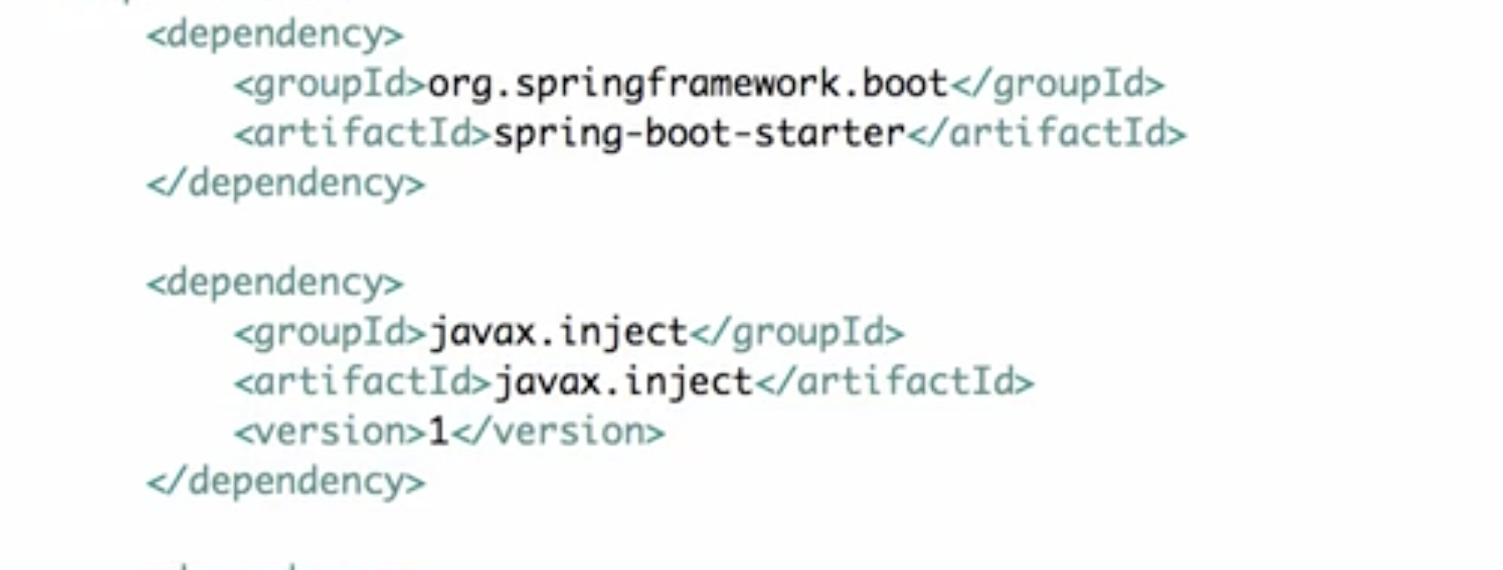

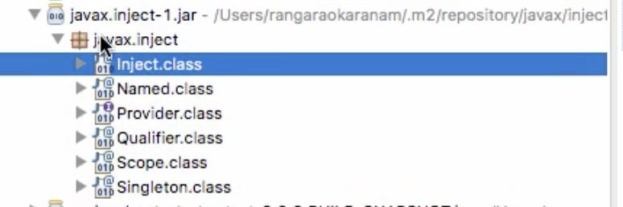

CDI doesn't do anything other than defining a few annotations.

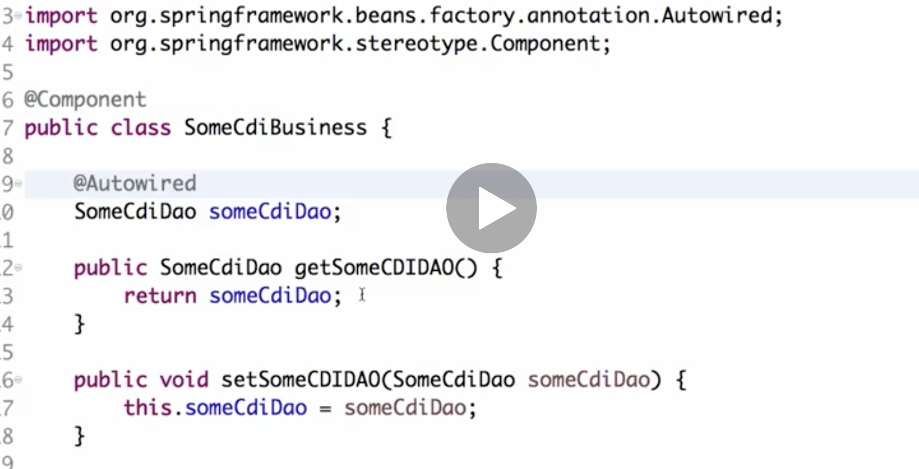

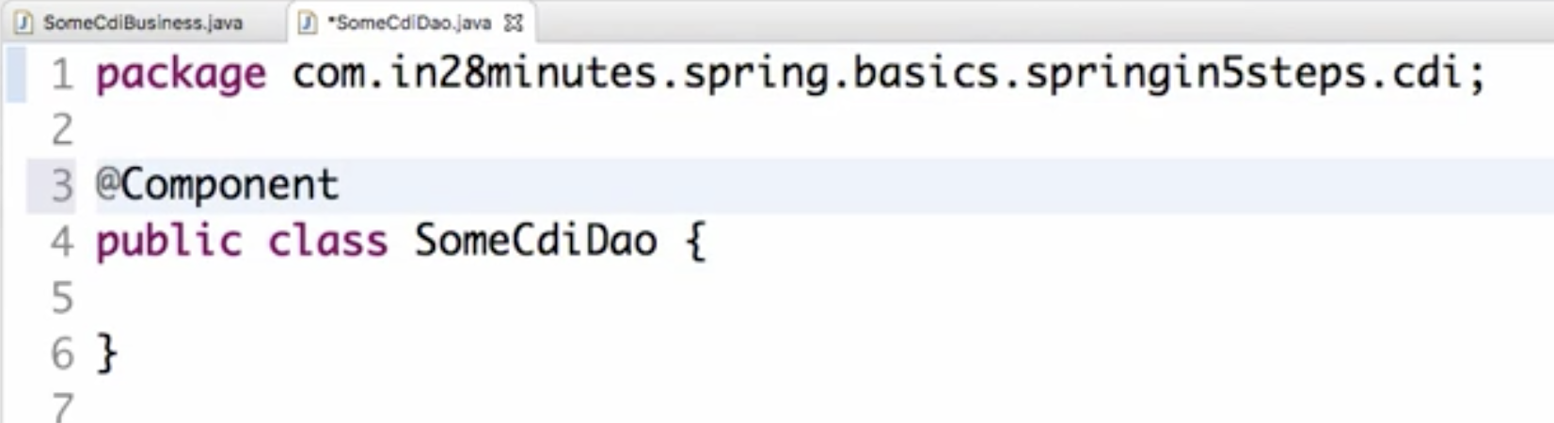

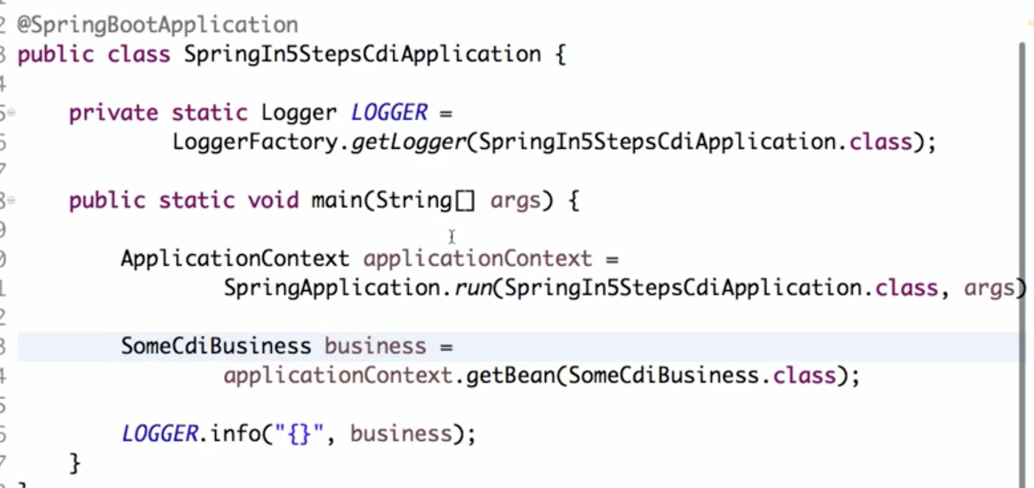

Run

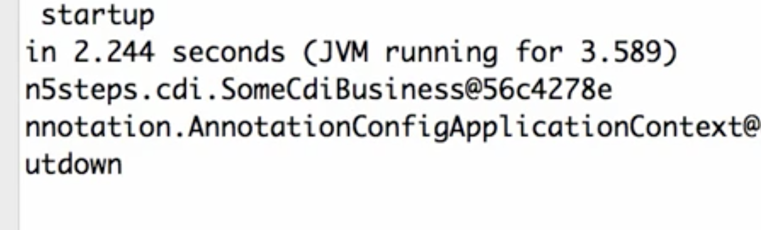

So this is something which we have been doing until now, nothing new in here.

However, CDI proposes a new way of doing this. So CDI says, instead of @Component, do something called @Named. So instead of @Component it's called @Named, and instead of @Autowired it's @Inject.

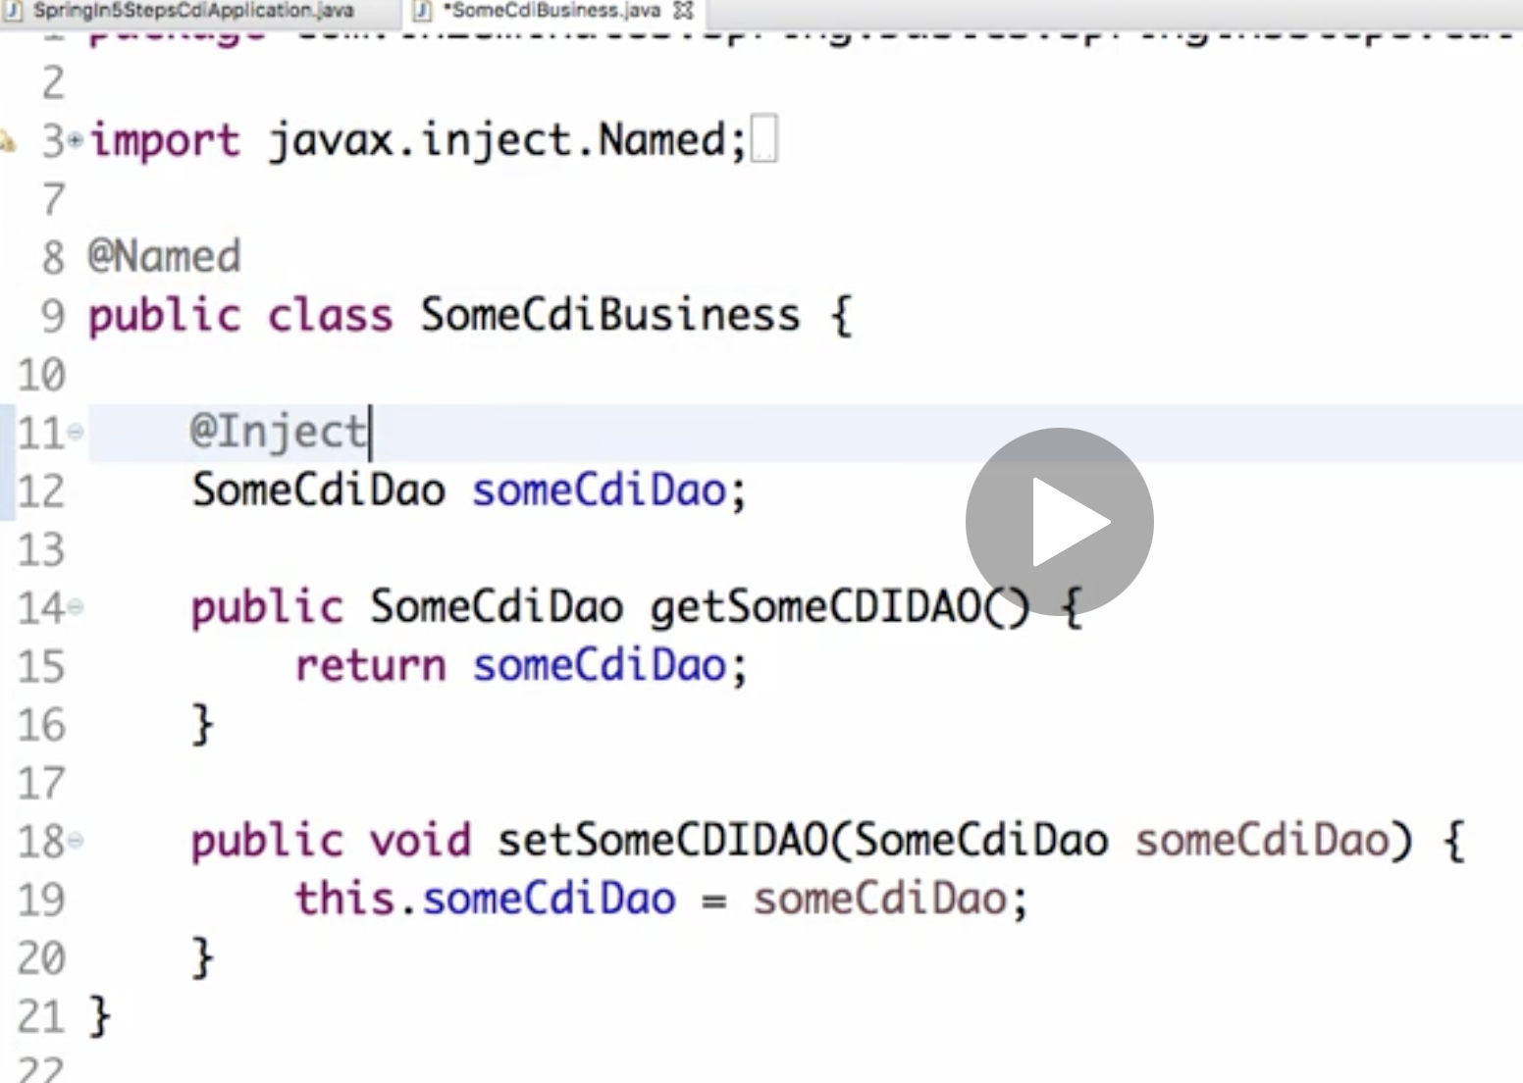

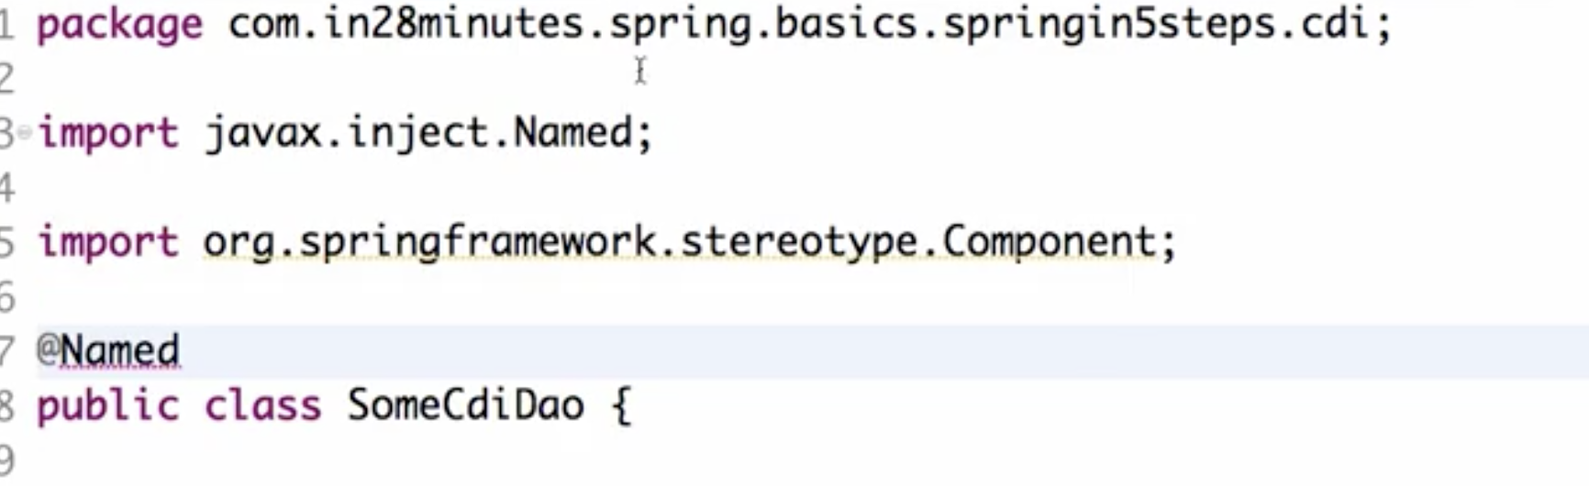

We still get same output. So whether you use the Spring annotations or the CDA annotations, it does not really matter,because Spring implements CDI.

Now, the most difficult question to answer is whether you should use CDI

or whether you should use Spring.

I think it's a tricky question to answer. CDI is a Java EE standard, so you are talking about using something which is really a standard, which is something which a lot people would like to do, right, so you always want to stick to a standard.

Whether you want to use CDI annotations or Spring annotations, you can go ahead and use them. Because you are going to use Spring as the implementation anyway, so it doesn't really matter.

===========  
Using basic Spring

Until now we have been using Spring Boot to create all our examples. However, it is very important that you understand how to use spring without Spring Boot. So the spring-boot-starter is the dependency, which starts bringing in all the Spring Boot functionality. I don't want to use Spring Boot functionality so I'll start with step by step getting rid of it. And use spring-core instead

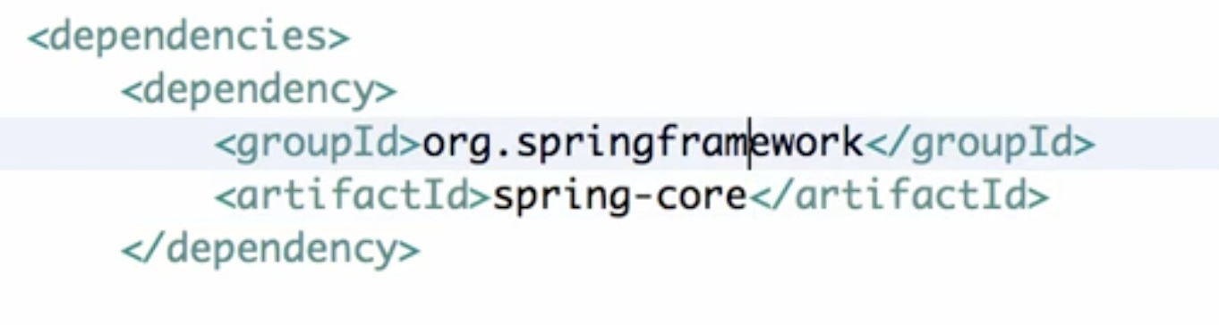

So spring-core is where your bean factory is defined the basic management of your beans, is defined in spring-core. So spring-context is for application context. Add that too

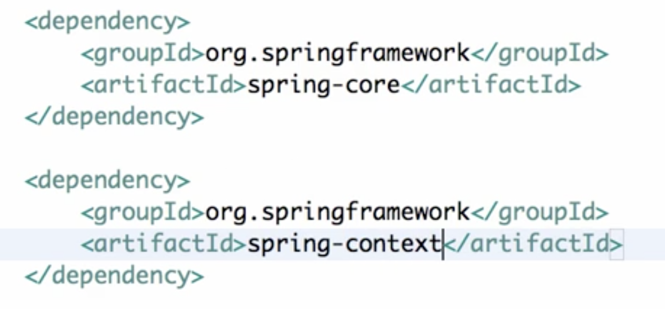

Also remove @SpringBootApplication from main class. Instead use @Configuration

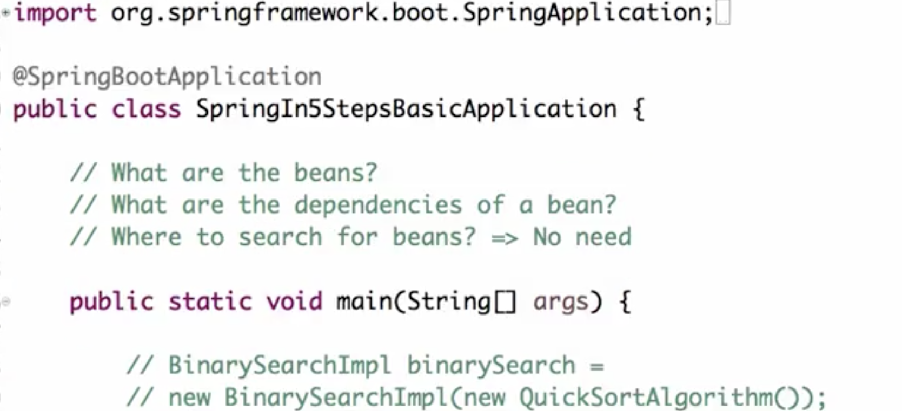 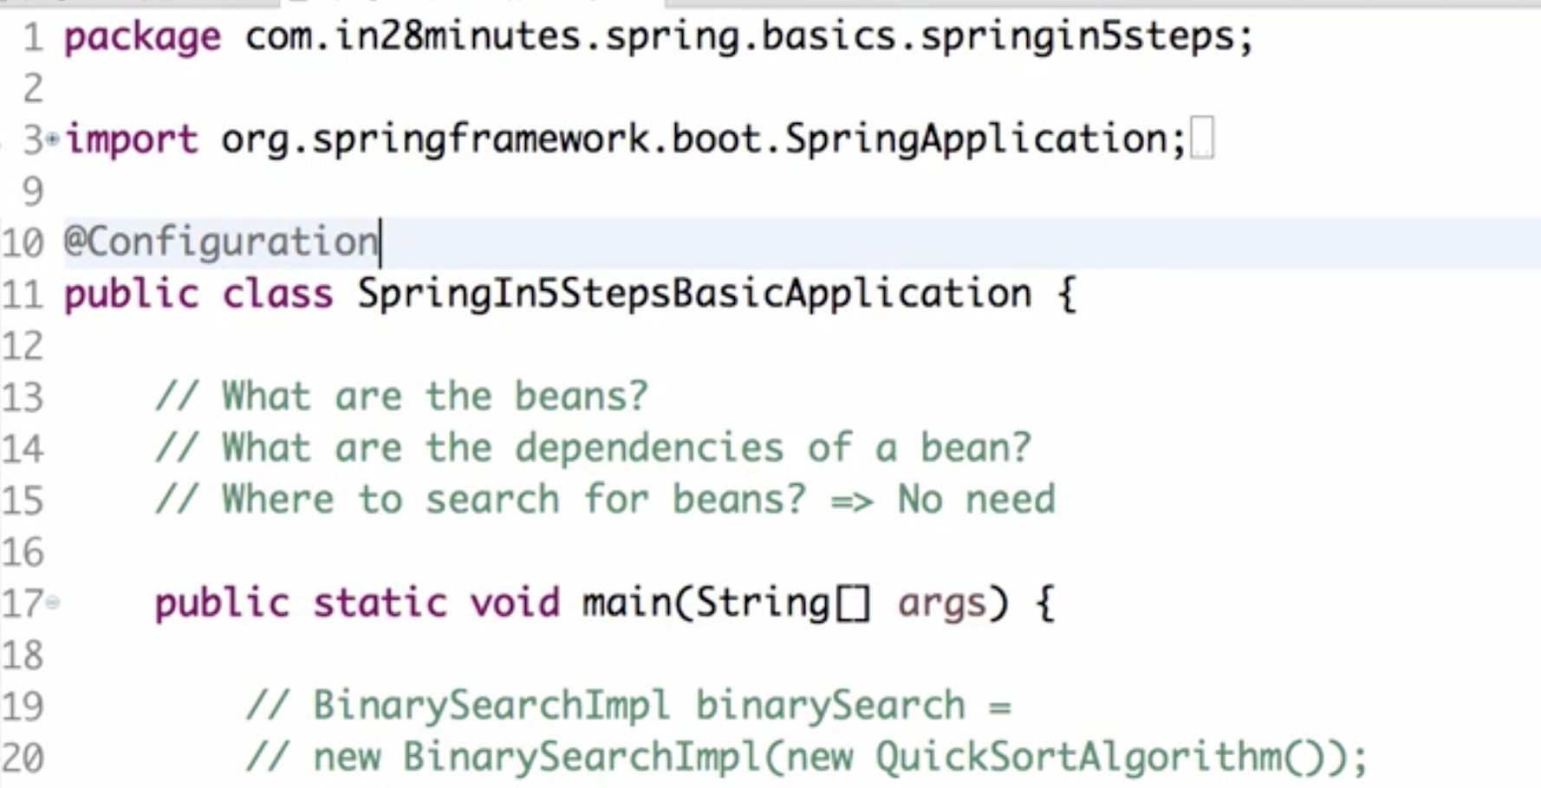

Run application. We get error Class not found for SpringApplication

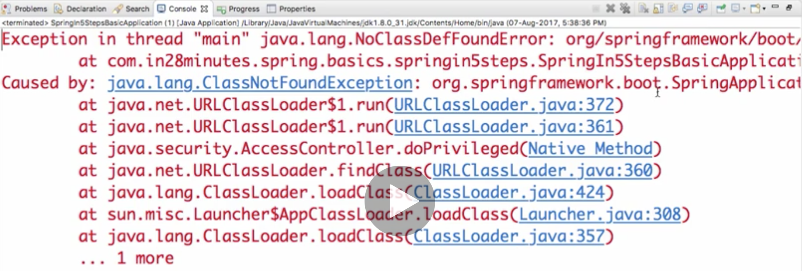

So we need to use AnnotationConfigApplicationContext and pass the main class to it

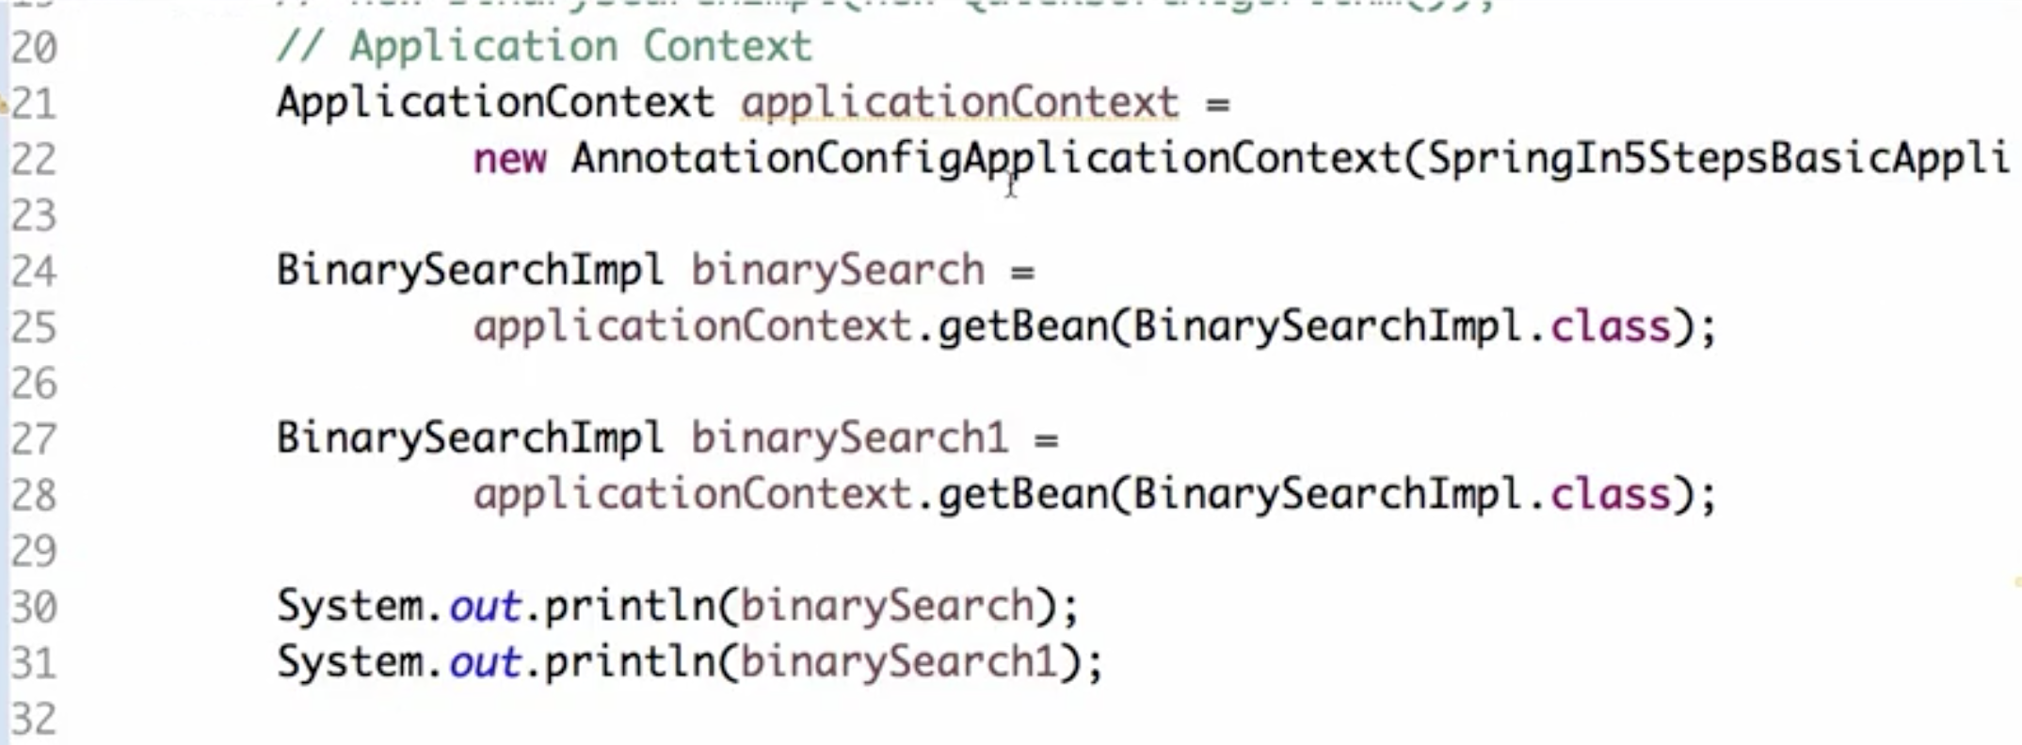

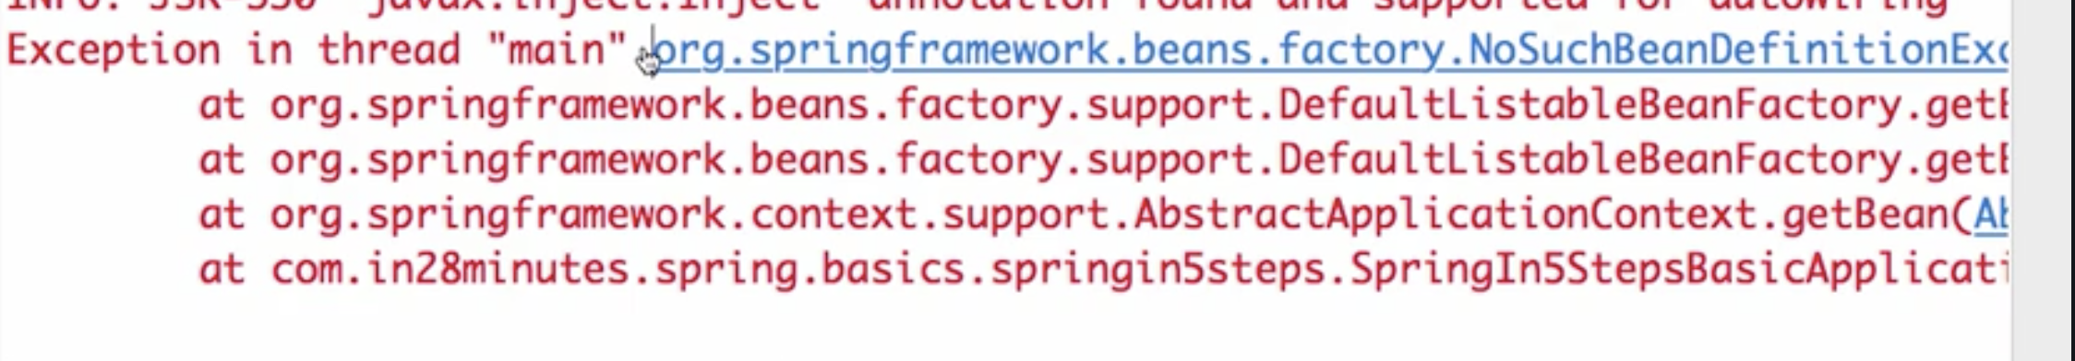

No bean exception

This is because we haven’t defined componentScan – spring boot does it by default but in spring, we need to explicitly do it

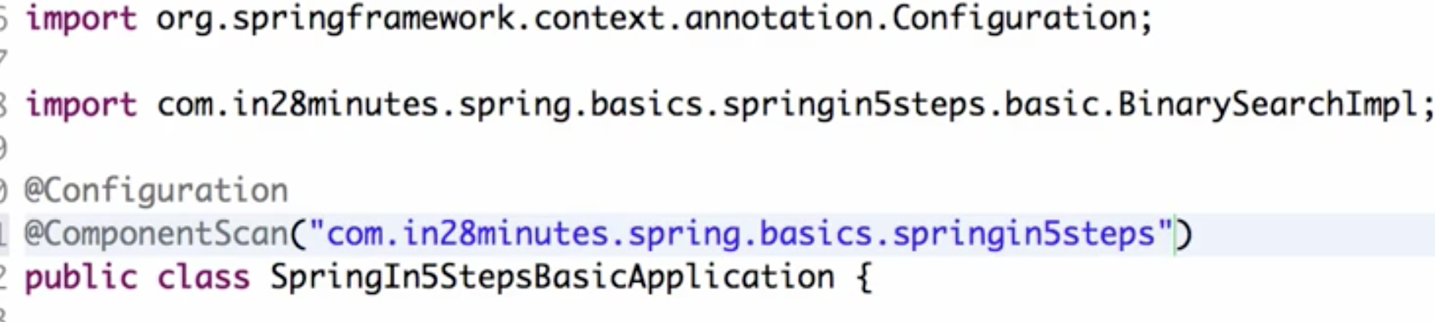

Now it will execute properly

So in this specific example that we have right now, we are not using Spring Boot at all. So all that we are doing is we are making use of basic spring.

The things which we have added in are

1. @configuration defines that this is a spring configuration.
2. @Component scan defines that this specific packageneeds to be scanned for components.
3. use AnnotationConfigApplicationContext to create the application context.
4. We removed spring-boot-starter and we added in spring-core,spring-context,

We are getting a warning in main class saying AnnotationConfigApplicationContext is not closed. So we need to close it at the end

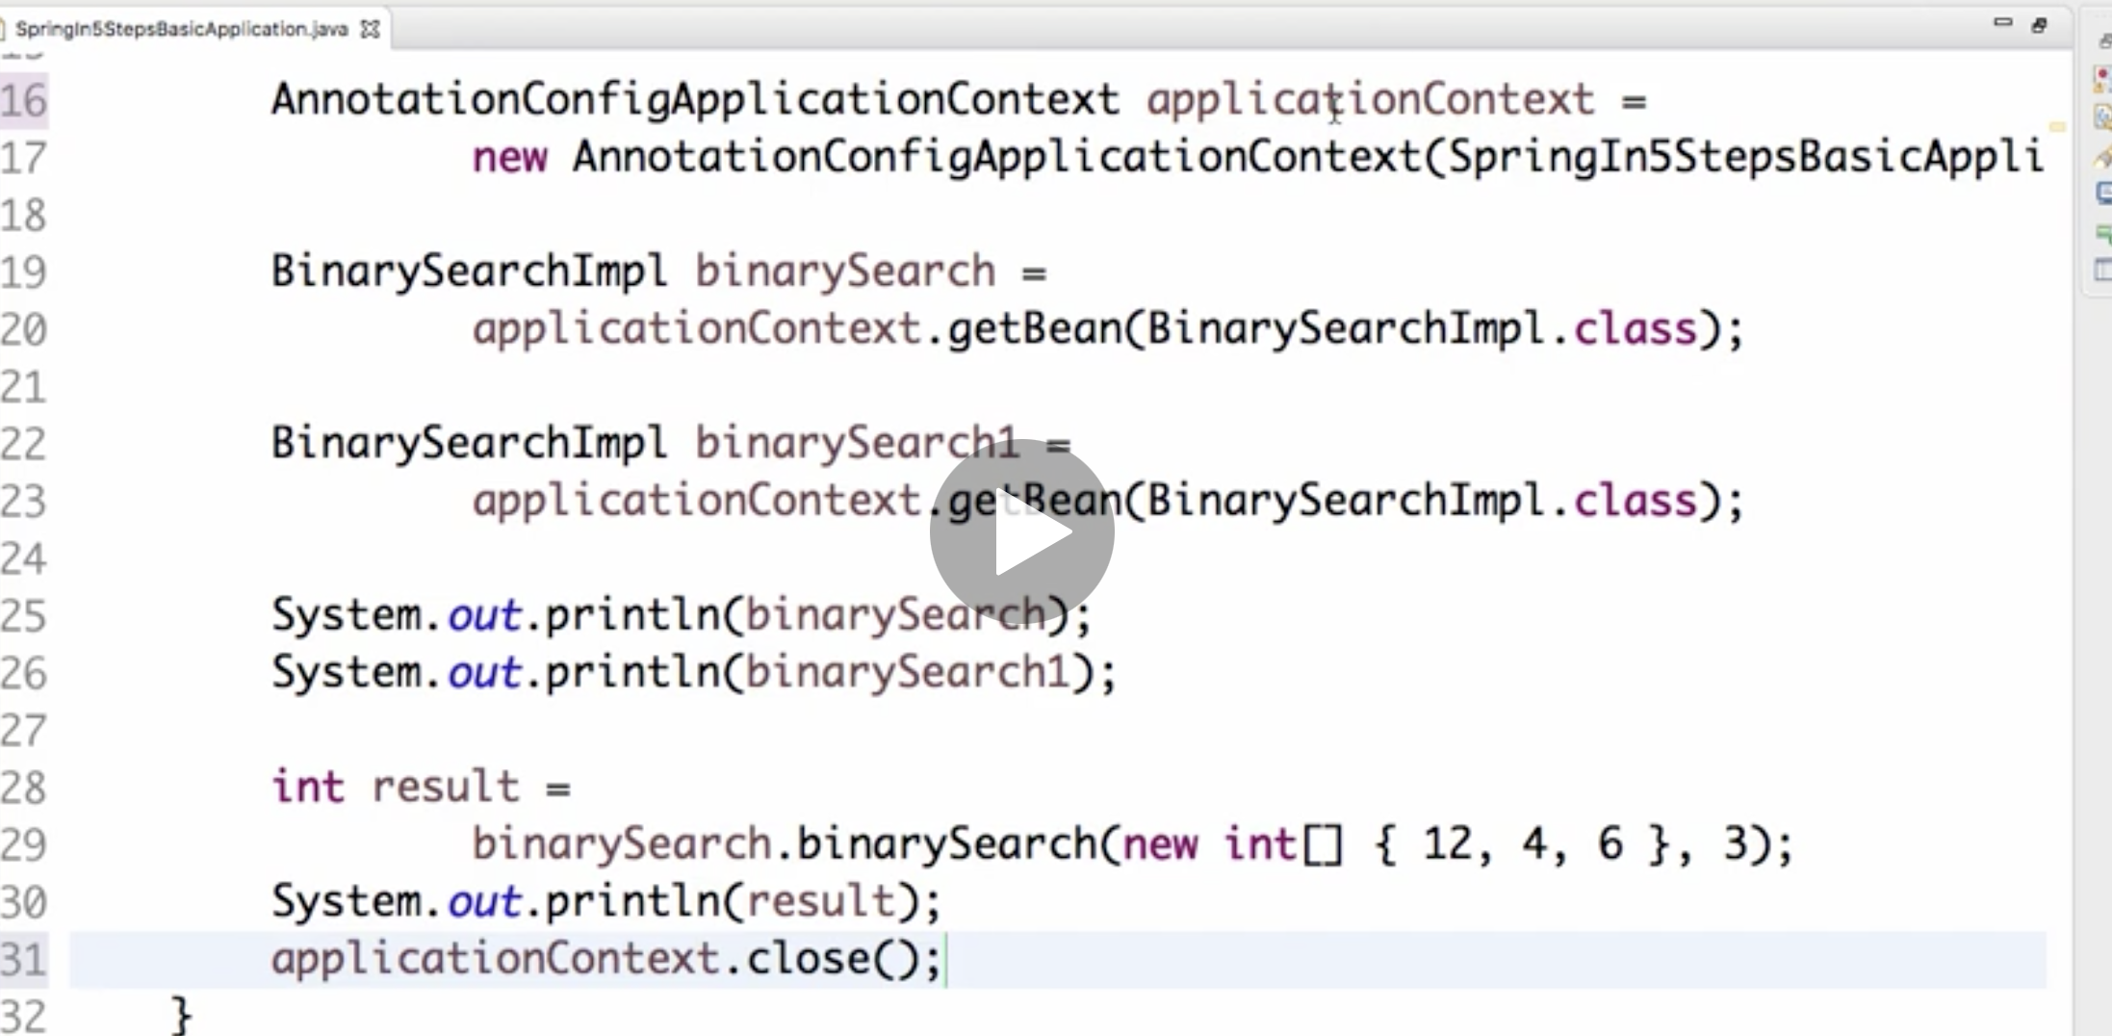

Or another way is to use try catch which will automatically close it

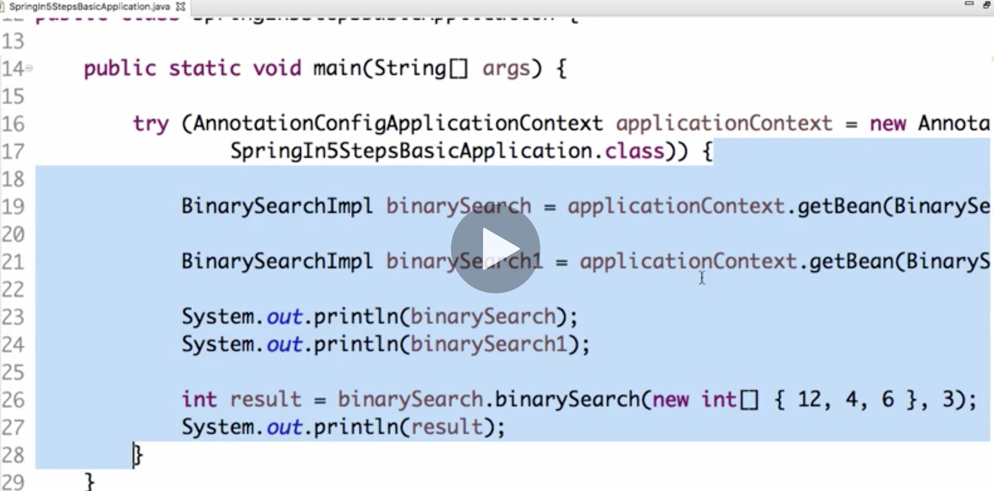

Even if there is any exception in this piece of code, connection would get closed because this, if you look at this, it would implement something called the AutoCloseable

To add logs

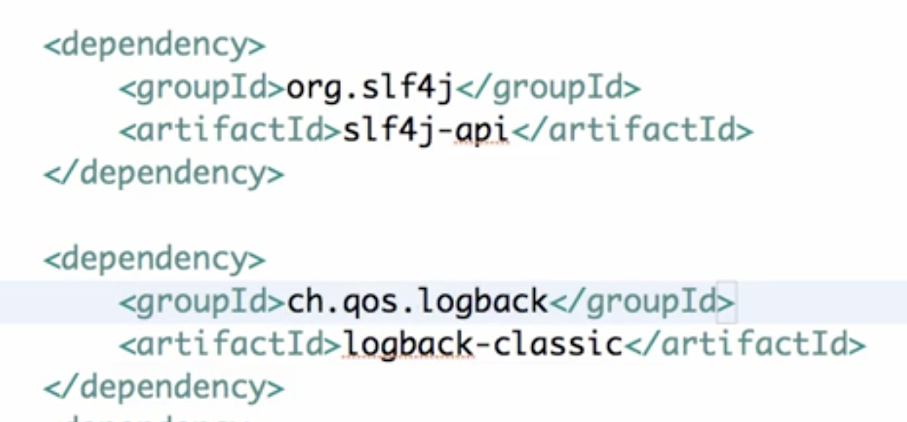

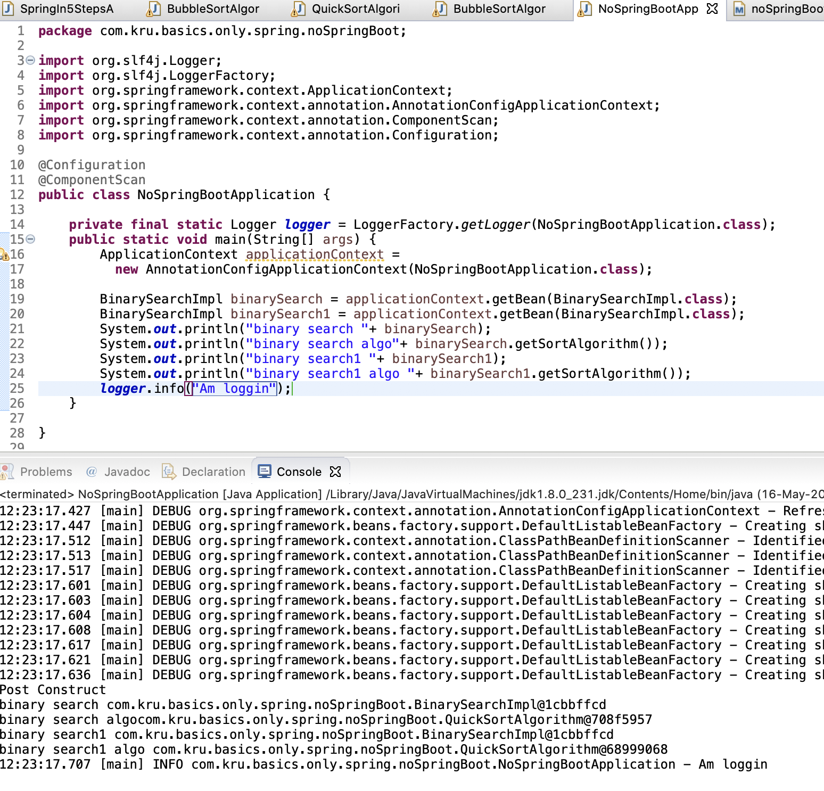

Before spring.5, we dint have annotations. Instead xml was used to instantiate beans and autowire them. Lets see an example of how to do it

1. We need a dependent and dependency classes. Do not put any annotations

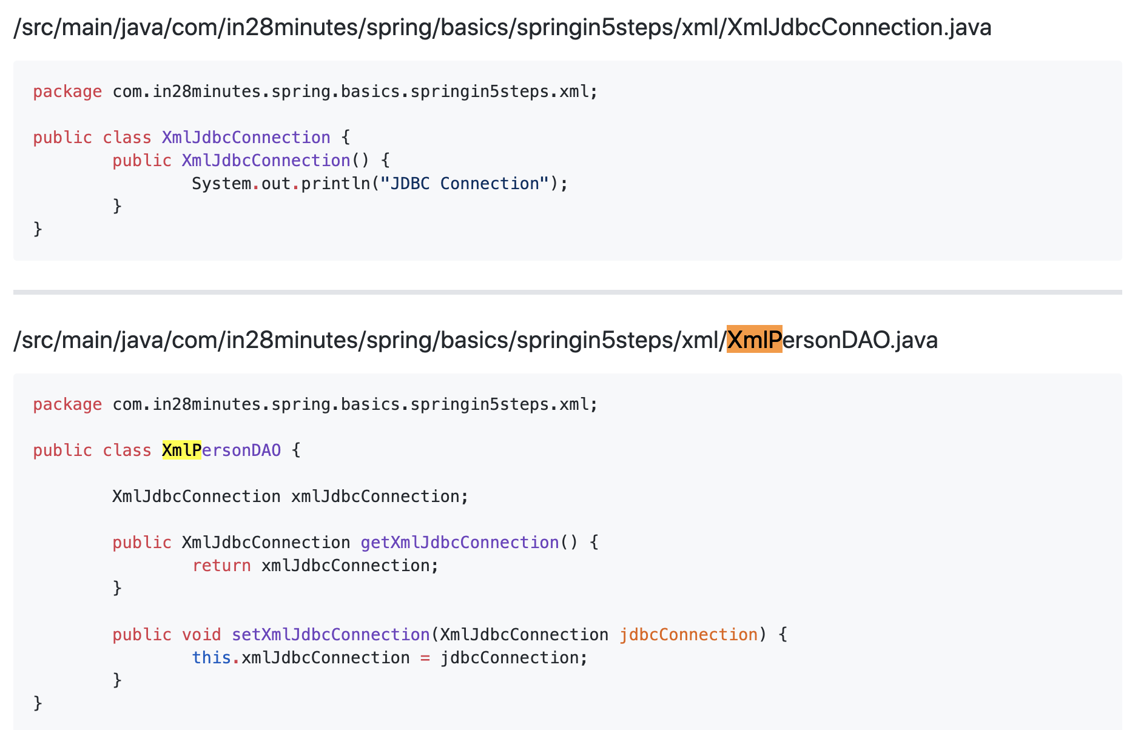

1. Now we need to add a file applicationContext.xml in src/main/resources which will have information about beans, autowiring, component scan etc

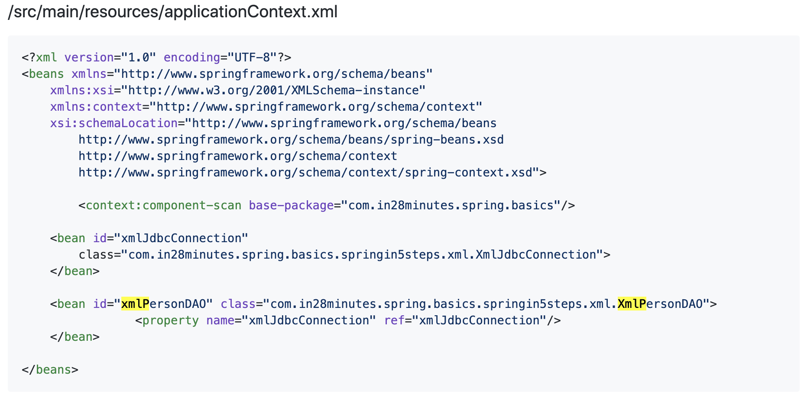

xmlns => for specifying namespaces

For beans, we are not giving any namespace, For context, namespace is context

xsi:schemaLocation => specifies the schema location for stuff added In xmlns like beans, context etc

Now define beans by giving their fullyQualifiedNames in class and an id



We now need to define the autowiring i.e, dependency. How to do that? Using <property></property>



ref in <property> should be the id of bean that our bean is dependent on

Next define component scan using context namespace



1. Define main class

Use ClassPathXmlApplicationContext class to get applicationContext instead of ApplicationContext found in new Spring versions and pass the .xml file to it

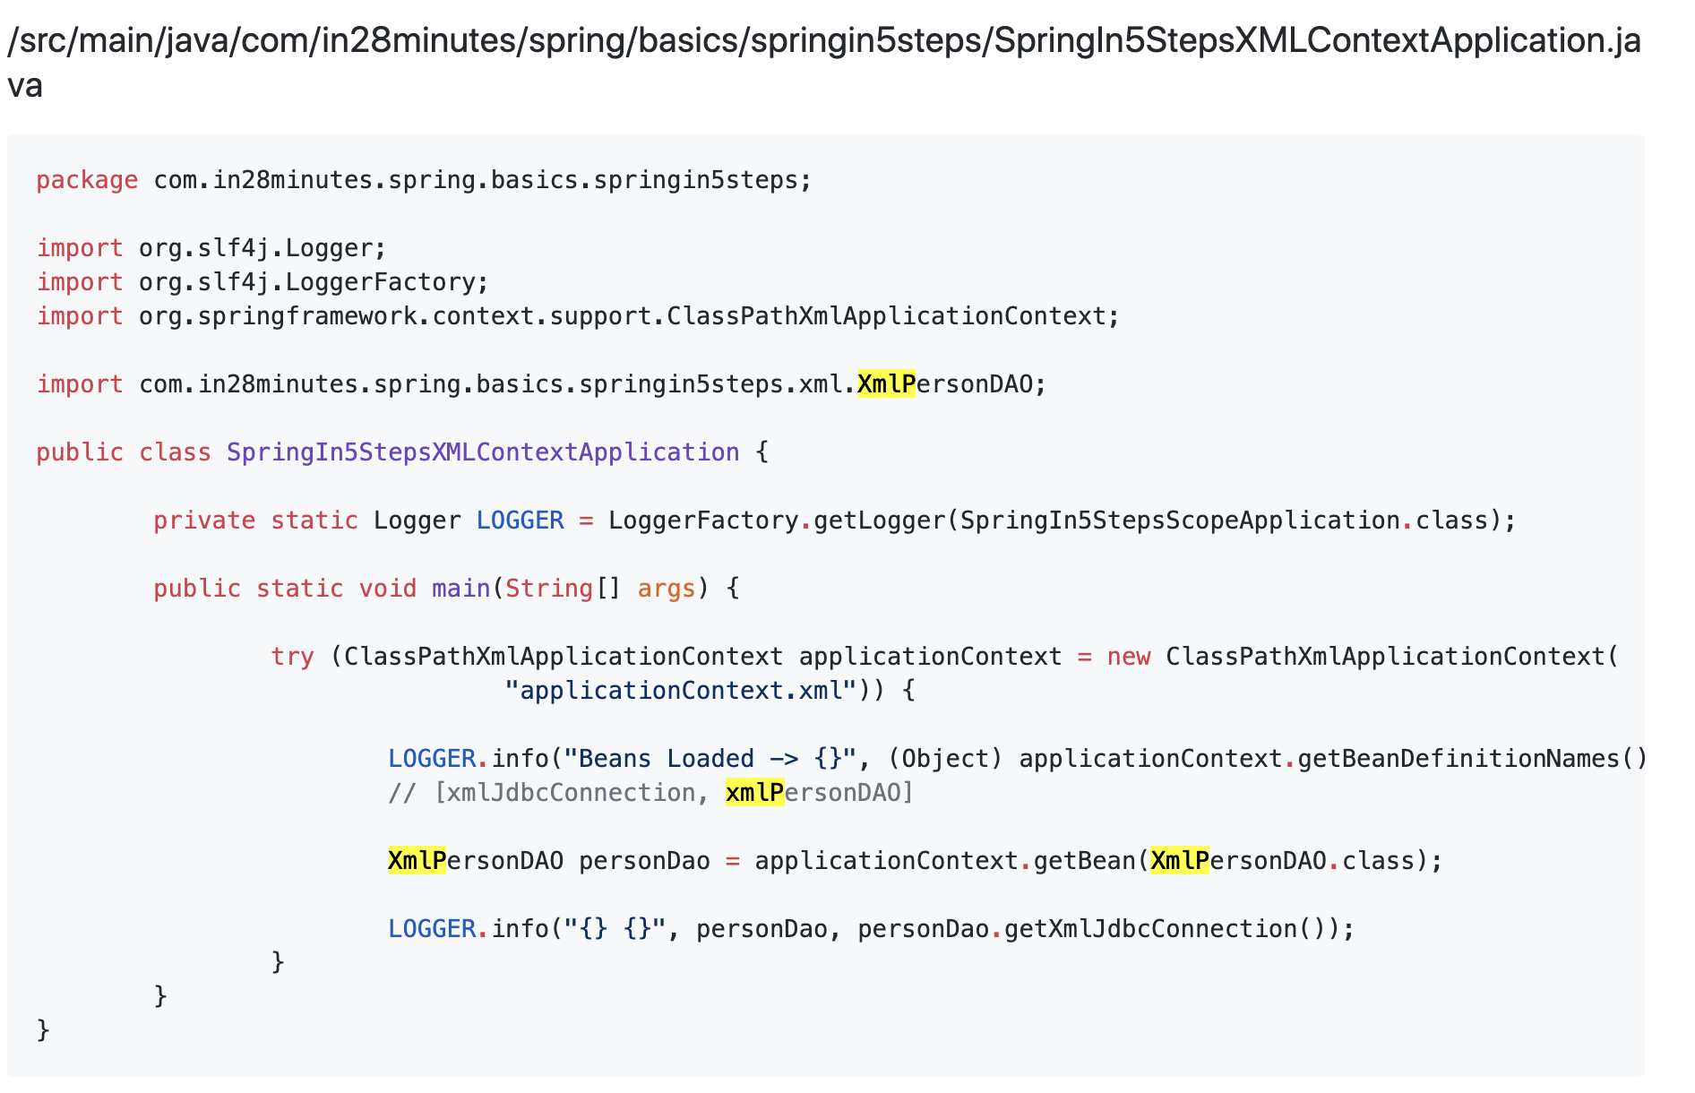

Run the app. IT works fine. This was before annotations

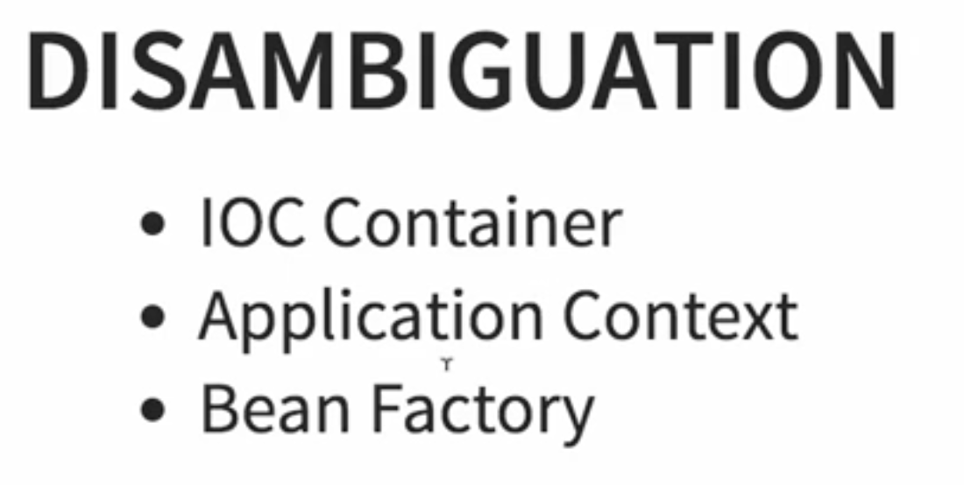  
IOC:

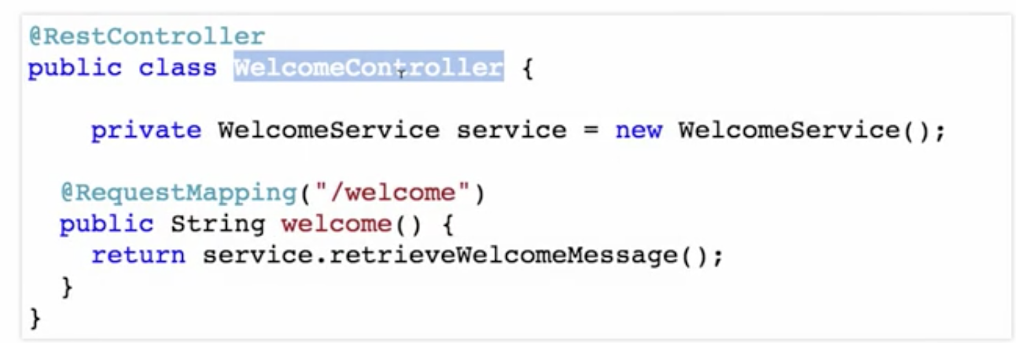

The WelcomeController was deciding when to create the WelcomeService.When to create the dependency? How to create the dependency?

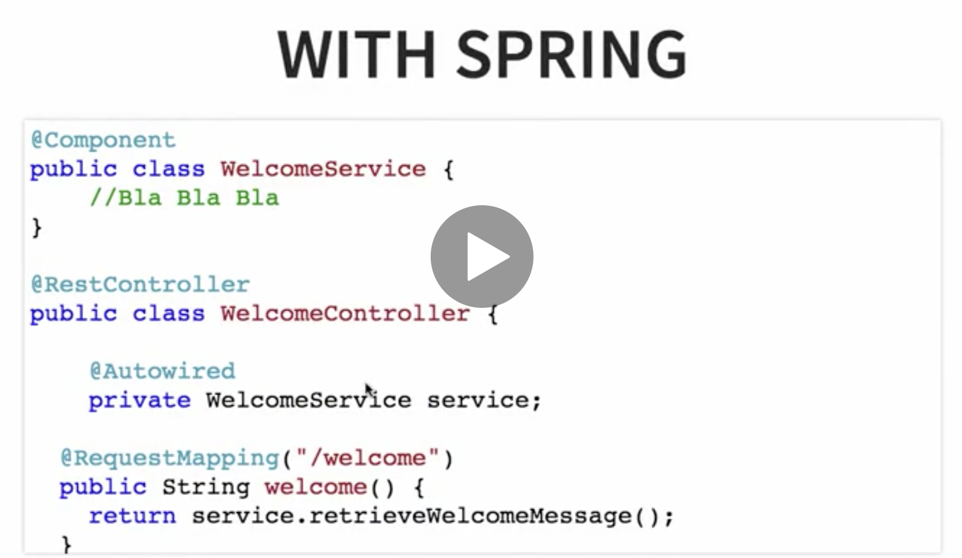

But now, with Spring, we are shifting that responsibility out to Spring. This is called inversion of control.

The control moves out of the controller, or the component which needs the dependency, to the framework which is injecting the dependency in.

Now, the framework is responsible to understand, what are the dependencies that this component needs. Make sure they are available and Autowire them in. This is called inversion of control.

And the program or the framework which provides this,is called the IOC Container

The IOC Container is the one which manages these Beans. So it creates an instance of the WelcomeService. It creates a Bean for the WelcomeController. It would Autowire the WelcomeService Bean, into the WelcomeControlller. All these things are done by IOC Container.

IOC Container is kind of a generic concept, it is not really framework specific.

So this whole thing, whichever does this stuff. Whichever does the wiring, creation of Beans and things like that Is called an IOC Container.

And in Spring, there are two implementations of the IOC Container.

1. The first one is Bean Factory
2. the second one is application context.

We have been making use Application Context. Because Spring recommends, to use Application Context in 99% of these scenarios.

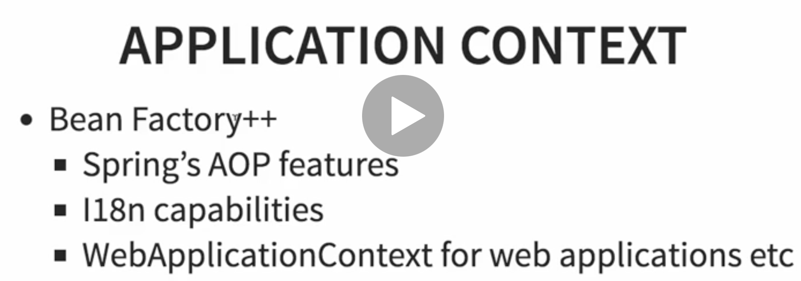

The core features of Spring, are inside the jar called Spring-Core. And that's what the Bean factory provides. Bean Factory provides the basic management for Beans and wiring of dependencies. Nothing else

The Application Context provides, more features than a Bean Factory. It provides all the features, that are typically needed by Enterprise Applications.

So you can kind of call the Application Context as Bean Factory++.

So examples of features, that the Application Context contains, but the Bean Factory does not, are the

1. Spring AOP features.
2. Things like internationalization.
3. WebApplicationContext for web applications.

Spring recommends to use Application Context, in all the situations, except when memory is at a premium.

So let's say you have a device, an IOD device or something where the amount of memory you can use. The amount of memory that is present on the device, is very, very less. In those kind of situations, you can go for a Bean Factory. But in all typical Enterprise Application scenarios, you can go with an Application Context

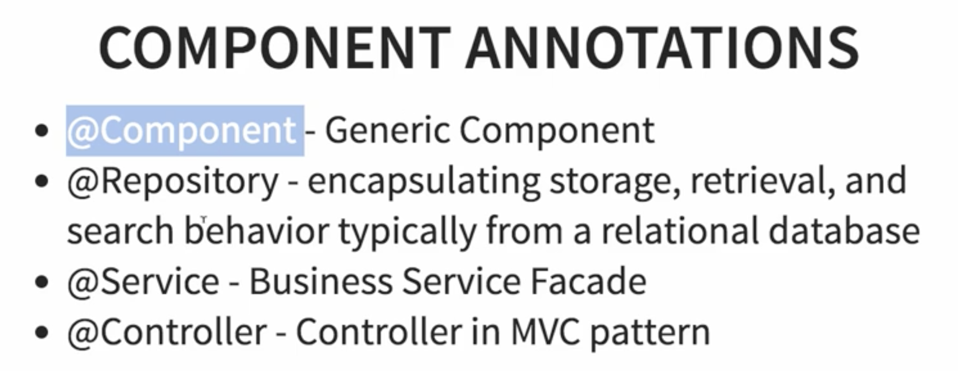

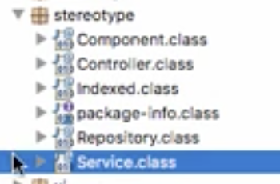

1. @Component is very generic, so in any of these stuff if you are not sure if something belongs to one of the layers then you can use an @Component.
2. In web application,

@Controller is used to define a controller in the web layer.(UI)

1. When it comes to the Business layer, we are supposed to use the @Service annotation.
2. When it comes to the Data layer, we are supposed to use the @Respository annotation.

So basically the, except for @Component, the remaining three annotations are specific to the layer. So @Controller is in the UI layer,

Eg:

PersonDao – getting data from Data layer

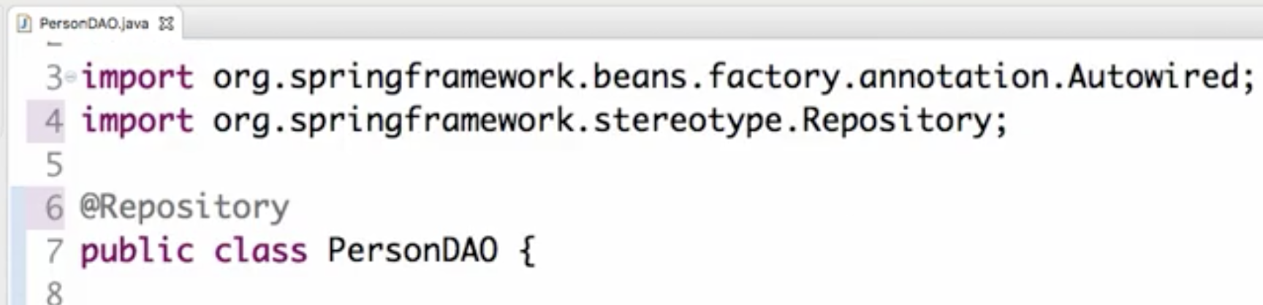

Business layer. So Service

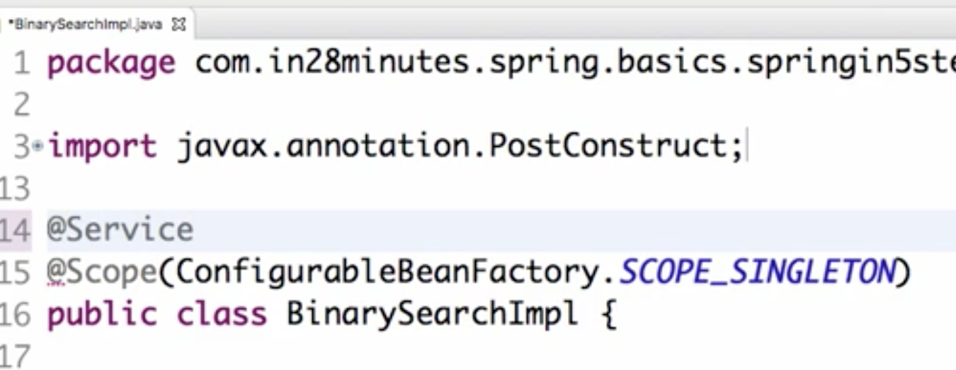

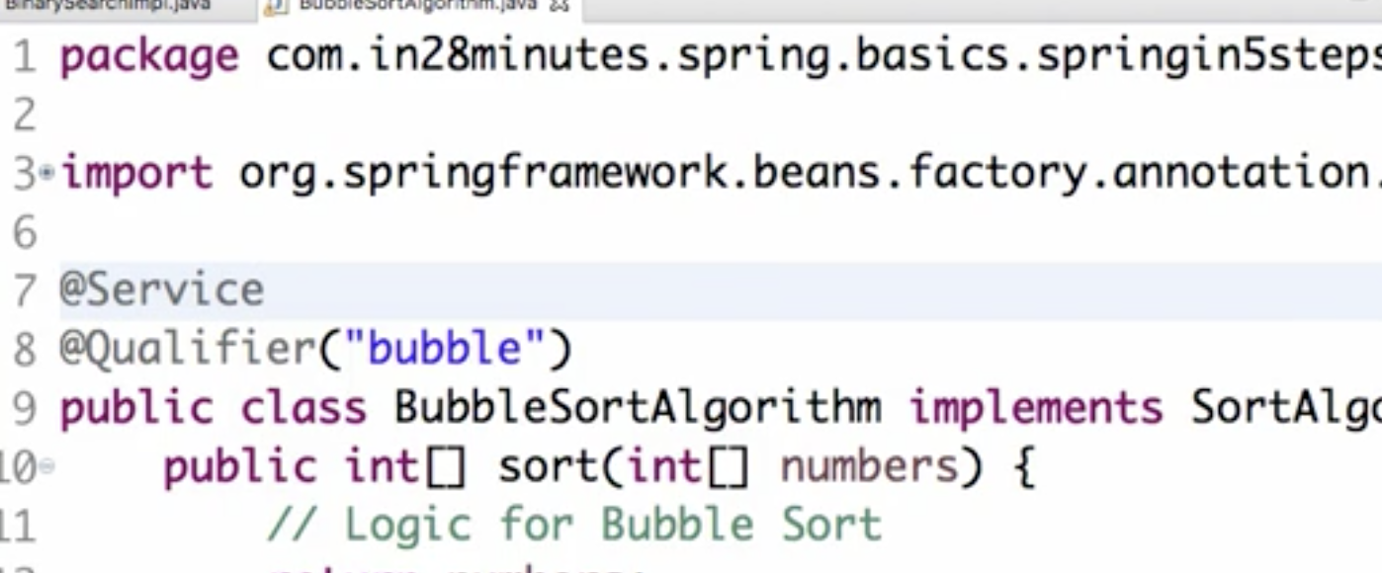

Why use specific annotation?

One of the things which we'll look at in the AOP section is that you can identify the annotation and add functionality over to that specific thing.

So these annotations, @Service, @Repository, @Controller allows you to classify your components into different categories and you can apply different logic for each of these categories.

For example, Spring provides a default exception translation facility, if you use @Repository. There are a lot of JDBC exceptions and Spring classifies them and translates them and that feature is provided only if you are using an @Repository annotation. So on your database component if you are putting an @Component you'll not be able to use that feature.

How to read values from property files in a Spring application?

Say we have a property in app.properties which we want to use in our class. Do that using @Value anottation



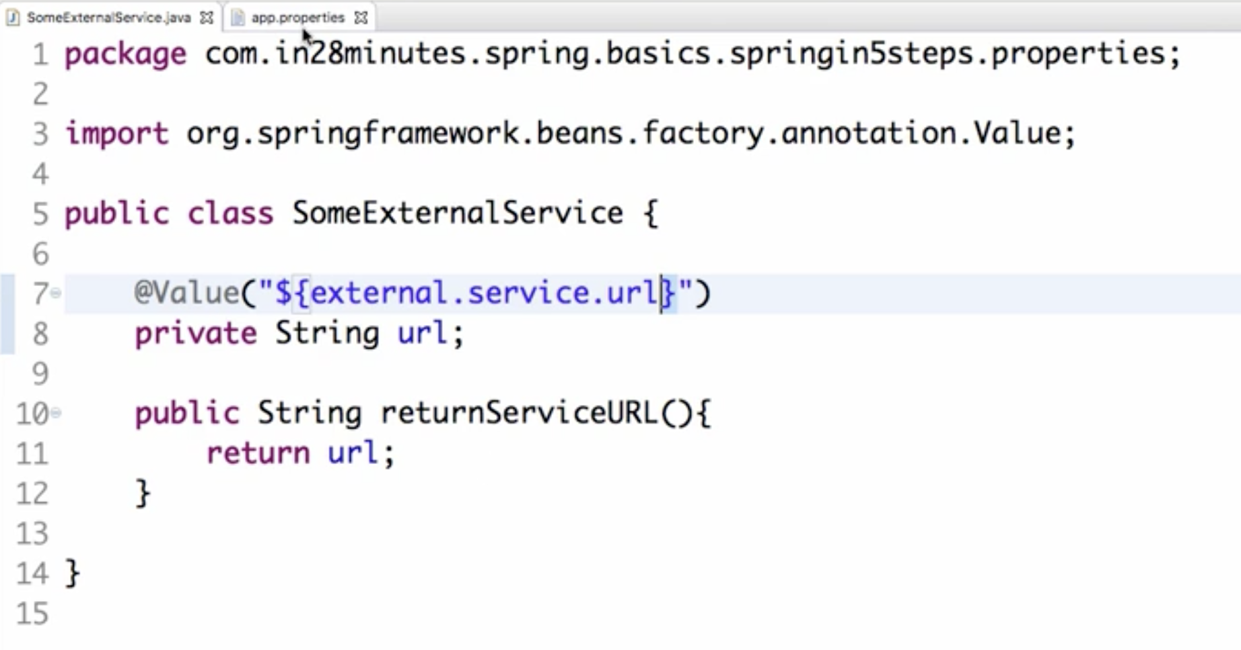

Now, I'm saying pick up the value from the property file, pick up this value from the property file. But I've not said the app.properties. I have not really configured it anywhere. We will configure that when we are loading up the context.

We can do that using @PropertySource and provide the classpath

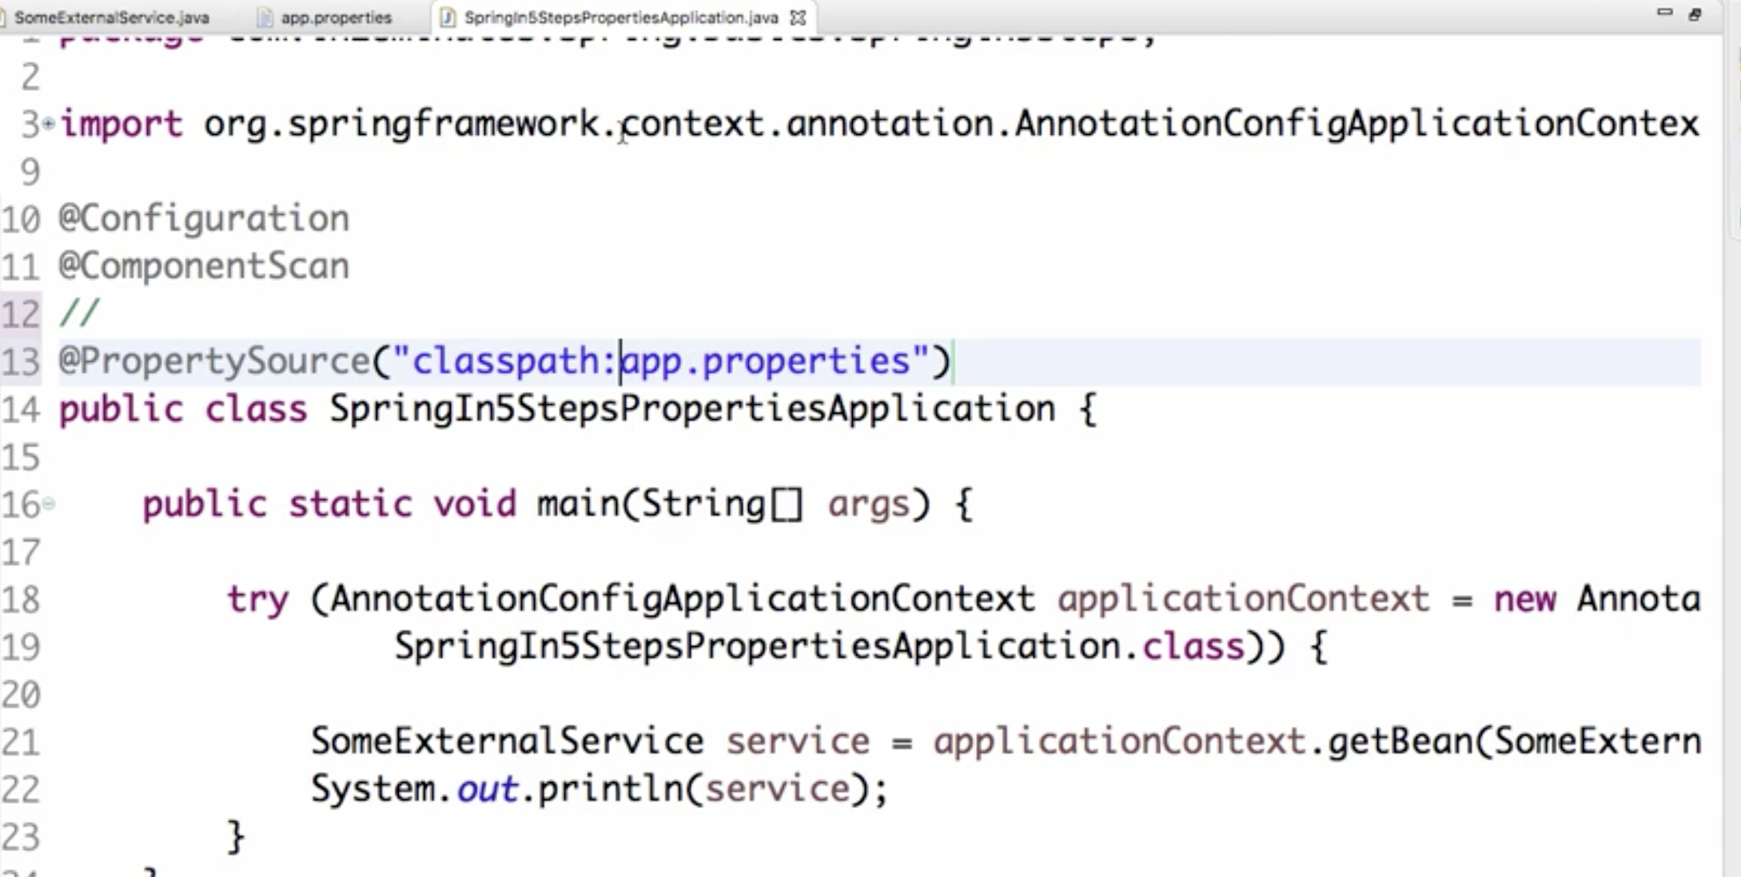

Junit

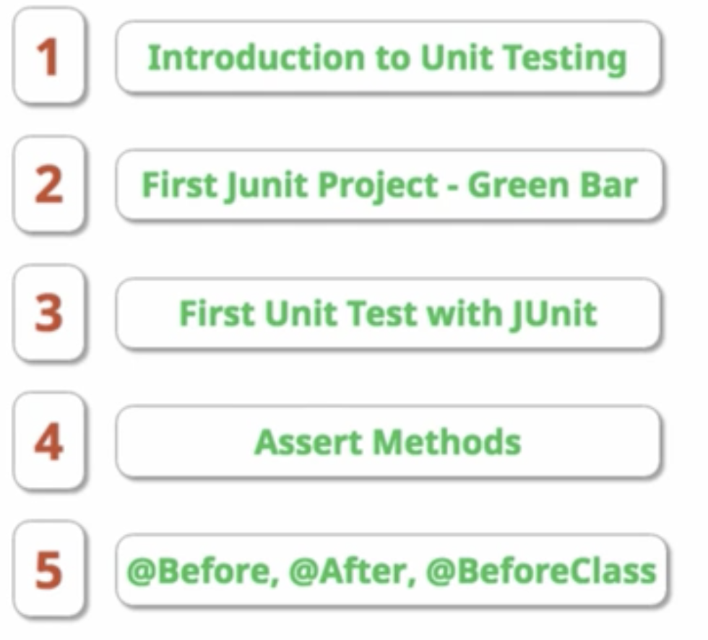

Unit testing is testing our specific piece of code or method or a specific class.

Junit is a framework which will help you call this method and check whether the output is as expected.

* assertEquals basically checks whether the left hand side and the right hand side are the same. Multiple variations of AssertEquals. double, long, String etc
* assertTrue used to check whether a condition is true. So you can put a condition here and check whether it's true condition or not.

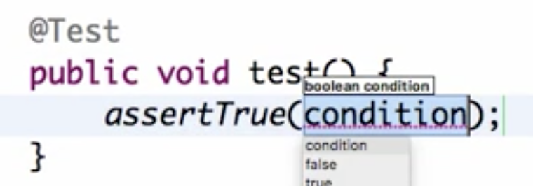

* The opposite is true is assertFalse. Check that’s the output of condition is false.
* The other method is assertNotNull. This is used to check whether a value is not null.
* Other one is assertNull.
* So if you want to check whether two arrays are equal then you can use assertArrayEquals

Few more annotation in junit

1. @Test
2. @Before  
   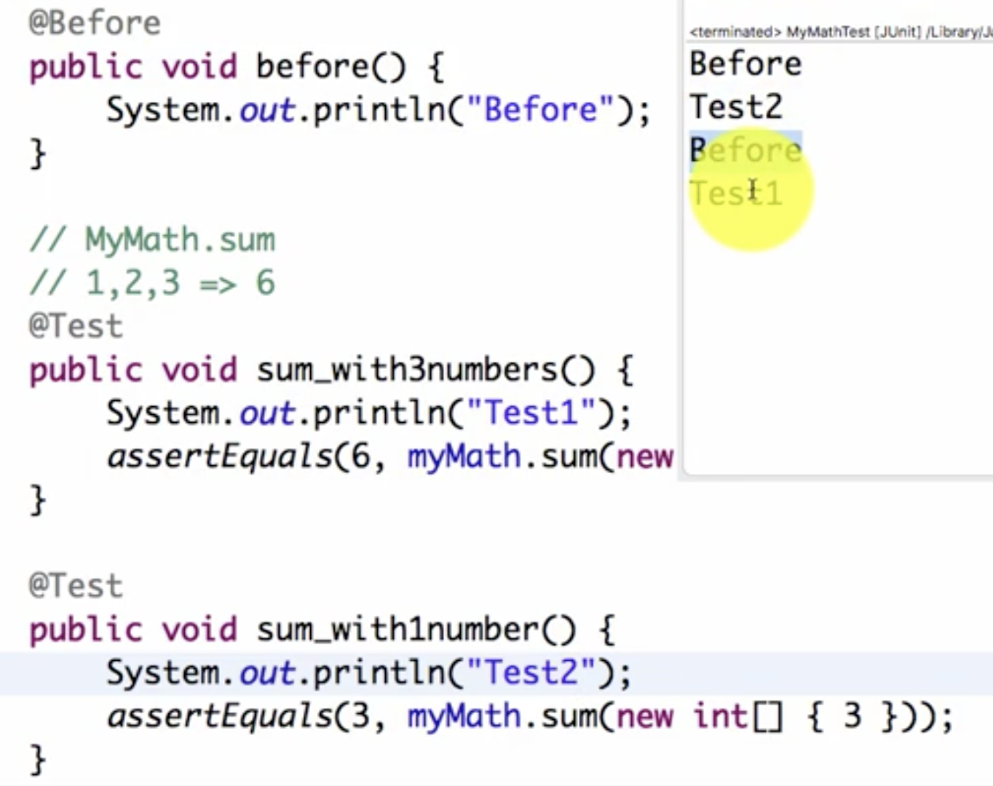

With Junit, there is no guarantee of order of the tests are run. The thing which is guaranteed with @Before is the fact that it would be running before every test. So if you want to do something before this - You want to establish a new connection to the database or something of that kind you can do that in the @Before.

1. @After

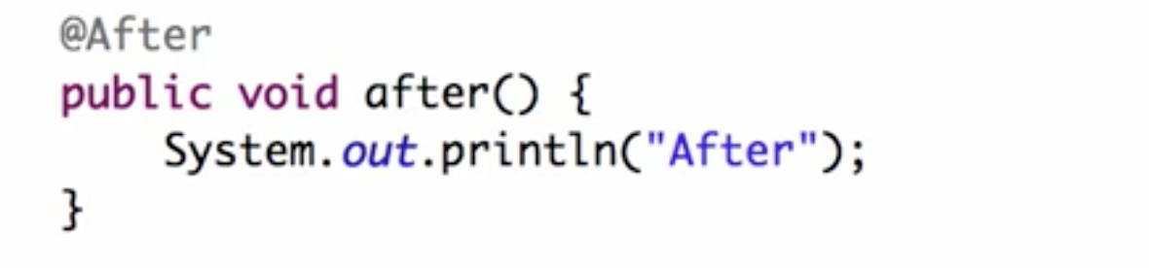

Done after every test. If there is some Clean-Up that you would want to do after this then you can do that in the @After method.

1. There are things called before class and after class before class and after class  
   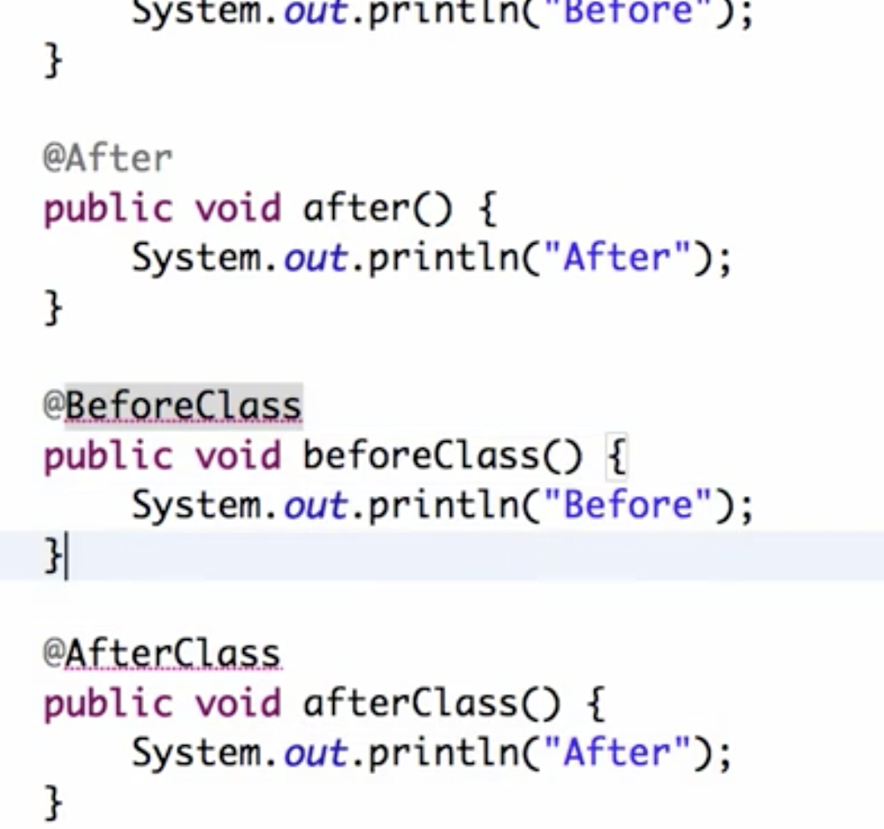  
   However if you run this right now you'd see that there would be an error. So it is initialization error.

The only solution is to use this method before class should be static.

One of the things that you need to remember is the fact that before class and after class are class level methods.

So they are applicable for the entire class and also class level method should be static in Junit

@BeforeClass and @AfterClass should be static methods.  
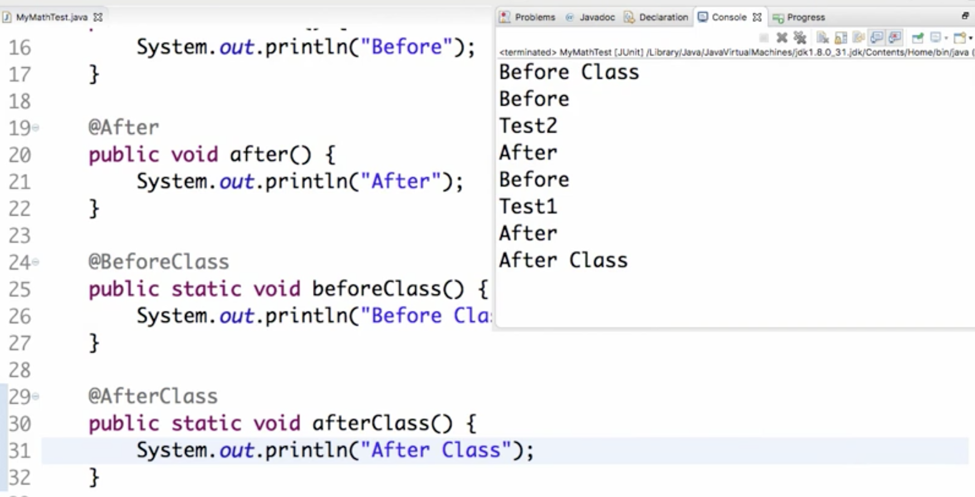

BeforeClass runs once before all tests

AfterClass runs once after all tests completed execution.

Probably things like establishing a database connection might be things that we were doing before class initialising some data for the test.

Mockito

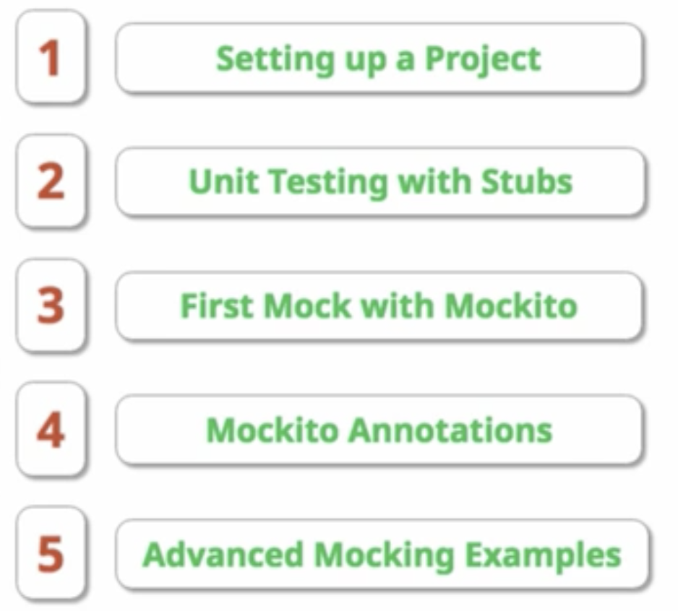

1)Create a business service dependent on Data service for getting the data. Dnt implement the data service

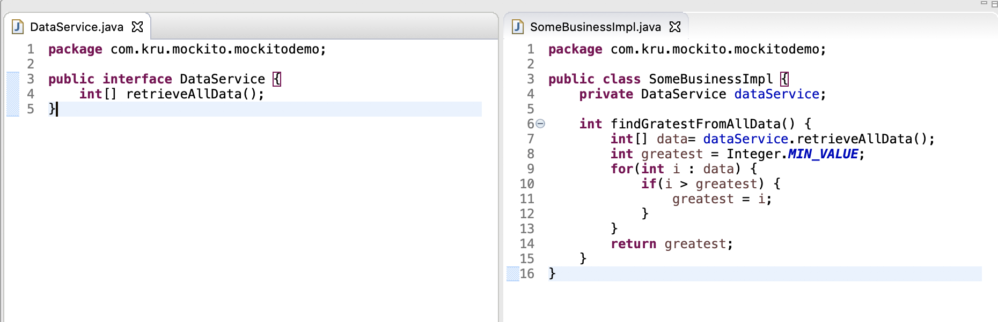

2)Write a test case and run it

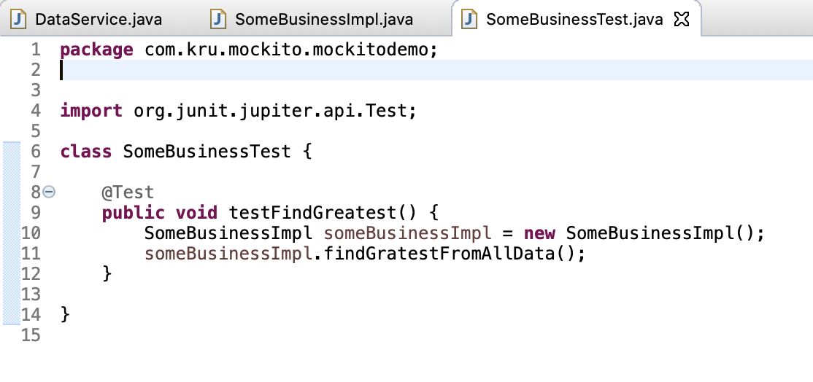

It will fail. Reason is because SomeBusinessImpl is expecting data from DataService which is an interface. We cannot implement it as its an interface. So what to do? How to test it? Tahts where Mockito comes

3)Mockito

So what do we want to do now is we would want to create a mock up of the data.

Create a mock using mockito.mock and use it to get whatever data u want using “when” and “thenReturn”



The great thing about mocking is that it's so simple. And I can easily repeat it for other data as well.

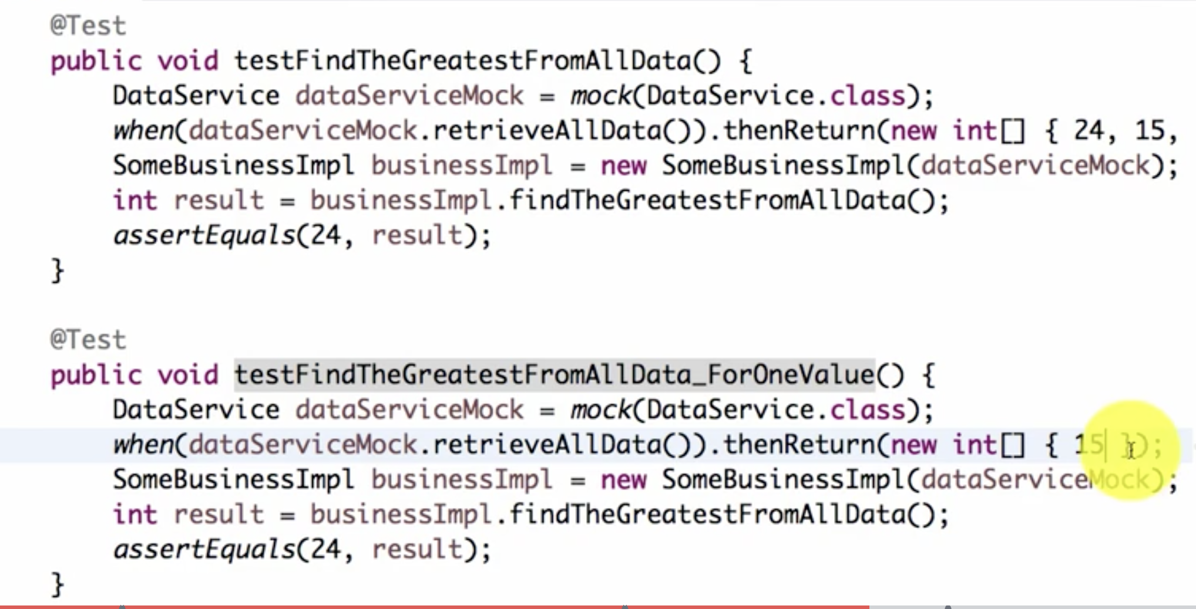

You can create mocks of either interfaces or classes

So what we're doing is you're passing a mock by creating a constructor. So we're using the constructor to pass the mock in.

Mockito Annotations:

1)@Mock – to mock the class

2)@InjectMocks – to inject the mocked obj into business class

3)@RunWith(MockitoJUnitRunner.class) – needed when we use annotations in mockito

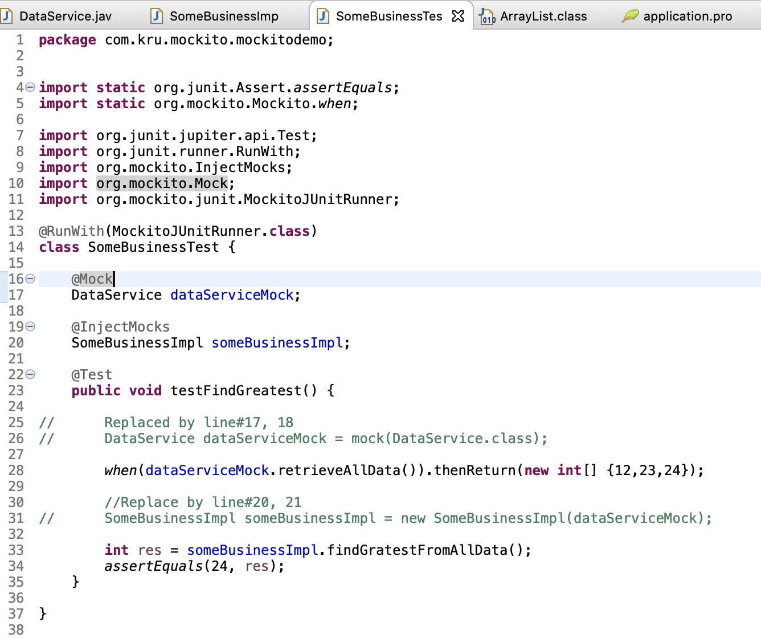

Mocking List interface

1)Multiple thenReturn

Mocking size() function to return 10 in first test case

In second test case, we want to return 10 when called first time and 20 when called second time

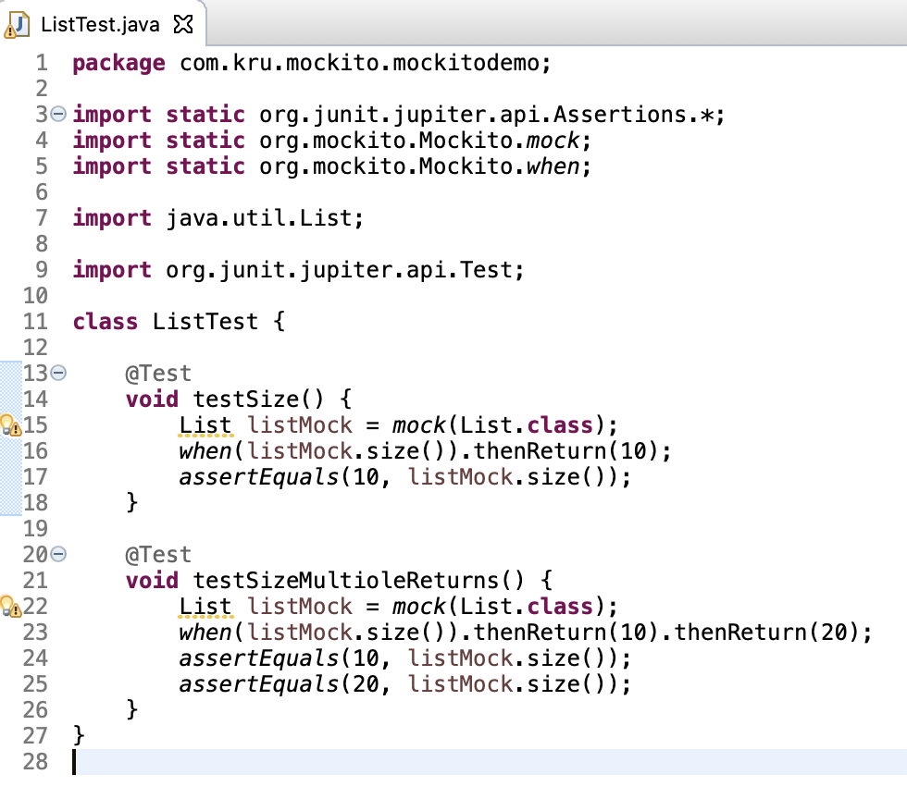

2)Using Mockito.anyInt()

1st func give SomeString if param to get() is 0, else null

2nd func gives SomeString for any param. Its done by using Mockito.anyInt() function as param to get()

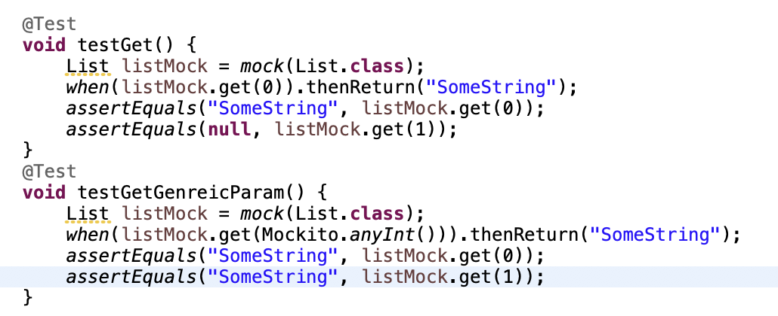

One of the important things as far as Mockito is concerned is if one of the parameter is generic then all the other parameters should also be generic.

You cannot have one generic parameter and one specific parameter.

Spring unit testing with a Java context

1)Depedencies needed for UT – comment spring-boot-starter-test

a) spring-test

b)mockito-core

c) junit

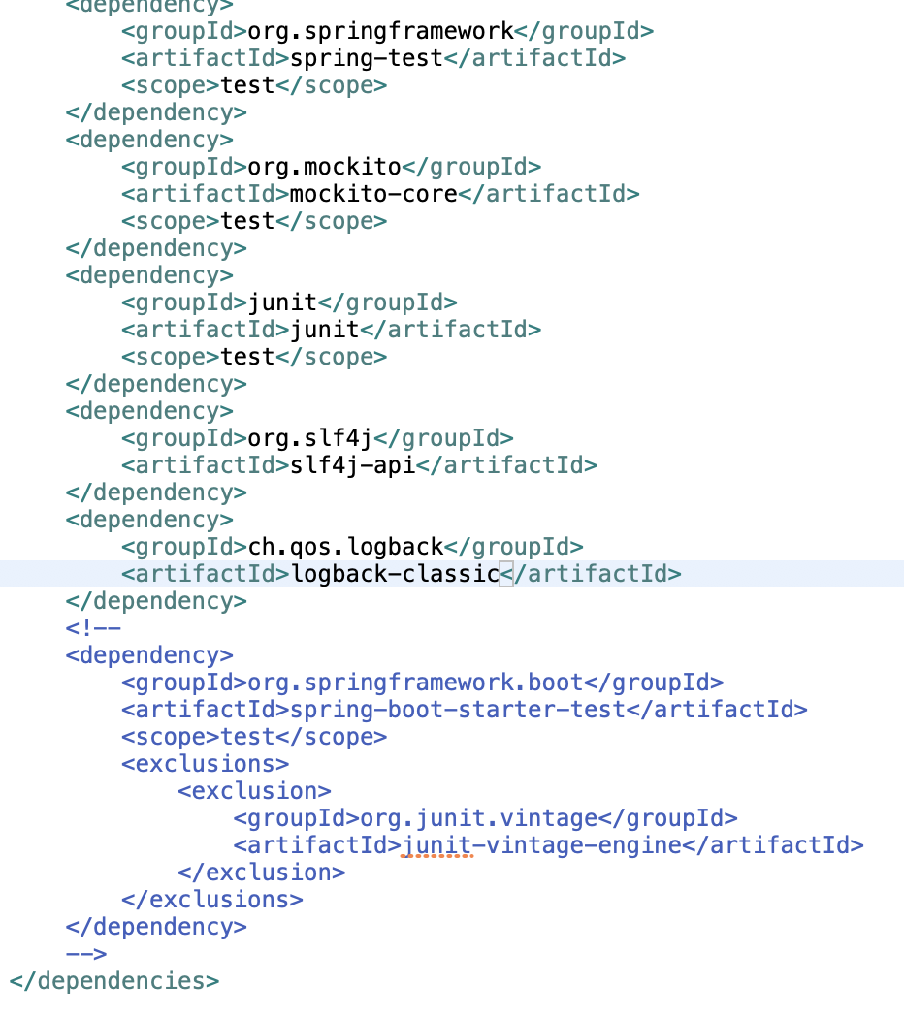

2) Commenting spring-boot-starter-test might give some error in Test class for main class. Fix or comment it

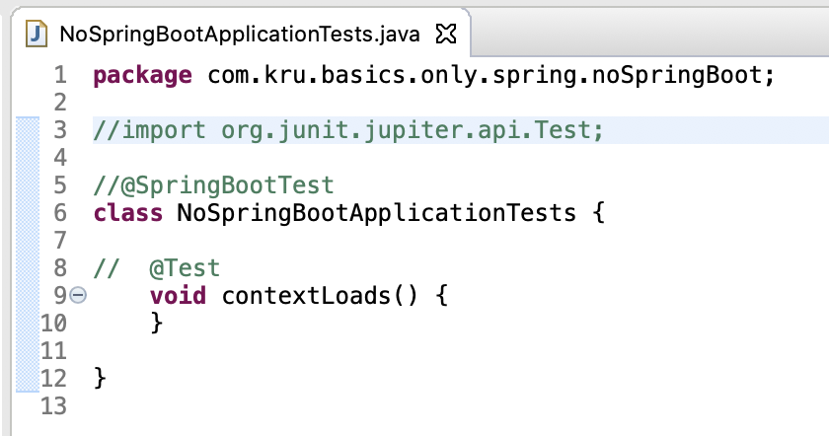

3)Create test file for our files

So whenever we want to create a unique test we would need to match the same package structure.

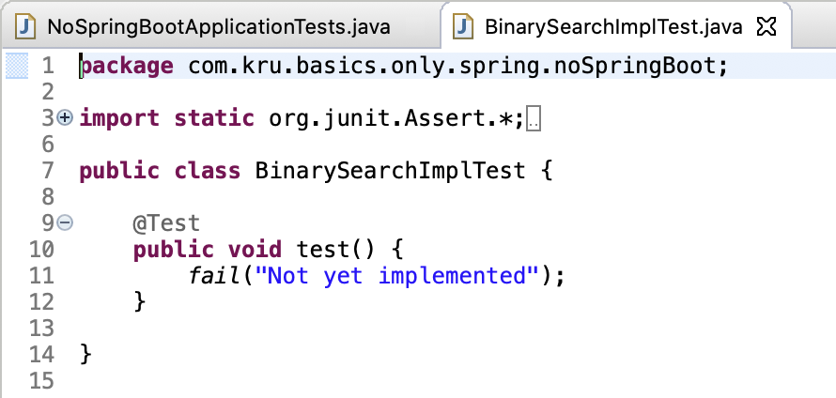

4)Load the context using @ContextConfiguration and then run it using @RunWith(SpringRunner.class)

5)Get bean from context using Autowired

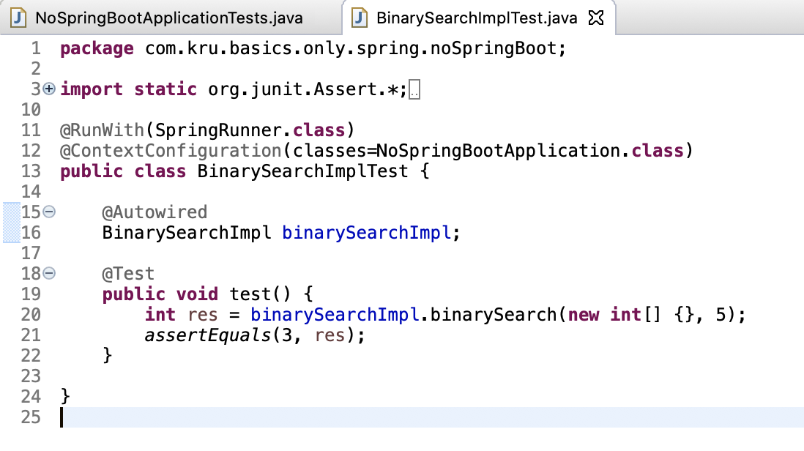

This passes

One of the important things that you would need to understand, You should never mix your test code with the operation. That's why we write all our test code in a separate folder called src/java/test.

Spring UT using XML

1. Define contextConfiguration using xml location in above test class instead of main class

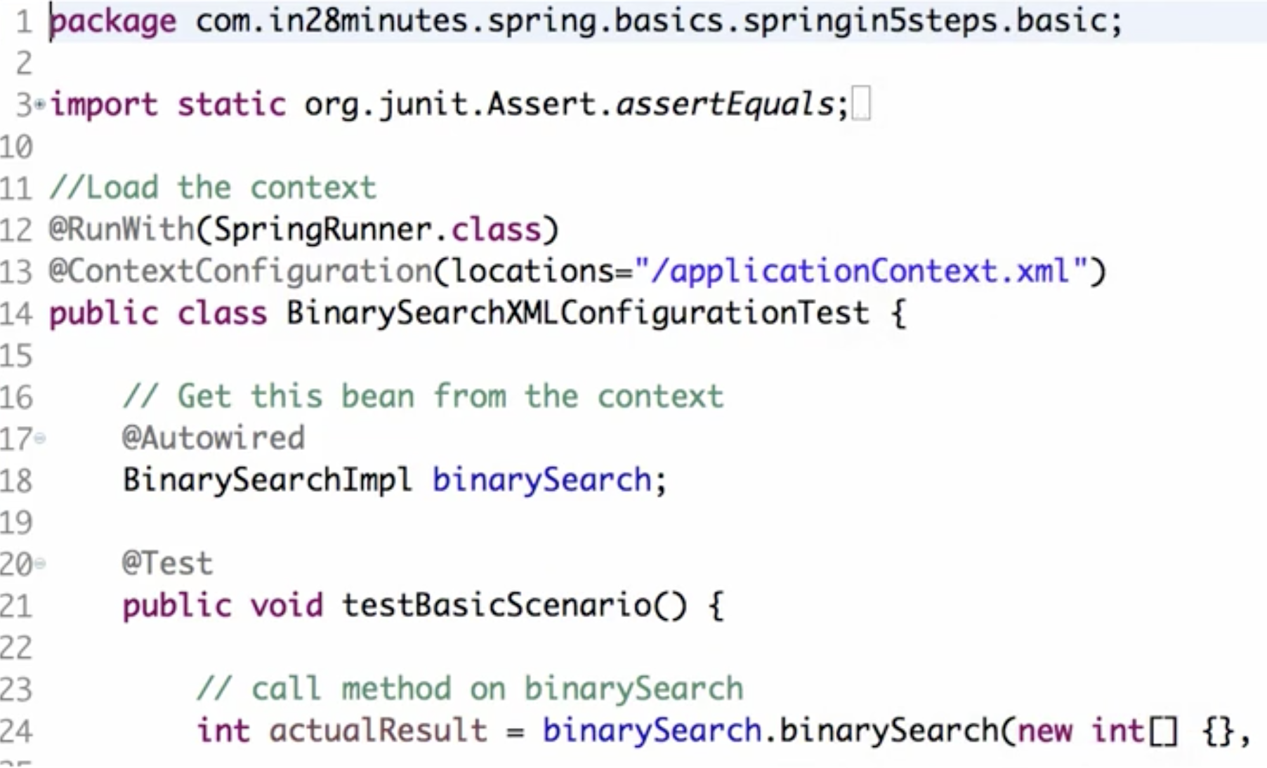

If you want to have a test configuration that is different from your real application context then copy the xml from src/java/resources and paste into src/test/resources and rename it to some name like testContext.xml

If you are writing a unit test and if you do want to or read something from another context then you can actually import that context in and or override the content of that.

This is written in testContext.xml

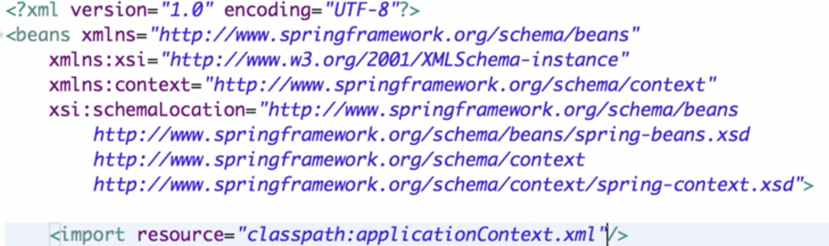

And then use it in Test

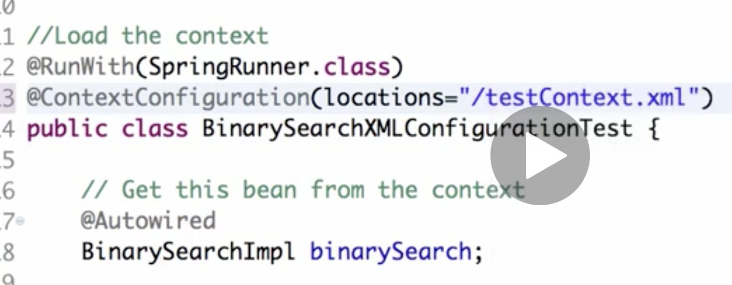 IT will pass

Spring UT using mockito

1. With Mockito, we wont need contextConfiguration

Just use RunWith(MockitoJUnitRunner.class)

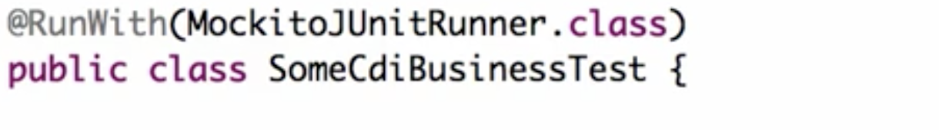

1. Then do mock and inject it

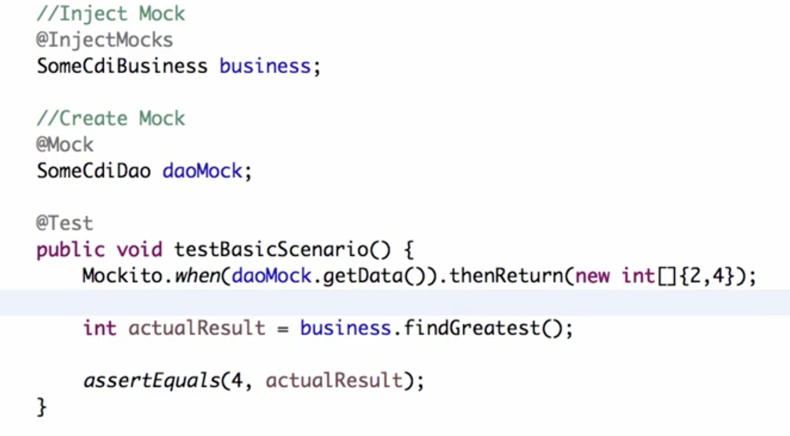

This passes

Spring AOP:

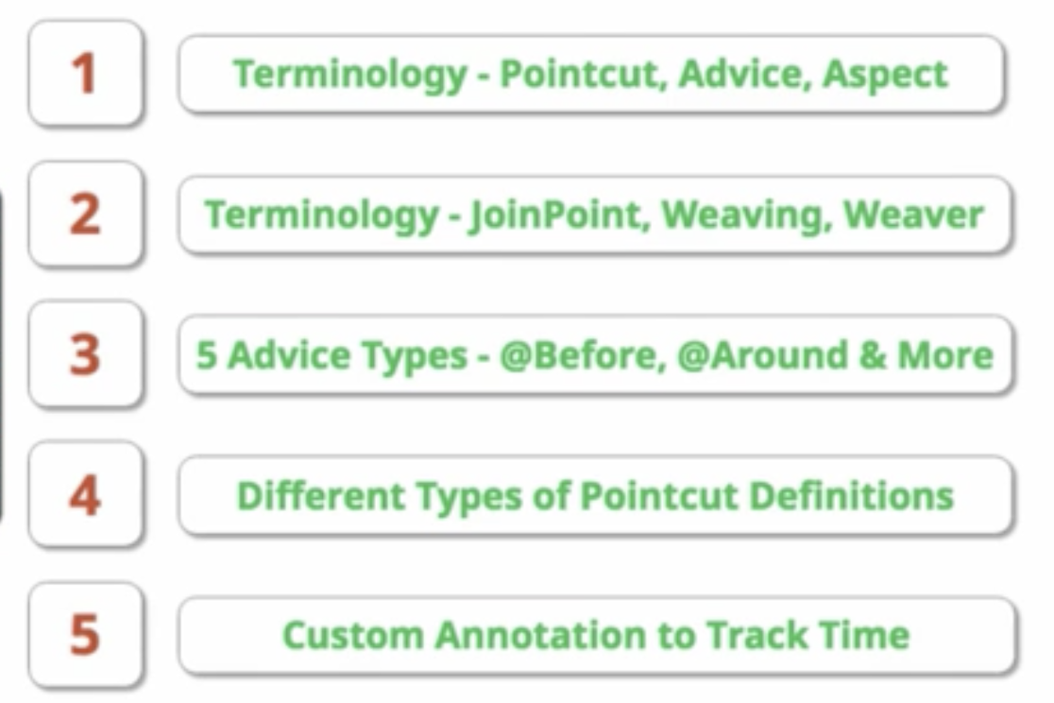

AOP is used for cross-cutting concerns meaning those things that are not specific to web or business or data layer but can be common in any of these

1. Create project and add this dependency for aop

<dependency>

<groupId>org.springframework.boot</groupId>

<artifactId>spring-boot-starter-aop</artifactId>

</dependency>

1. Create 2 business class, 2 dao class and use implements CommandLineRunner in main class and call the business class fucntions

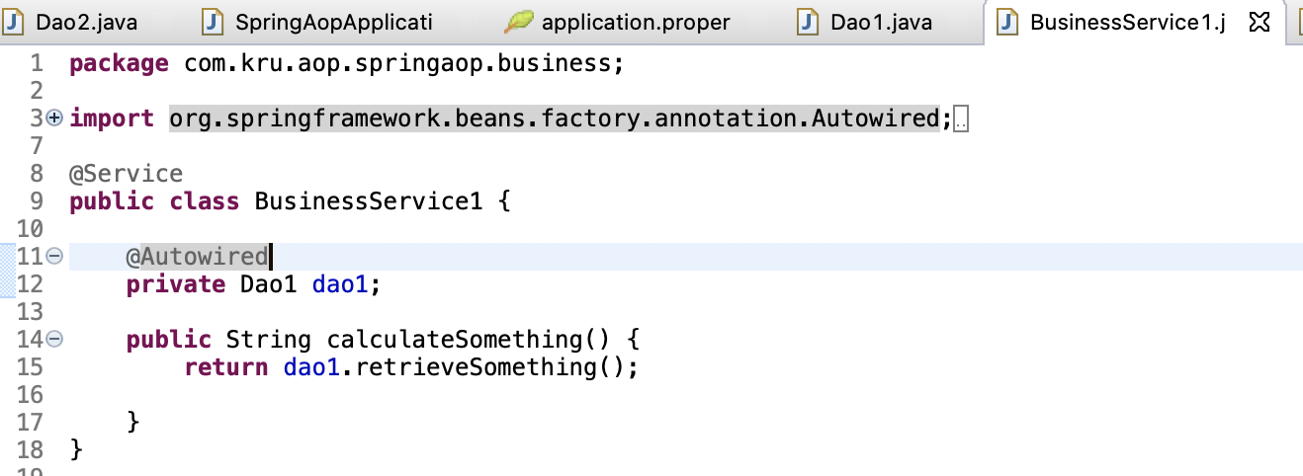

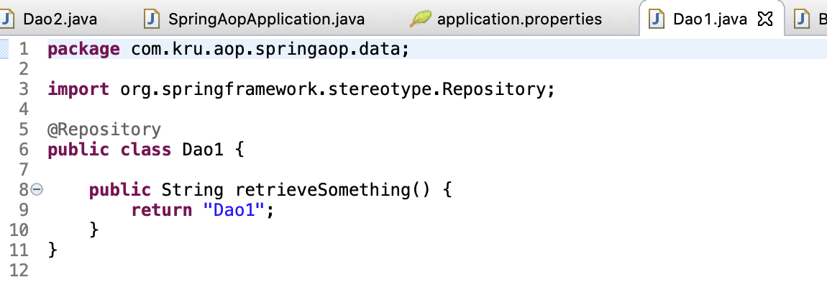

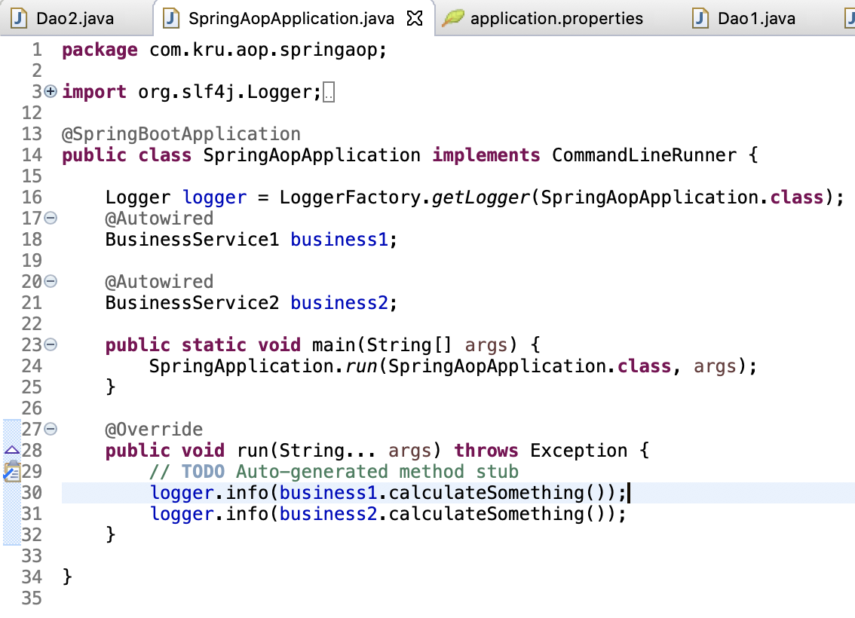

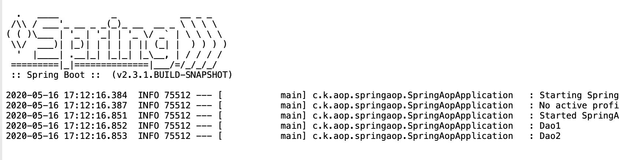

1. Lets define an aspect to intercept the call to do business layer.

Lets aspect before the call

1)Define configuration

@Aspect

@Configuration

2)What kind of methods I want to aspect

@Before => for intercepting call before it is called => IT takes an argument pointcut which looks like this => (execution(* PACKAGE.*.*(..)) => means intercept any method in package PACKAGE , any class, any method irrespective of arguments  
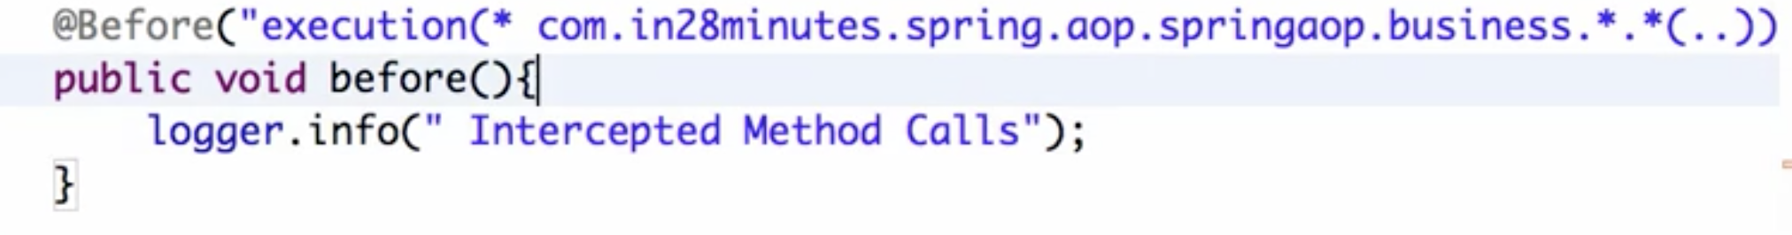

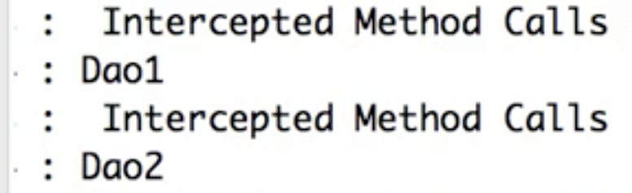

Now we know that 2 times Intercepted is called as in the package there are two methods. But we dnt know what those methods are.We can get it by passing argument JointPoint jointPoint

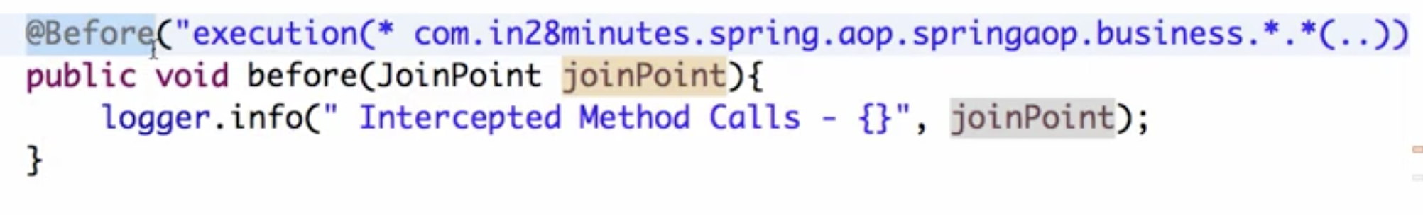

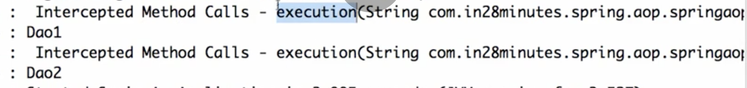

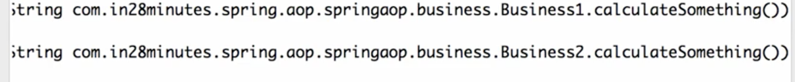

Where do we use @Before?

So for example I would want to make sure that the user has the right access before I would allow him to execute the method

1. What to do when call is intercepted

Check for user access etc…

If you do user access check by using AOP then the thing is this is applicable to everything in the. business layer so you don't really need to implement the access check at every point in every method.

This is what AOP loves us to do.

So here security we are defining at one place. So we are defining at a single place and that is applicable for all the methods in the business layer.

=======  
What if we add one more dot after package name. It would start intercepting all calls inside this sub package.

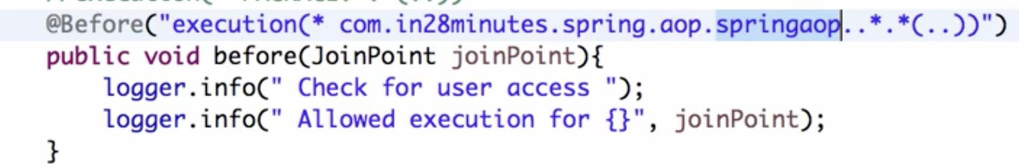

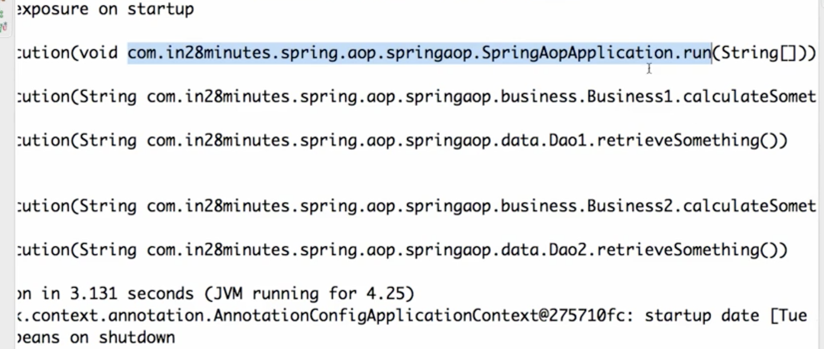

So its very important to define our pointcuts

AOP Terminology

1. pointcut. Is this expression so the expression which defines what kind of method I would want to intercept.
2. What should I do when I do the interception. So I intercepted a method called what should I do. The logic here is called advice
3. an aspect is a combination of your point cut plus your advice
4. The join point is specific interception of a method call.

So the business one that calculate something is getting called it's being intercepted and that data is present inside the join point

5) Process where this whole thing gets weaved around your code is called viewing. So what is happening here is when I'm defining this aspect the AOP framework this spring aop framework is ensuring that this is getting executed at the right moment.

This process is called Weaving.

6)And the framework which does this is called the weaver

Eg for After aspect

Say I want to intercept call after values are returned from method

Then use @AfterReturning. We can give point cut to it as argument. We can also get returned data from function it intercepts by giving another argument as follows

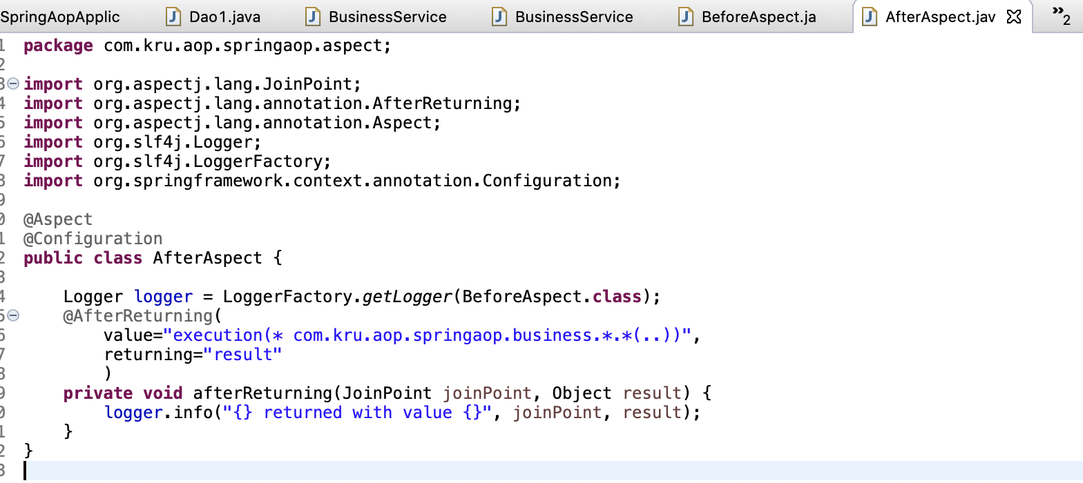

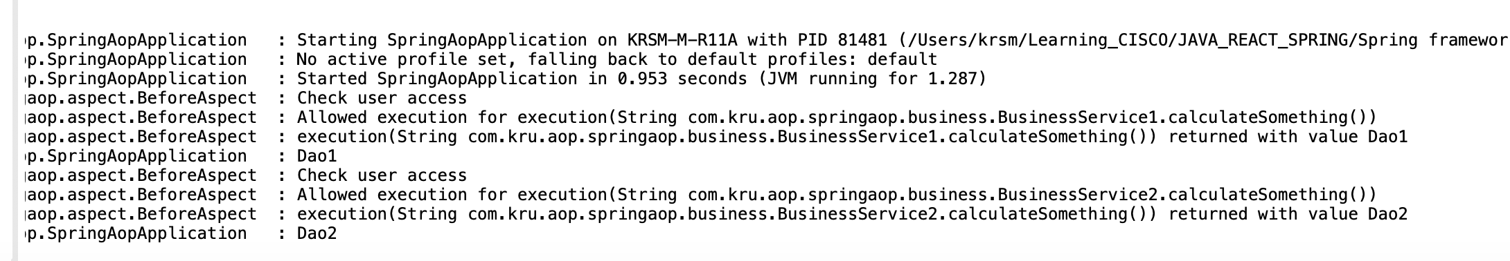

NOTE: AfterReturning is called only if methids returns successfully

IF method throws exceotion, it can be intercepted using AfterThrowing

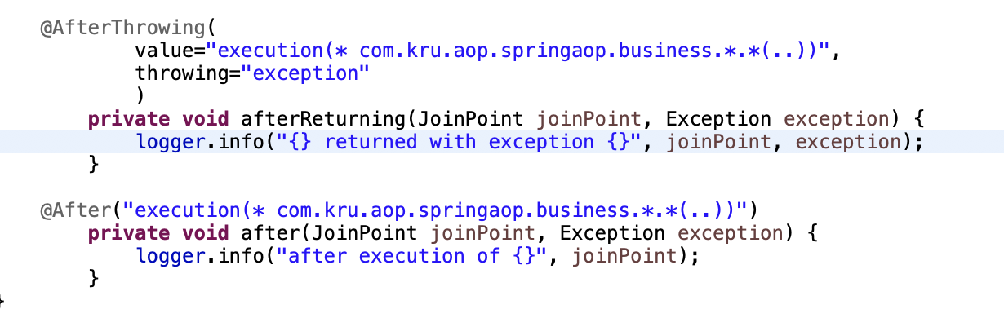

If we dnt know what method returns, use @After

1. @Around – used for performance indication

Eg: how much time is a method execution taking

So the proceeding joint point would allow you to continue with the execution of the method.

So I would intercept it. I would allow the method to proceed and then find the time taken

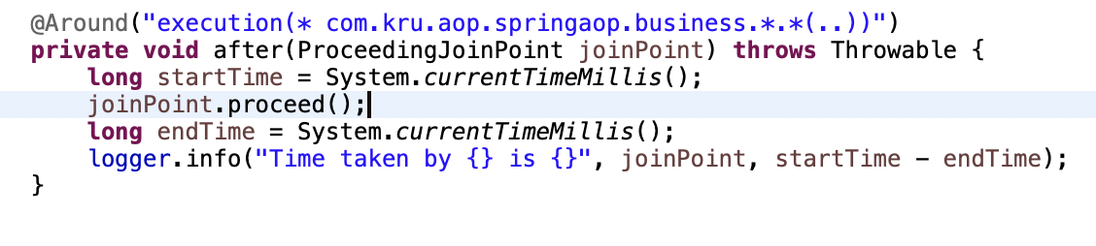

joinPoint.proceed() => tells to execute method

So @Around is better as we get before and after method call at one place.  we looked at intercepting a method allowing to proceed doing something before. it and after it.

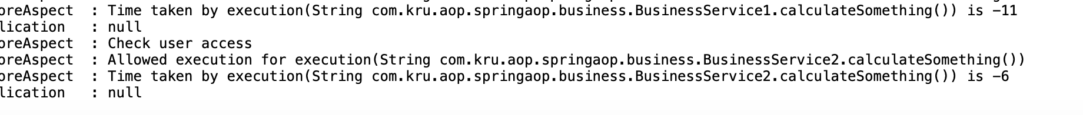

Using common pointcut configuration

Instead of repeating pointcut in different classes, we need to have a separate file to define pointcut in one place

Define a common class like this and use it wherever u intercept calls

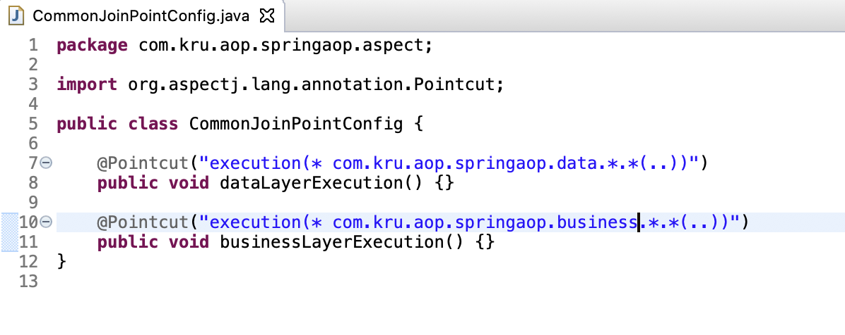

Using it as point cut for @BEfore

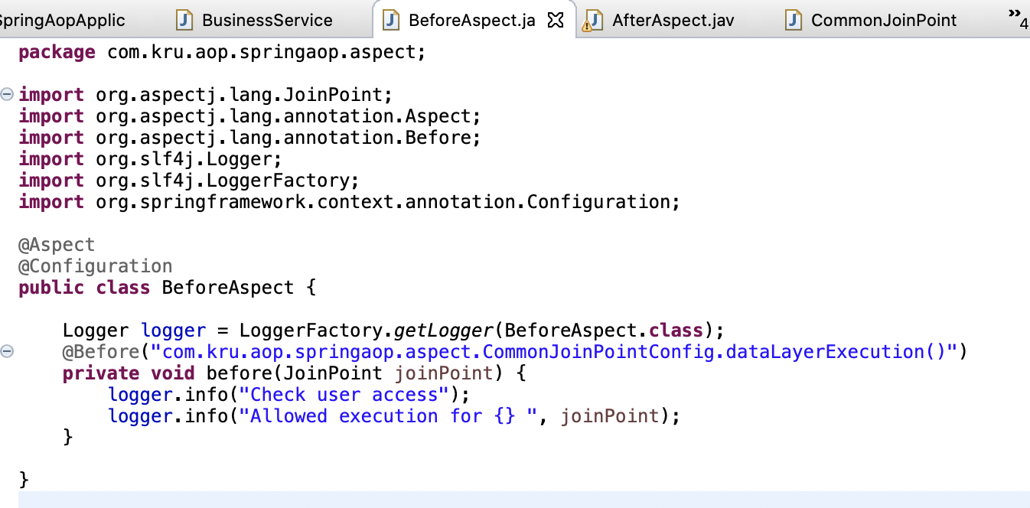

Works same as previous

We can also combine the pointcuts – check allLayerExecution

We can also intercept all calls for Bean names starting or containing substring

We can intercept all methods within a package sub-package using within

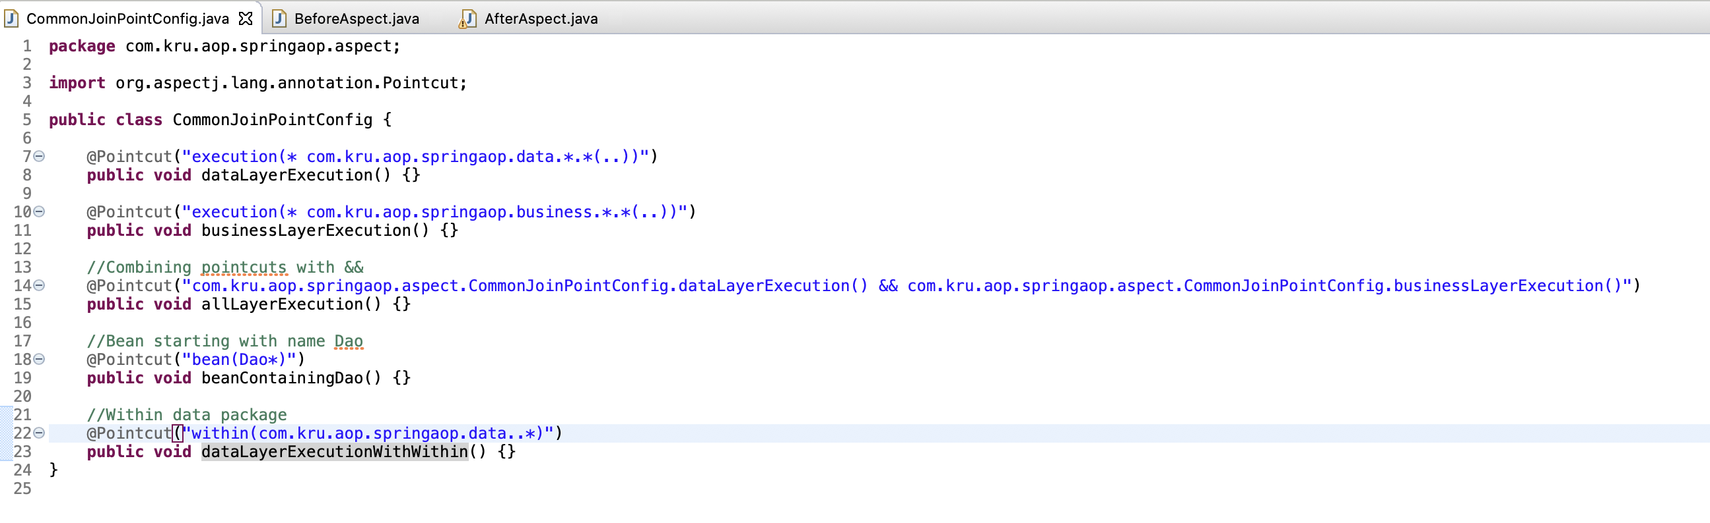

Instead of all intecrptin methods in a package, I want to intercept only on those methods which have a custom annotation. So lets create that custom annotation which if specified upon methods will only be intercepted

1. Put any annotation you want on any method you want to intercept

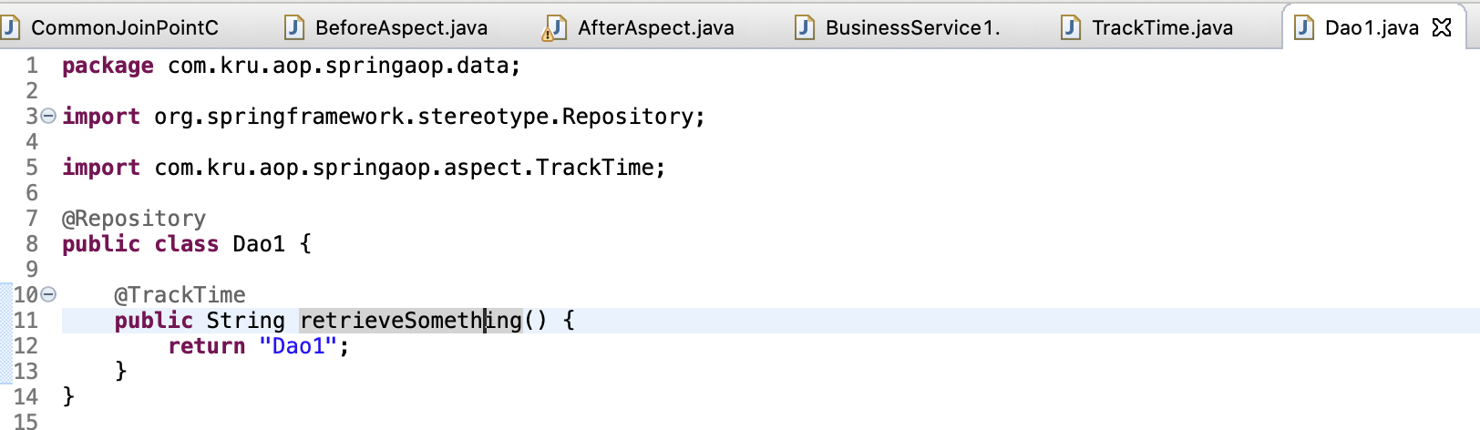

1. Create the annotation you gave in above class. You need it to target it for methods only. And it should be available on run time

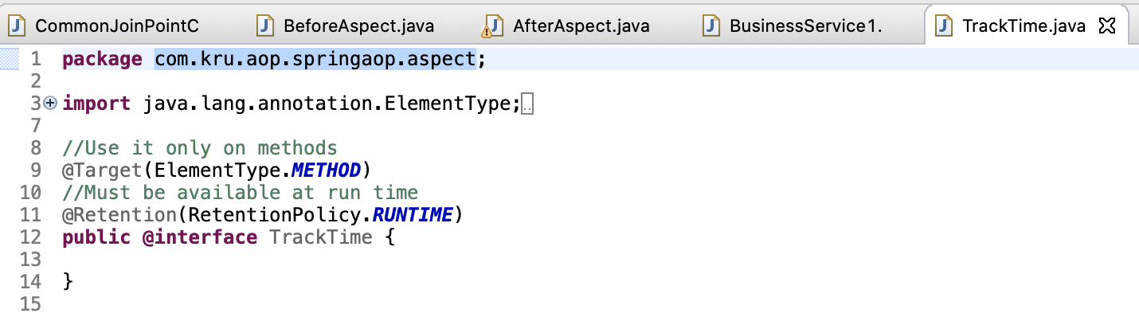

1. define pointcut for custom annotation

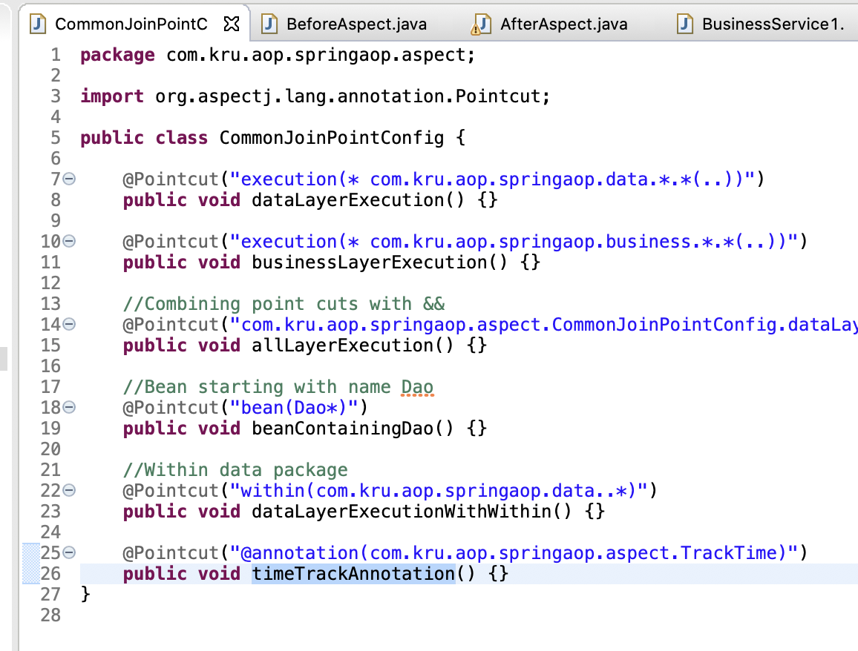

1. Use the custom annotation in ur aspect files

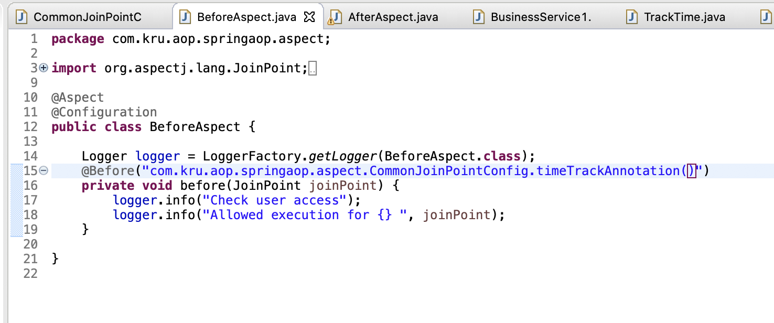

5)O/p shows that only Dao1 method is intercepted

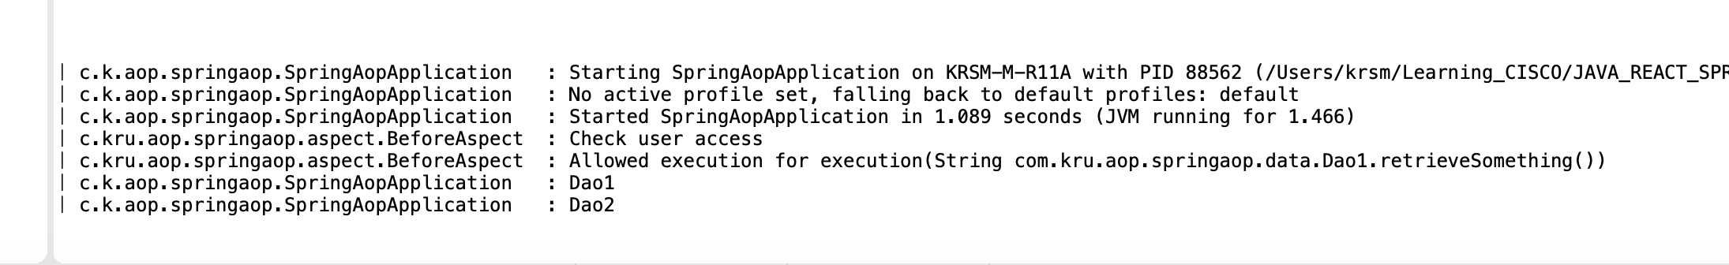

Interacting with Databases

1. Create project with JDBC, JPA, H2, web
2. Add below props

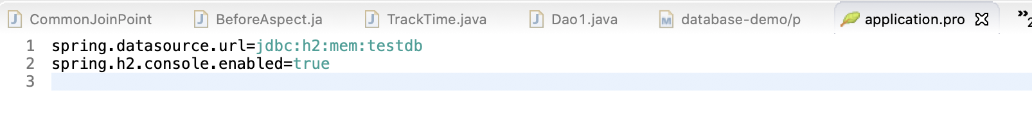

1. Launch <http://localhost:8080/h2-console/>
2. Create schema

we create person table and insert data into it. *Spring Boot version 2+ has a minor change*

All DDL(Data Definition Language) - Table Creations should be done in *schema.sql*

***Listing 1 - schema.sql***

1. create table person
2. (
3. id integer not null,
4. name varchar(255) not null,
5. location varchar(255),
6. birth_date timestamp,
7. primary key(id)
8. );

All DML(Data Manipulation Language) - Data Updates should be done in *data.sql*

***Listing 2 - data.sql***

1. INSERT INTO PERSON (ID, NAME, LOCATION, BIRTH_DATE )
2. VALUES(10001,  'Ranga', 'Hyderabad',sysdate());
3. INSERT INTO PERSON (ID, NAME, LOCATION, BIRTH_DATE )
4. VALUES(10002,  'James', 'New York',sysdate());
5. INSERT INTO PERSON (ID, NAME, LOCATION, BIRTH_DATE )
6. VALUES(10003,  'Pieter', 'Amsterdam',sysdate());
7. Spring JDBC stuff

JdbcTemplate is given by Spring.

jdbcTemplate.query => is when querying for many things like for findAll

jdbcTemplate.queryUpdate => is when doing some update opn like delete, update etc..

jdbcTemplate.queryObject => is when querying for specific thing like for findById

BeanPropertyRowMapper is used when your DB table names are same as variable name in Person Entity

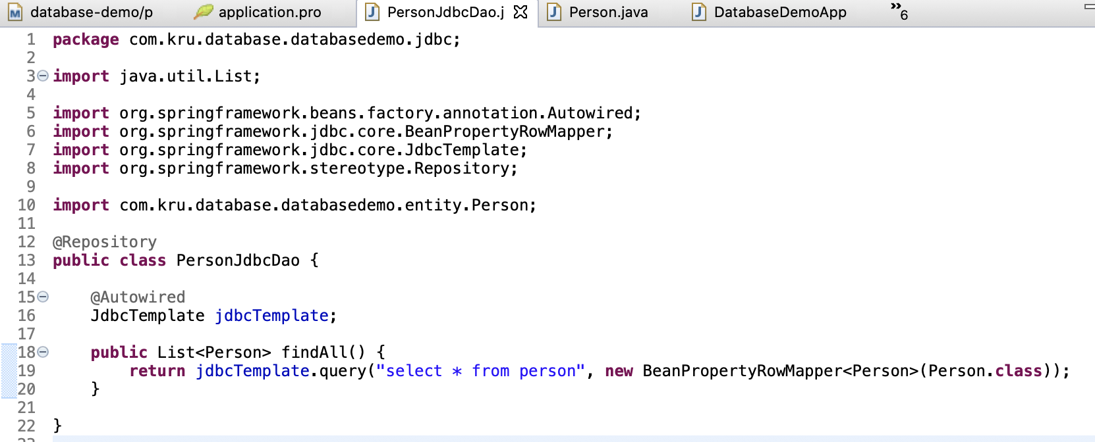

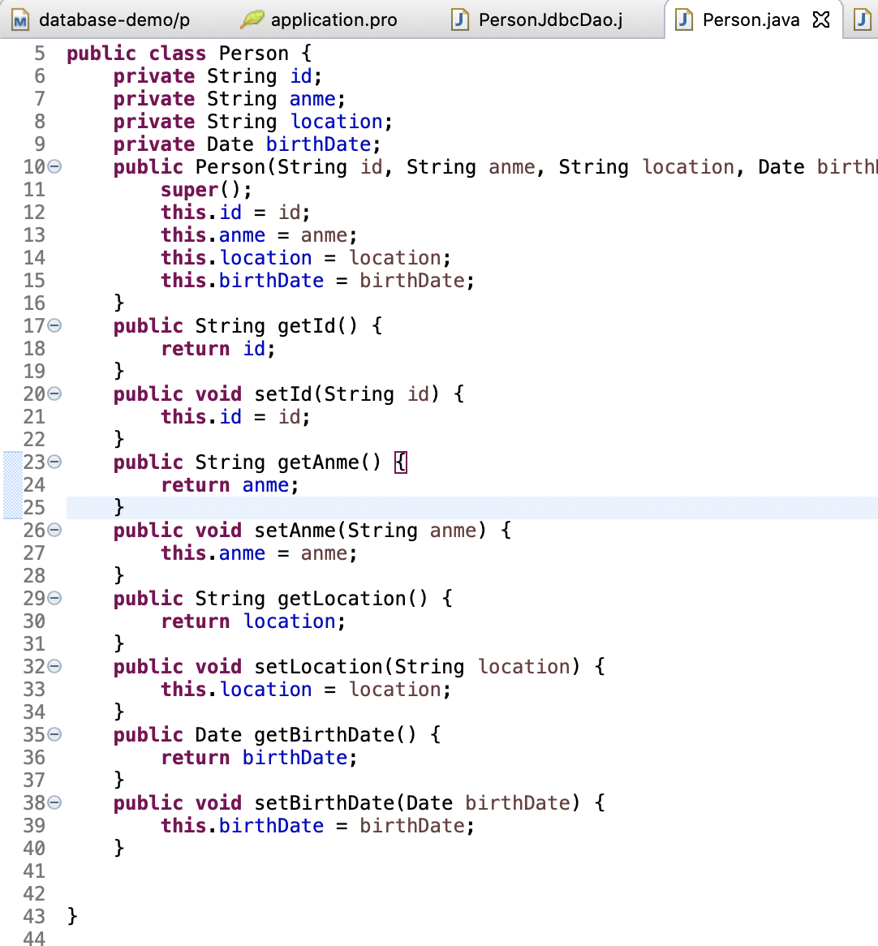

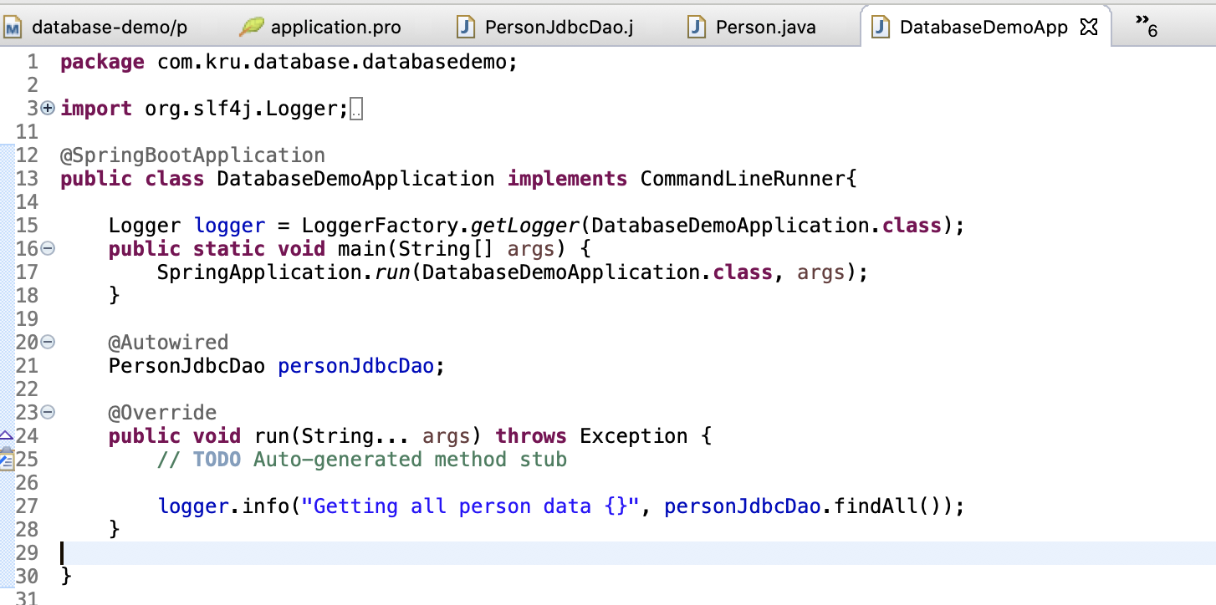

Run application => This gives error

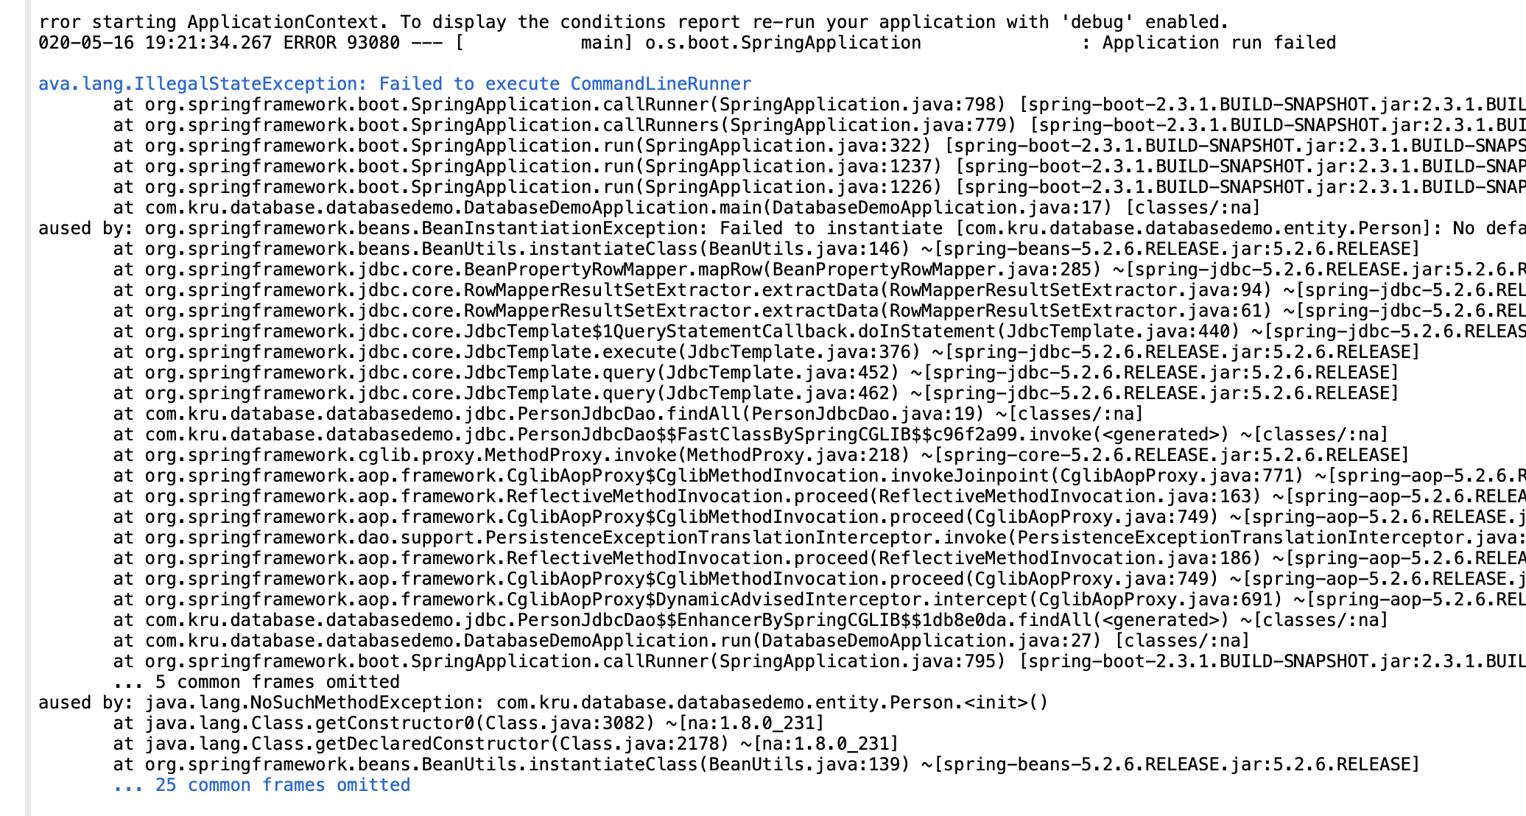

This gives error because it expects default constructor in Entity class

Whenever I use a BeanPropertyRowMapper, the Bean on which the PropertyRowMapper is defined should have a no argument constructor.

So I need to create a simple no argument constructor. One of the things is this is the default one which is provided by Java

So if this constructor was not there this is provided by default so I don't need to provide this at all.

But since we provided this constructor Java will no longer provide the default no argument constructor. So I need to provide that right now.

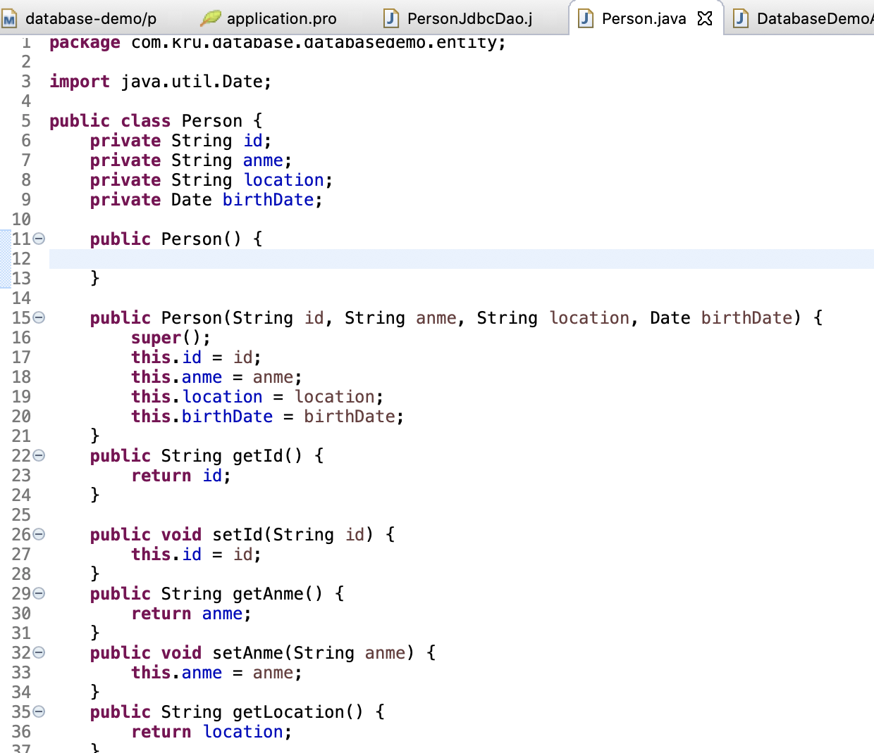



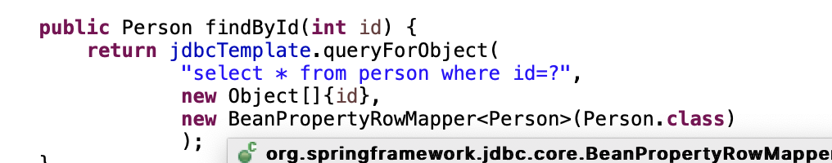

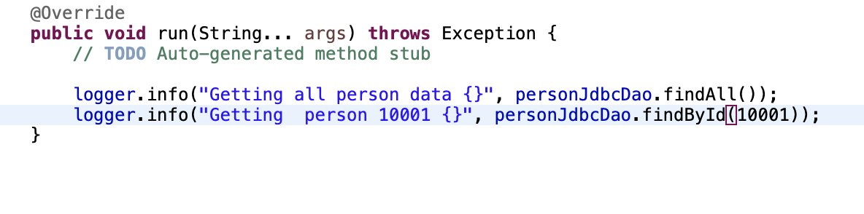



DeleteByid

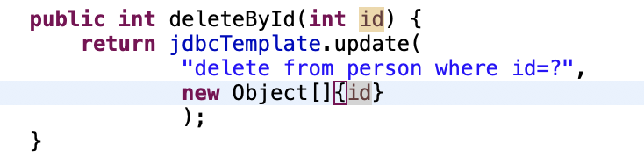

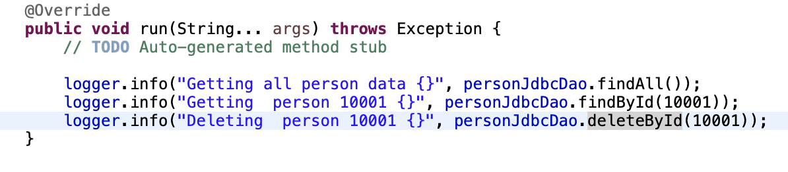

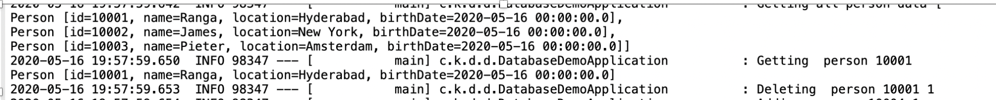

To add and update rows

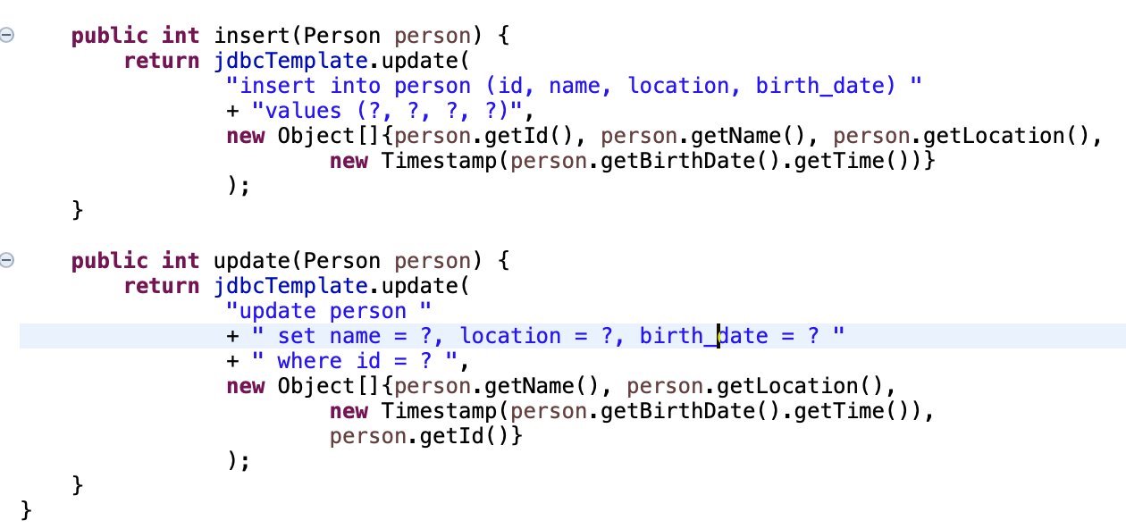

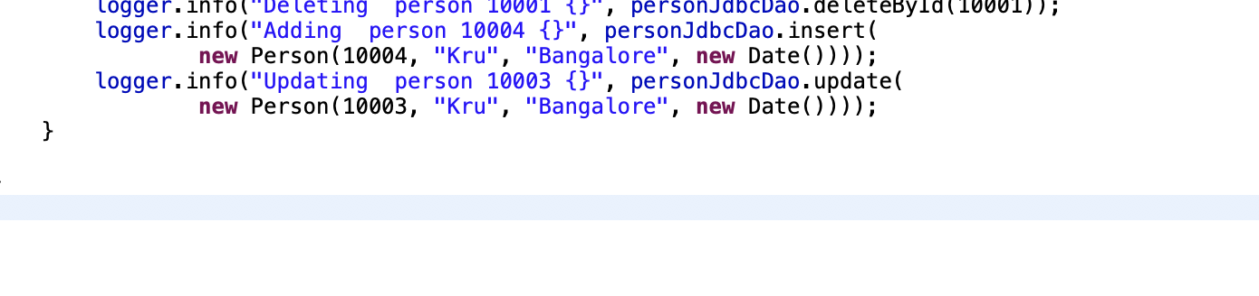

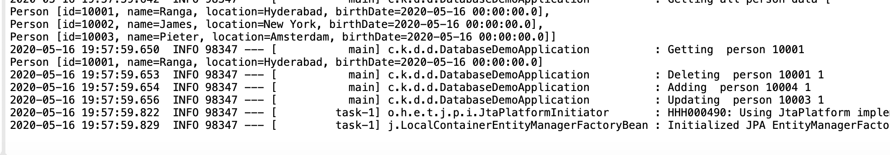

Creating a custom Row mapper

WE saw that our Person data types matched with person table elements. Hence we used BeanPropertyRowMapper

What if they are not same, we need to create custom RowMapper

So if the data which is coming back from the table is of a different structure compared to your bean. we need to create custom RowMapper

How to do it ?

1)By implementing interface RowMapper

I’m creating an inner class here because

I would want this to be used only inside the PersonJdbcDao.

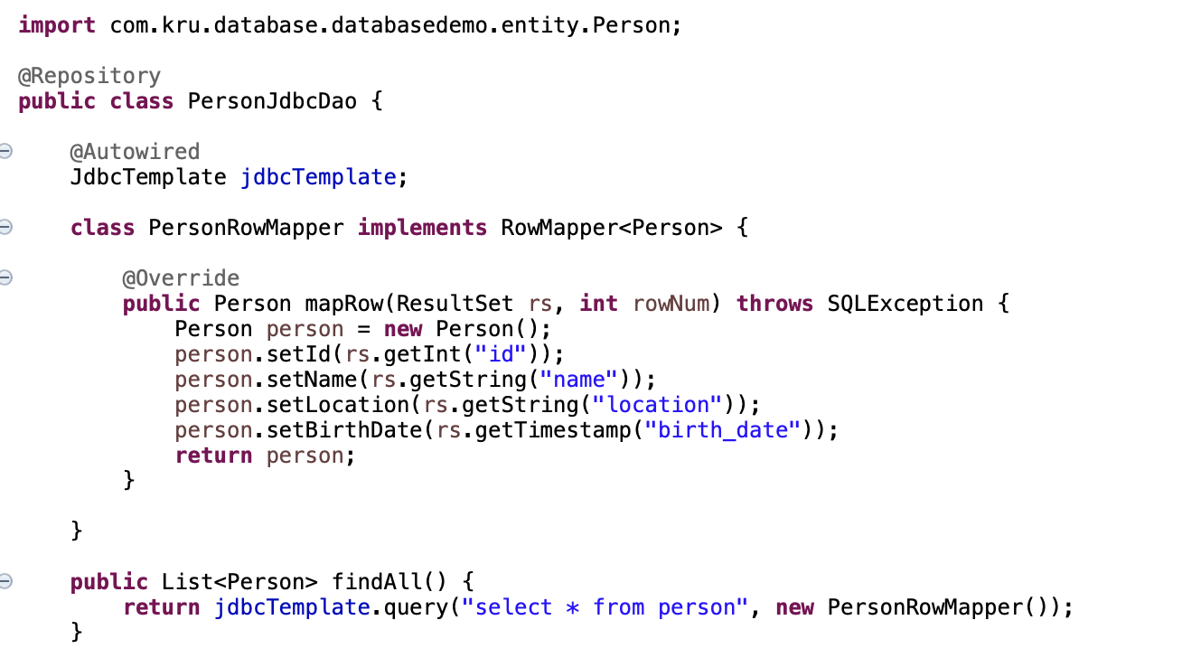

We can do all above things with JPA. Refer another document for that

For JPA, 

when ever we’re connecting to a embedded database, schema gets automatically created. All that you need to

do is insert the data in.

1)Entity For jpa

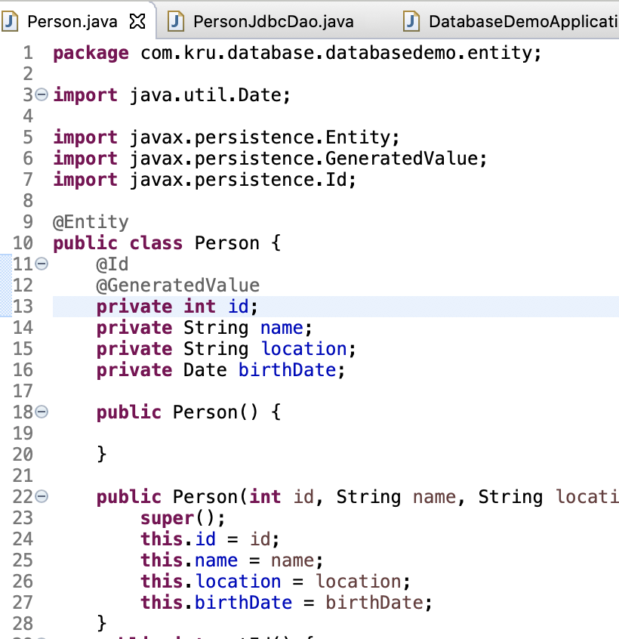

2)Create a repo

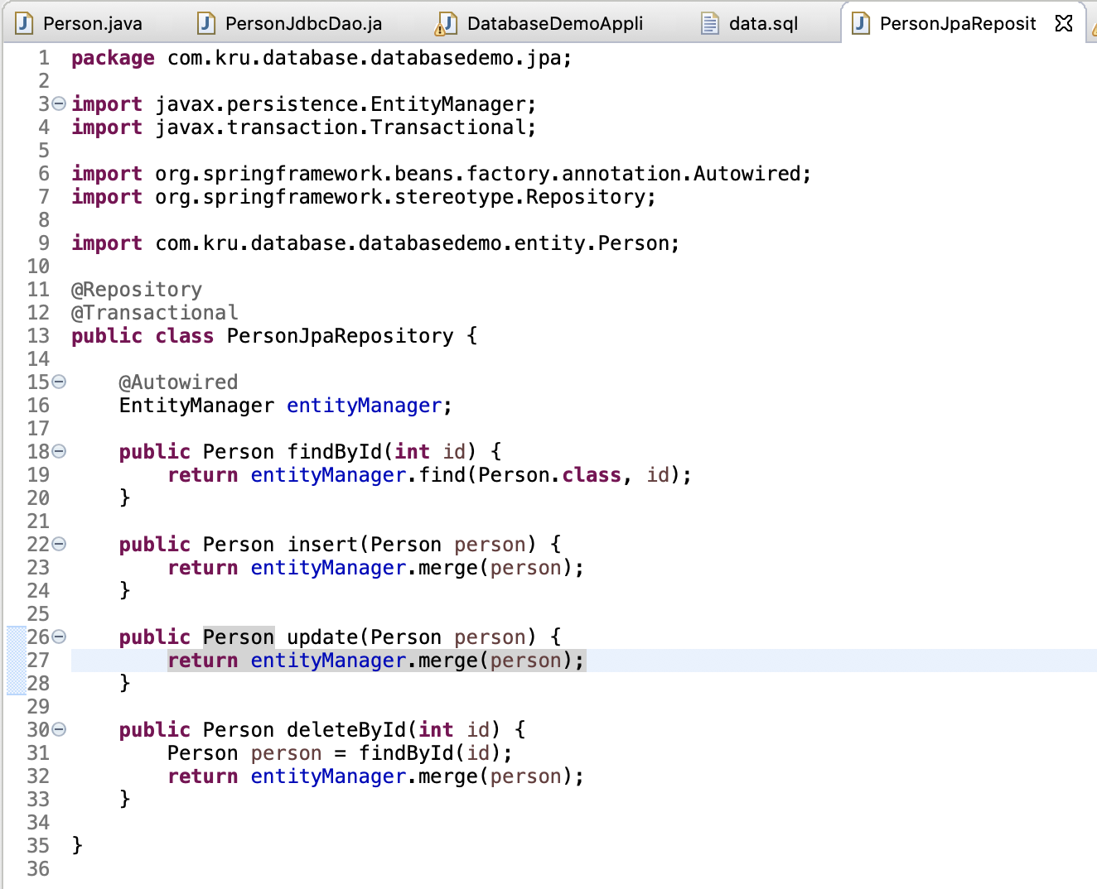

3)main

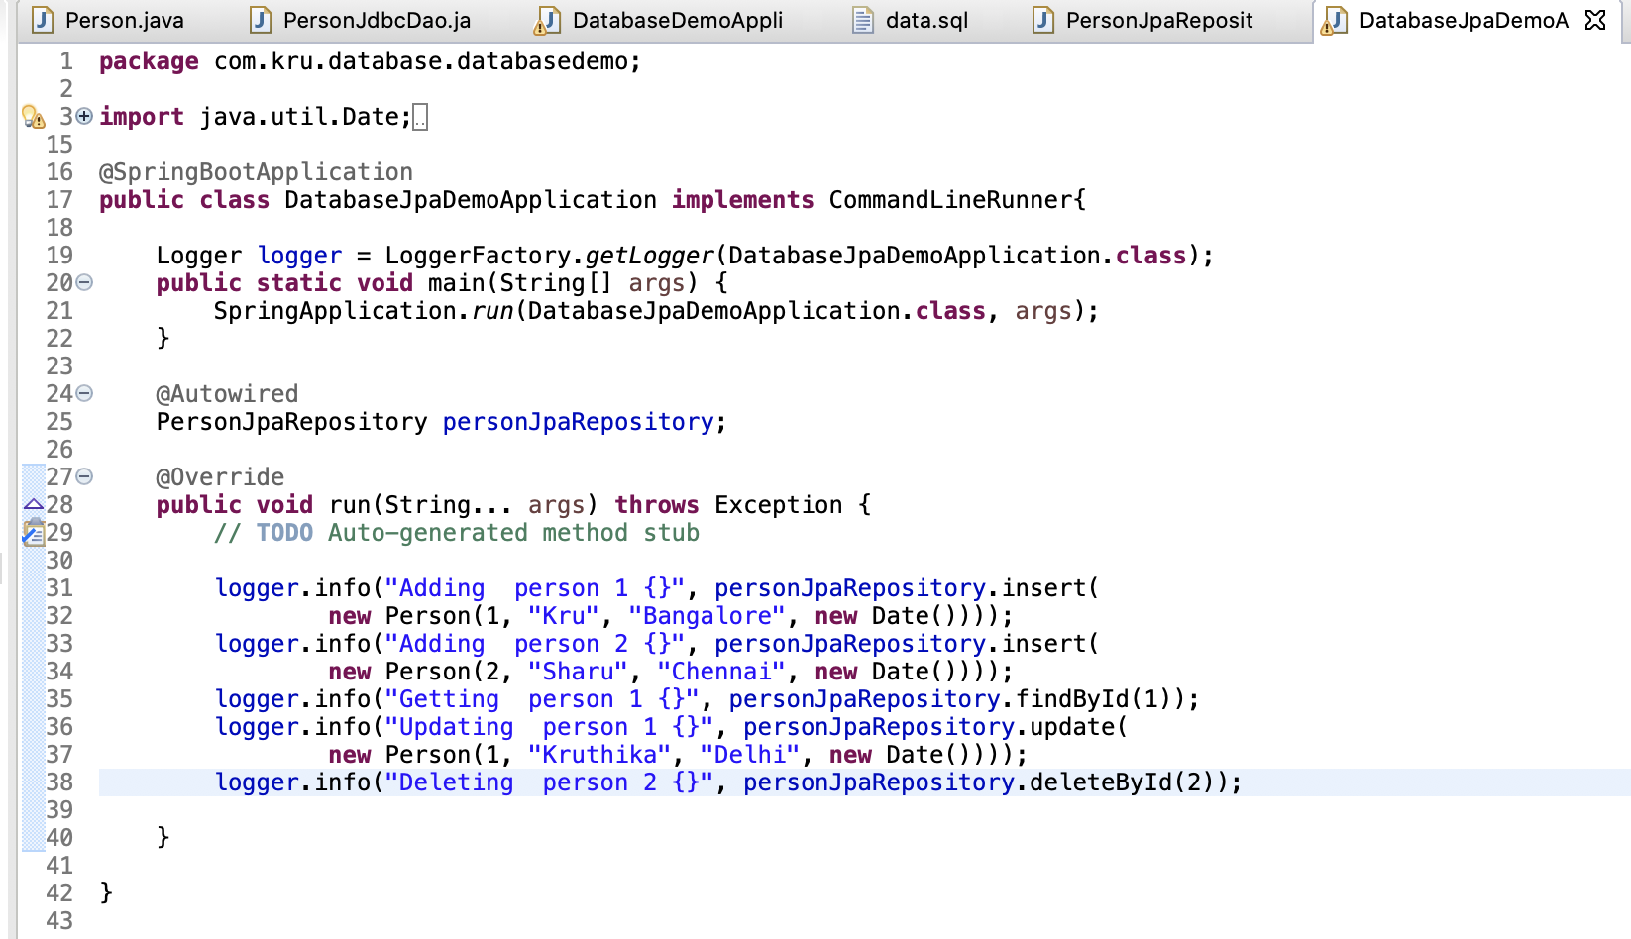

1. Output

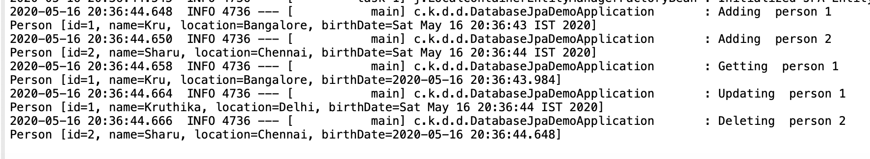

1. findAll()

The only method which is not implemented in the person JPA repository which is present in the JDBC Dao is the find all method.

So I would want to find all the persons who are present in the database. How do I do that?

With an entity manager, you have to write something called a HQL.  But with JPA you need to write a query using something called JPQL. Java persistence query language.

Instead of directly defining the query we’ll use a concept called named query.

The Java persistence query language does not use database. It does not use tables from the database. It uses the entities. So what we would use here in the query is entities.

1)Define a named query

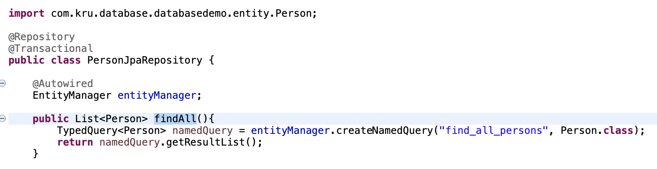

2)Specify the named query in Person entity because The Java persistence query language does not use database. It does not use tables from the database. It uses the entities. So what we would use here in the query is entities.

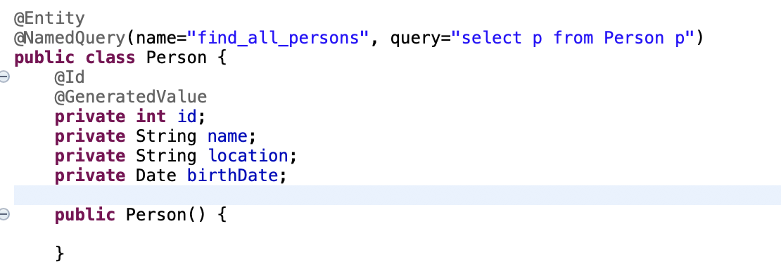

3)main class

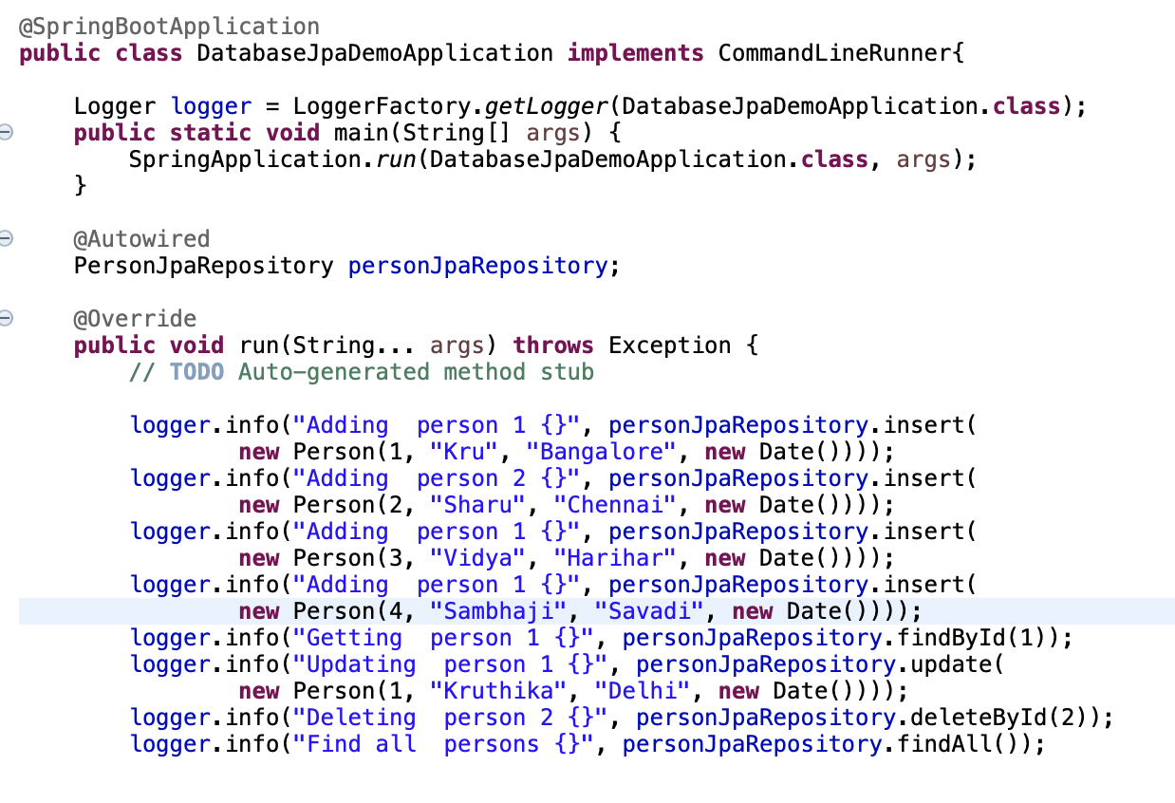

Output:

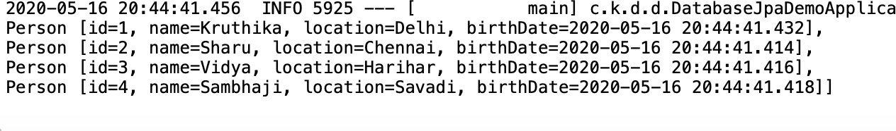

Spring data JPA

1)We have JpaRepository – just implement it

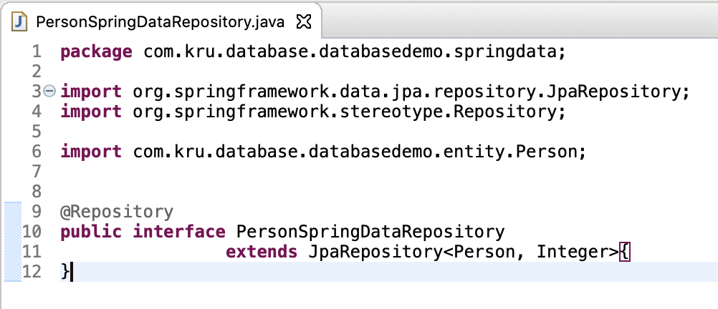

1. JpaRepository gives us functions save etc to do operations. So we can call them directly in main class

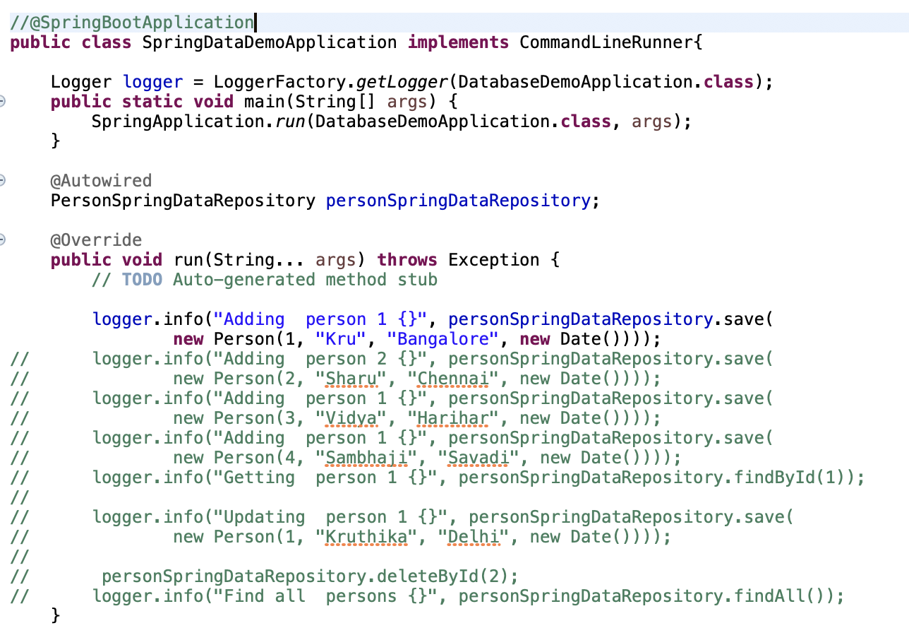

Connecting to other DB

Spring Boot really makes it very easy to connect to other databases.

So you can switch from one database to another just by defining a couple of properties and switching a couple of dependencies.

Spring Boot makes it easy to switch databases! Yeah really simple.

**Steps**

* Install MySQL and Setup Schema
* Remove H2 dependency from pom.xml
* Add MySQL (or your database) dependency to pom.xml

<dependency>

<groupId>mysql</groupId>

<artifactId>mysql-connector-java</artifactId>

</dependency>

* Configure application.properties

spring.jpa.hibernate.ddl-auto=none

spring.datasource.url=jdbc:mysql://localhost:3306/person_example

spring.datasource.username=personuser

spring.datasource.password=YOUR_PASSWORD

* Restart the app and You are ready!

Spring Boot can setup the database for you using Hibernate

Things to note:

* Spring Boot chooses a default value for you based on whether it thinks your database is embedded (default create-drop) or not (default none).
* spring.jpa.hibernate.ddl-auto is the setting to perform SchemaManagementTool actions automatically
  + none : No action will be performed.
  + create-only : Database creation will be generated.
  + drop : Database dropping will be generated.
  + create : Database dropping will be generated followed by database creation.
  + validate : Validate the database schema
  + update : Update the database schema
* Reference : <https://docs.jboss.org/hibernate/orm/5.2/userguide/html_single/Hibernate_User_Guide.html#configurations-hbmddl>

application.properties

#none, validate, update, create, create-drop

spring.jpa.hibernate.ddl-auto=create

**Installing and Setting Up MySQL**

* Install MySQL <https://dev.mysql.com/doc/en/installing.html>
  + More details - <http://www.mysqltutorial.org/install-mysql/>
  + Trouble Shooting - <https://dev.mysql.com/doc/refman/en/problems.html>
* Startup the Server (as a service)
* Go to command prompt (or terminal)
  + Execute following commands to create a database and a user

mysql --user=user_name --password db_name

create database person_example;

create user 'personuser'@'localhost' identified by 'YOUR_PASSWORD';

grant all on person_example.* to 'personuser'@'localhost';

* Execute following sql queries to create the table and insert the data

Table

create table person

(

id integer not null,

birth_date timestamp,

location varchar(255),

name varchar(255),

primary key (id)

);

Data

INSERT INTO PERSON (ID, NAME, LOCATION, BIRTH_DATE ) VALUES(10001, 'Ranga', 'Hyderabad',sysdate());

INSERT INTO PERSON (ID, NAME, LOCATION, BIRTH_DATE ) VALUES(10002, 'James', 'New York',sysdate());

INSERT INTO PERSON (ID, NAME, LOCATION, BIRTH_DATE ) VALUES(10003, 'Pieter', 'Amsterdam',sysdate());

Web app with Spring MVC

1)New => Others => Maven Project => GroupId =>artifactId => war => finish

2)pom.xml

Configure plugin tomcat

To be able to run the web application

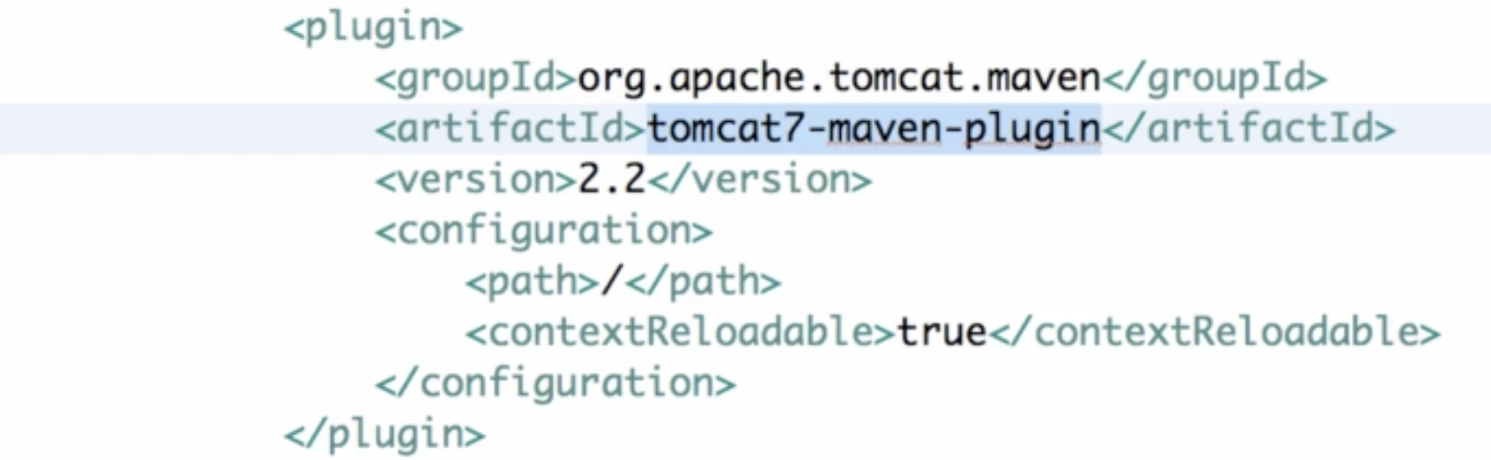

Maven compiler

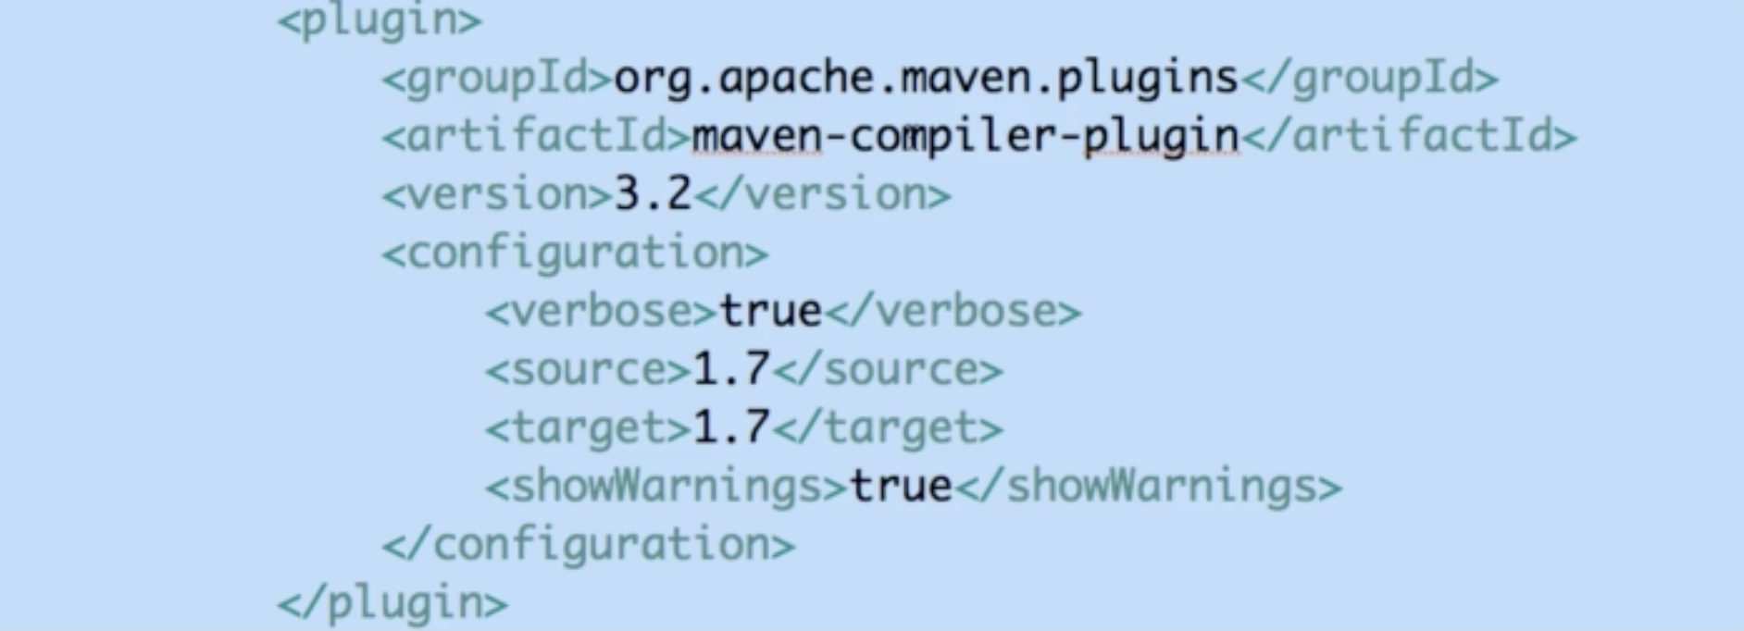

 Takes care of compiling the Java classes that we created and also building the jars,wars using Java 1.7 source and target as Java 1.7.

We have added in is a dependency.

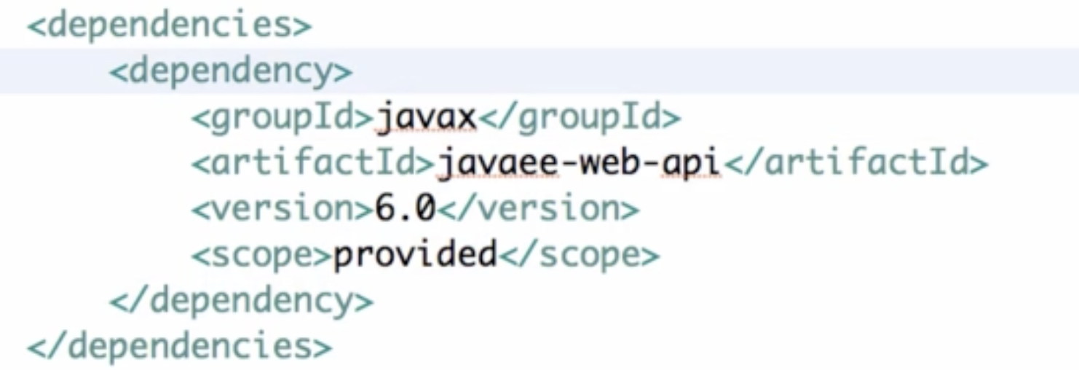

We're running a Java EE-6 web application.

How do we add the Java EE API just to the code in the server.

3) web.xml

When we do localhost:8080, we wil be redirected to welcome file login.

We are using the specification version 3.0.

So 3.0 is the latest version and we're using 3.0 so we are using we are creating a web app version 3.0 and we gave a display name to this particular project as “To Do List” because we wanted to build todo management application

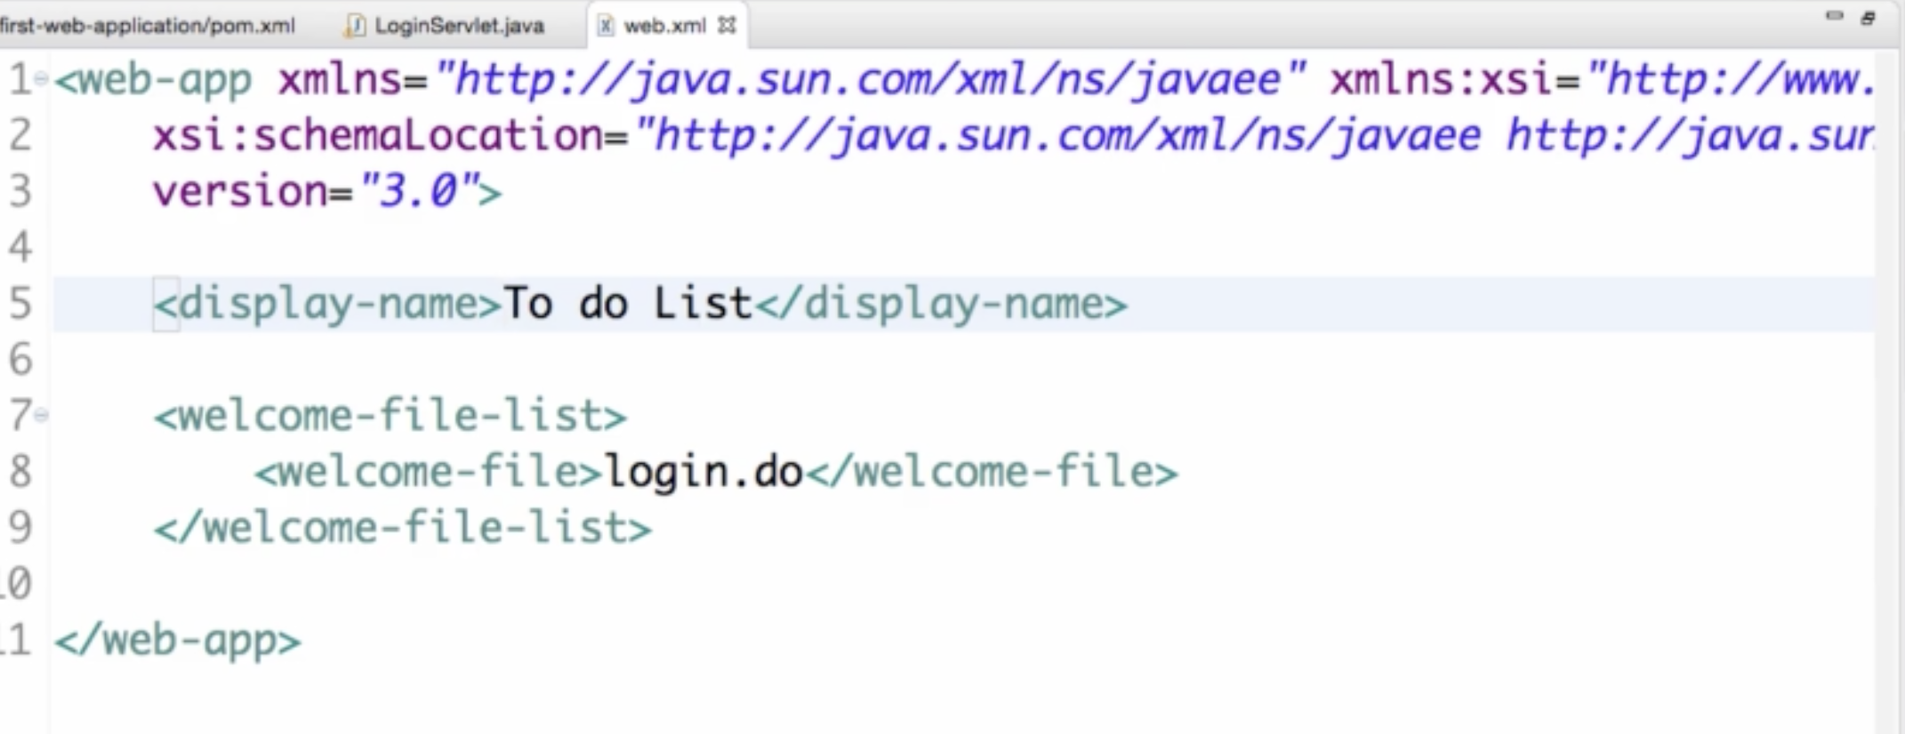

4)Servlet

Java EE - It is nothing but a set of specifications that define how various things are developed in Java enterprise applications.

This specific thing that we are focusing on in this particular course is the Java servlet technology.

So we're going to use Java Servlet to create our web application.

A Servlet is nothing but a very simple Java class which can take a request in and can respond back with a response.

//Servlet is a Java programming language class

//used to extend the capabilities of servers

//that host applications accessed by means of

//a request-response programming model.

When I type in localhost:8080 the browser create a get request to localhost:8080 along with a few request headers.

The request goes to the server and the server is responding back with his http response which contains

the HTML content as well as a few headers on the response.

This is how all the web applications work.

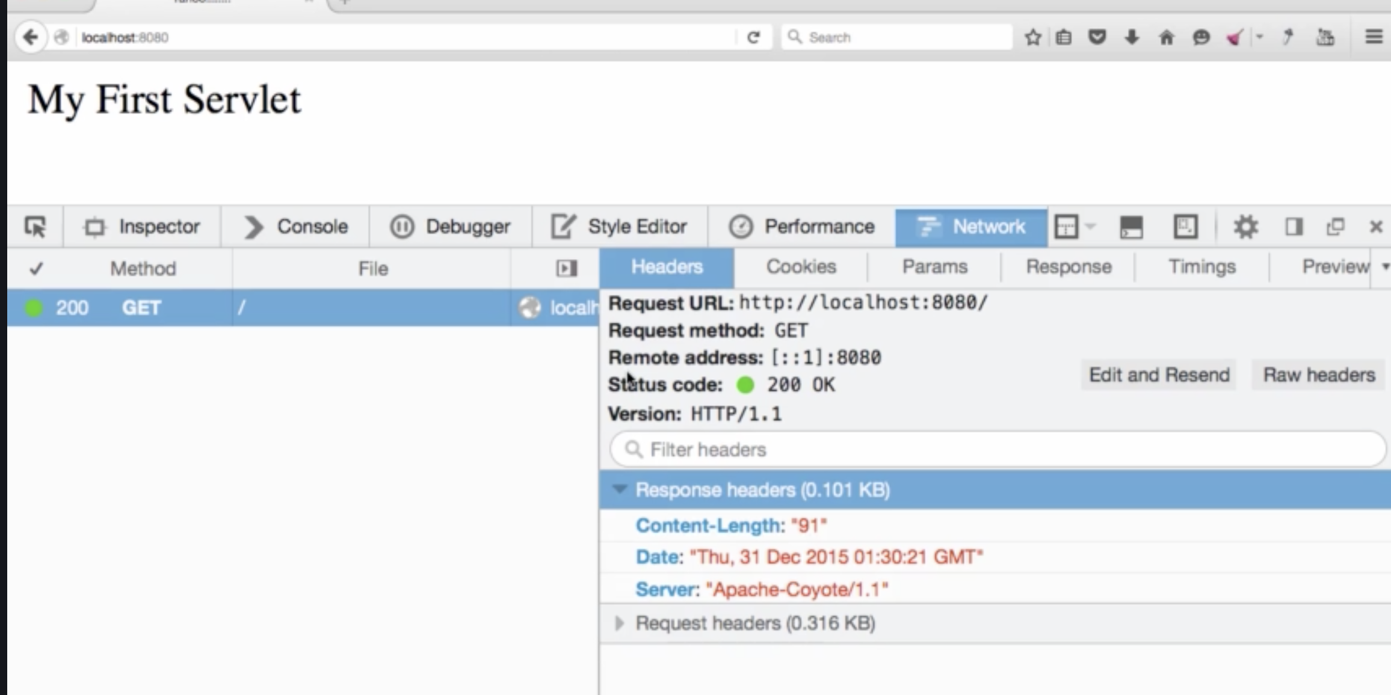

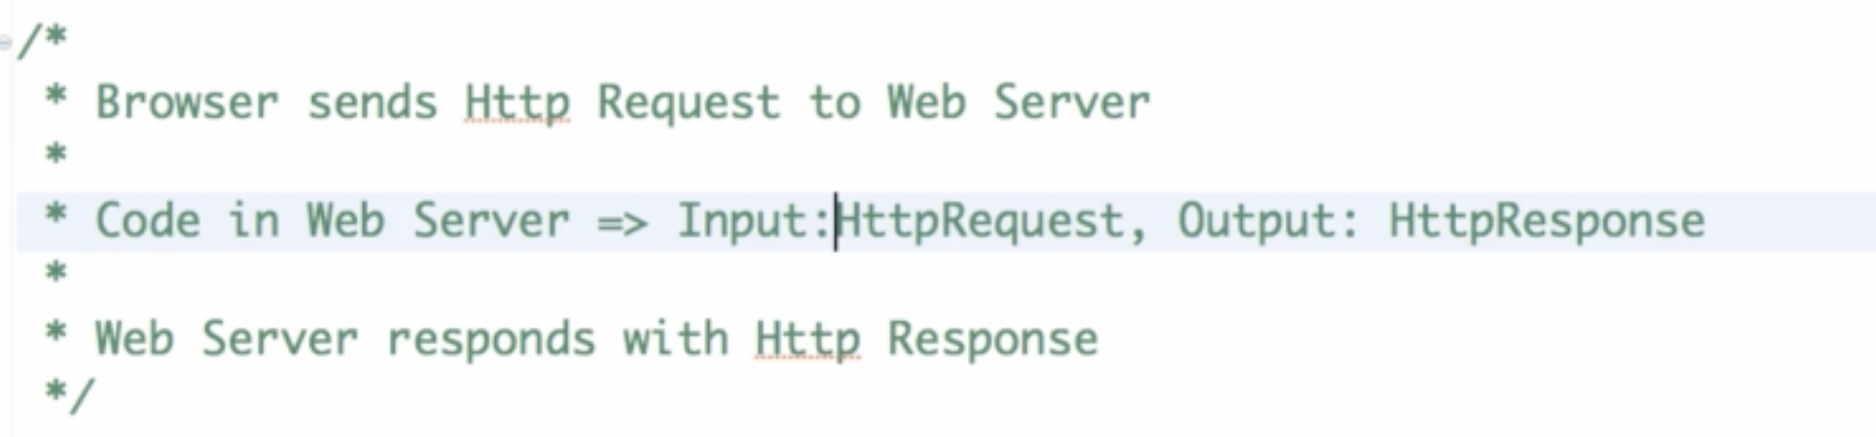

Our servlet

1)Any servlet should extend HttpServlet

2)Use @WebServlet to define url pattern for this Servlet

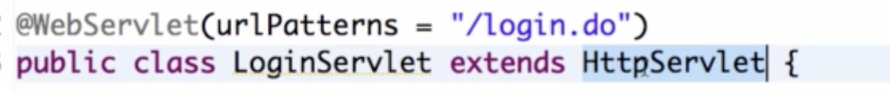

3)Handle requests like GET, post etc

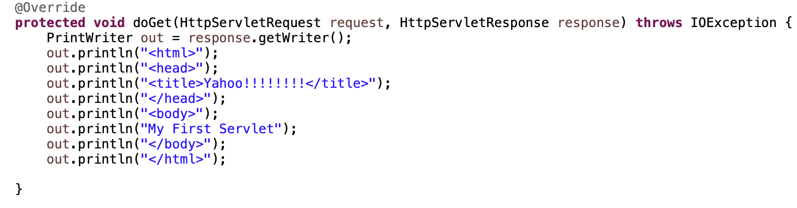

So we created a method to get to handle the request to login.do

what kind of request we're going to handle - the get requests.

4)Create a view

Create folder views under WEB-INF. Create a file login.jsp under it like this

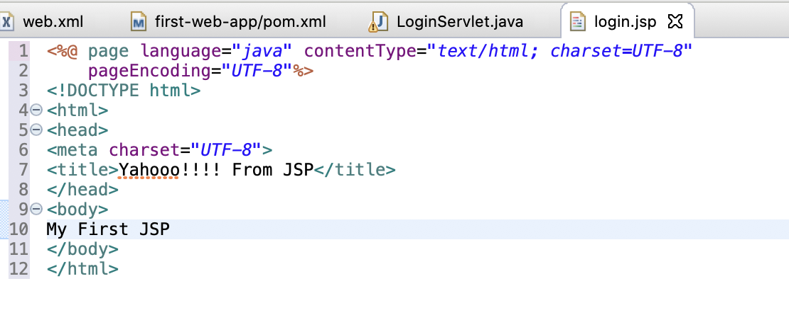

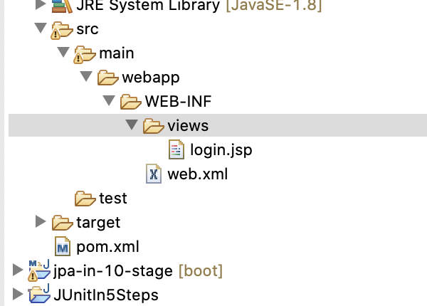

5)Lets connect login.jsp with LoginServelt i.e, redirect request to jsp

getRequestDispatched from request , give it path to .jsp and forward the request and resposne

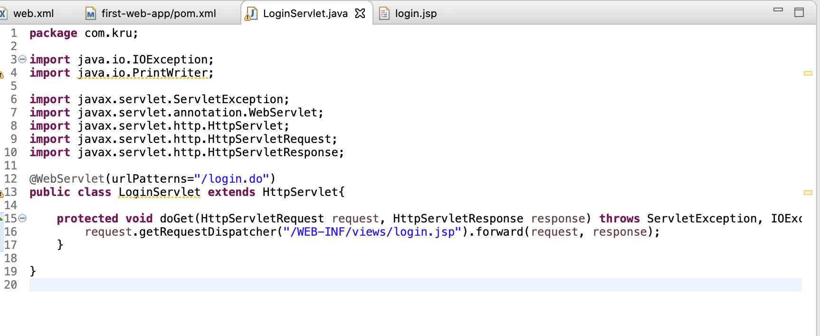

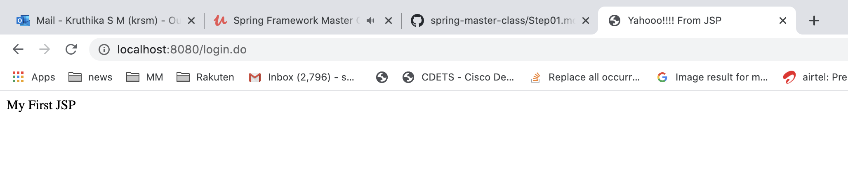

6)Pass request params to GET request

<http://localhost:8080/?name=kru>

request.getParameter(“name”) will get kru from url

and then request.setAttribute will set name to kru

This will be forwarded to login.jsp where it can be accessed using ${name}

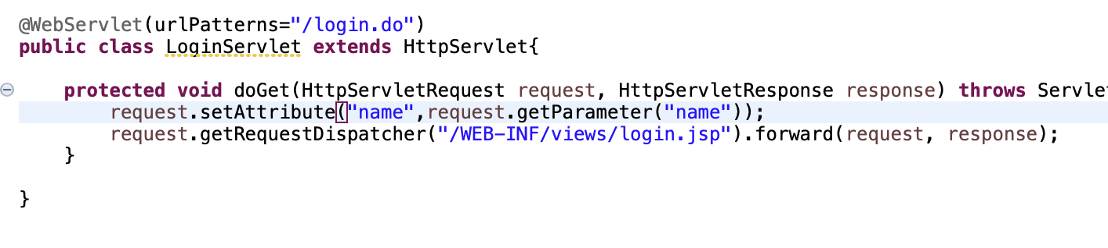

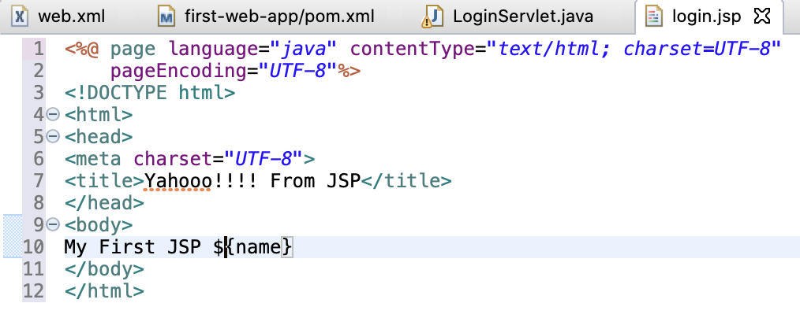

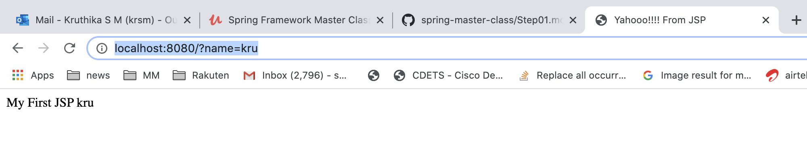

Jsp is nothing but a servlet. When it gets request, its internally converted to servlet.

In jsp , anything written within <% <java code>%> is Scriptlet. But its not good practice to write it in there

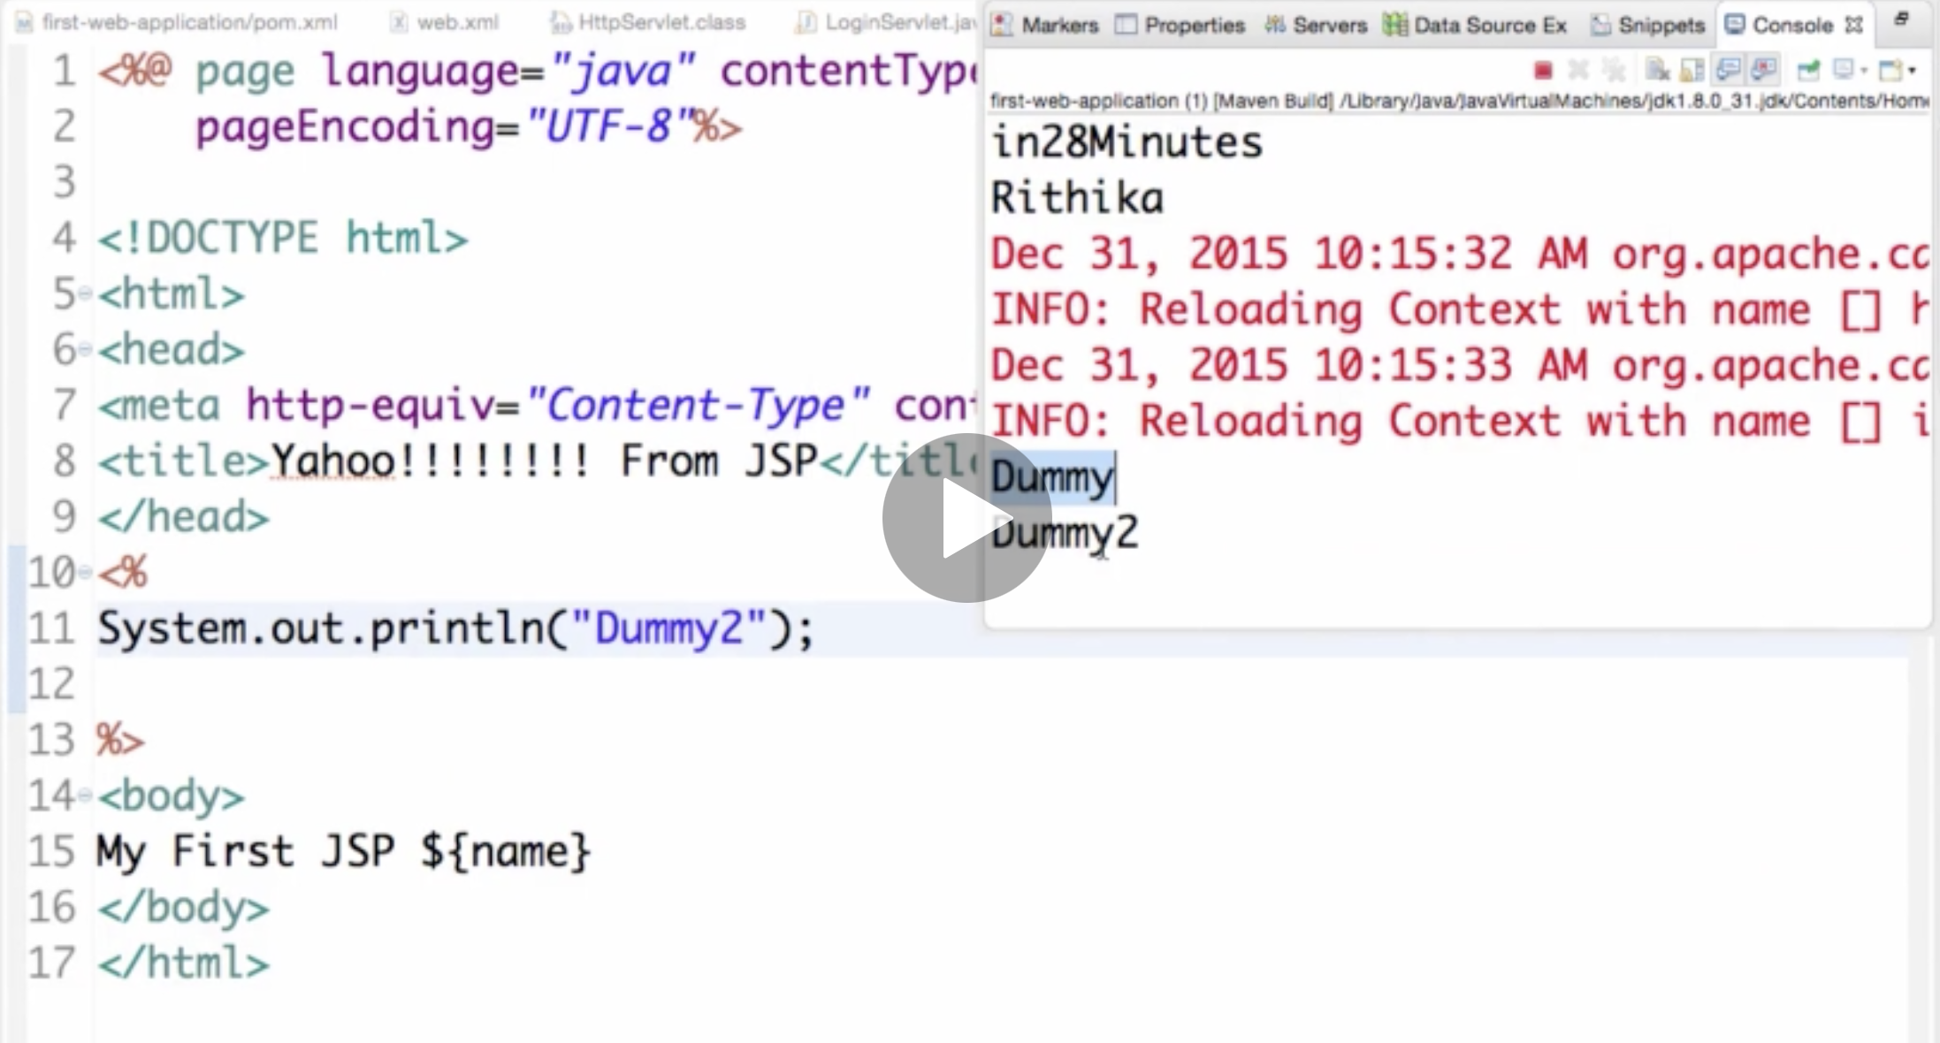

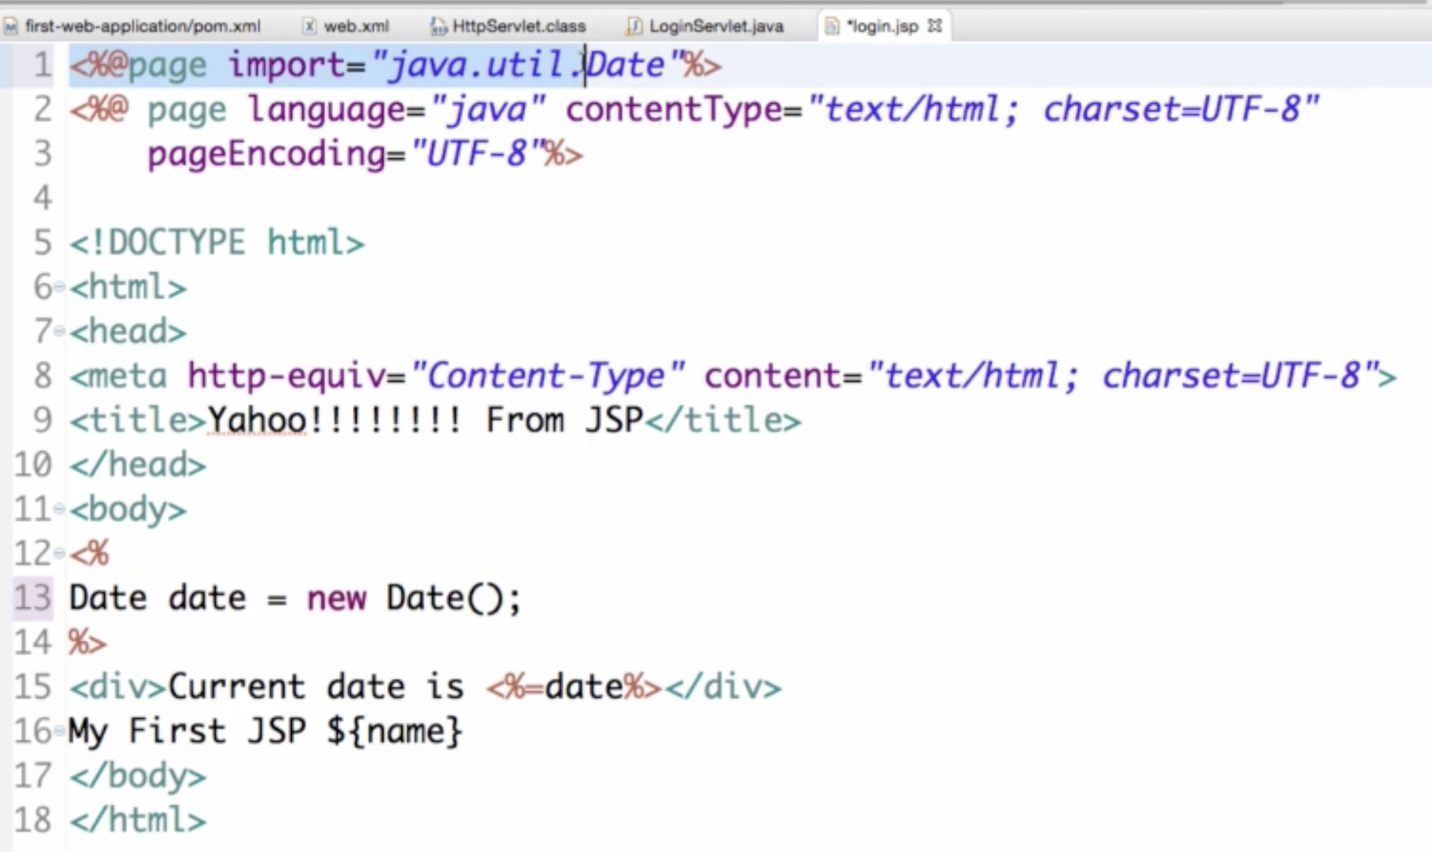

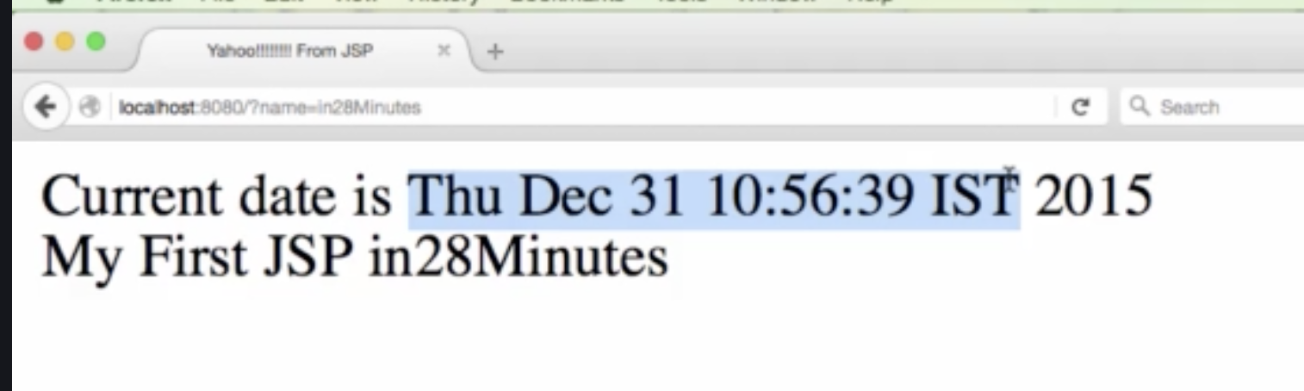

This Servlet controls the flow and the JSP is a view

============

Disadavntages of GET parameter

Its not secure to send in params in url as anyone with route will know those information. That’s why we can go for POST request to send more securily(although its not entirely secure but better than GET)

Post request:

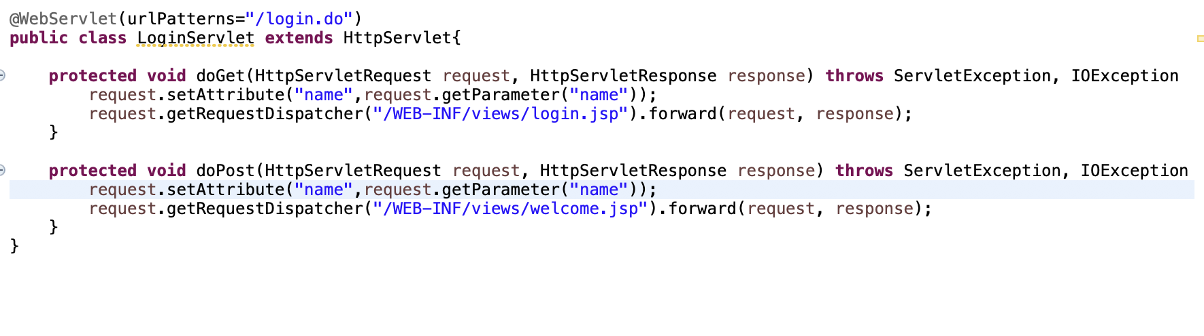

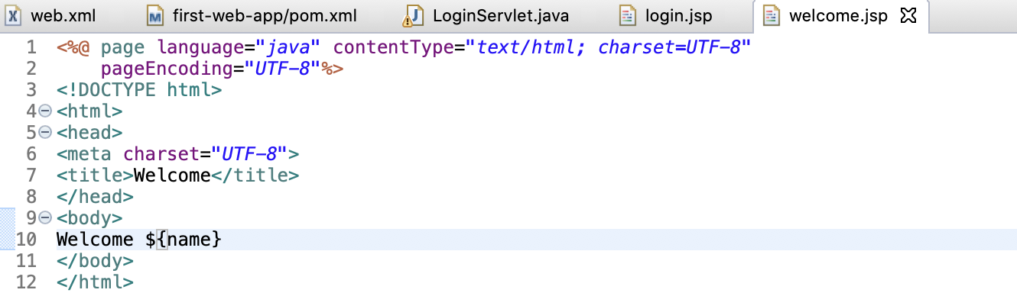

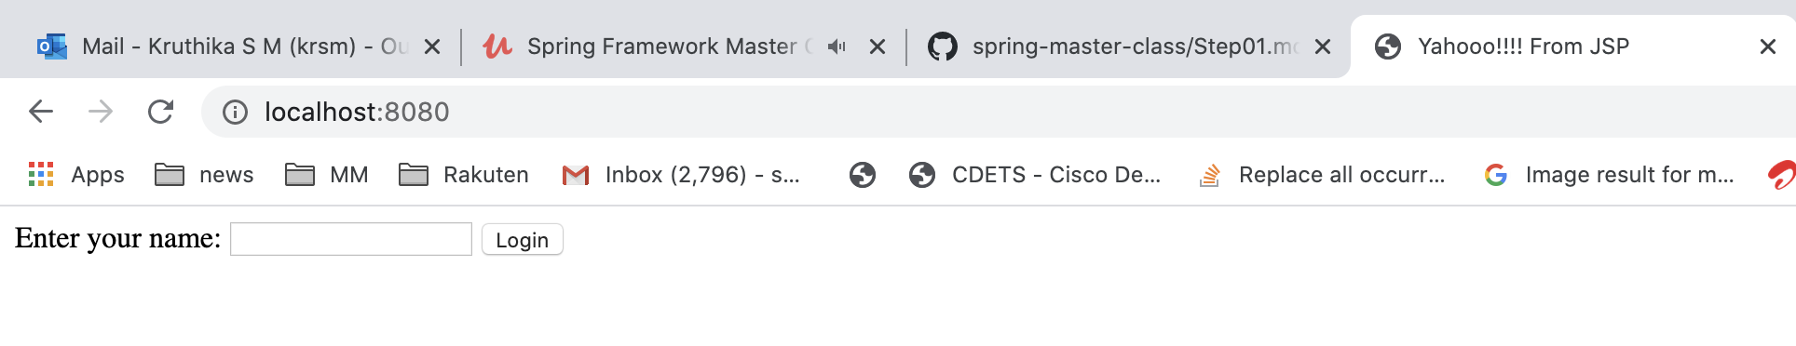

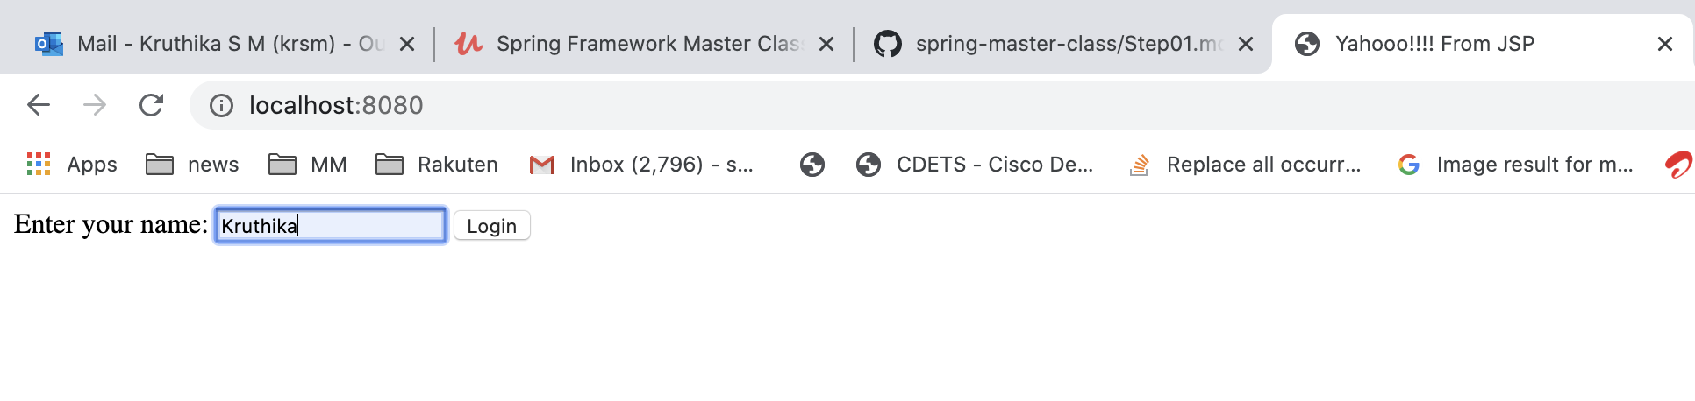

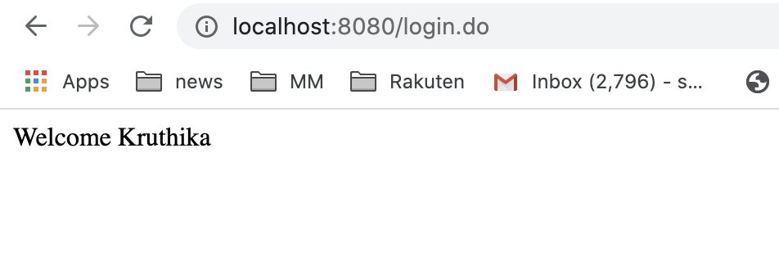

Login page:

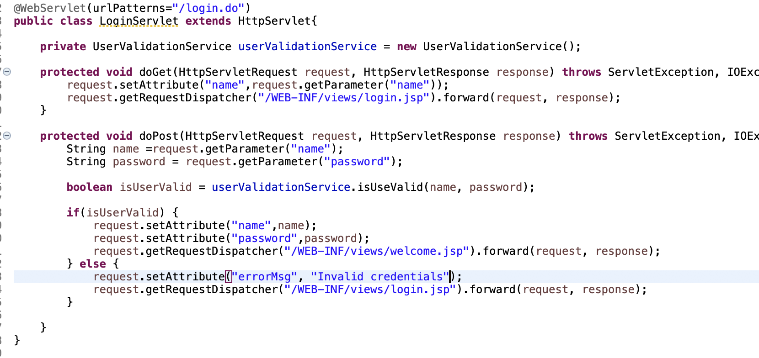

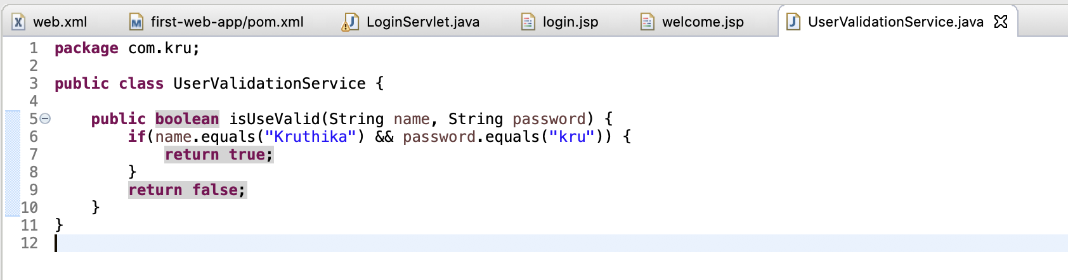

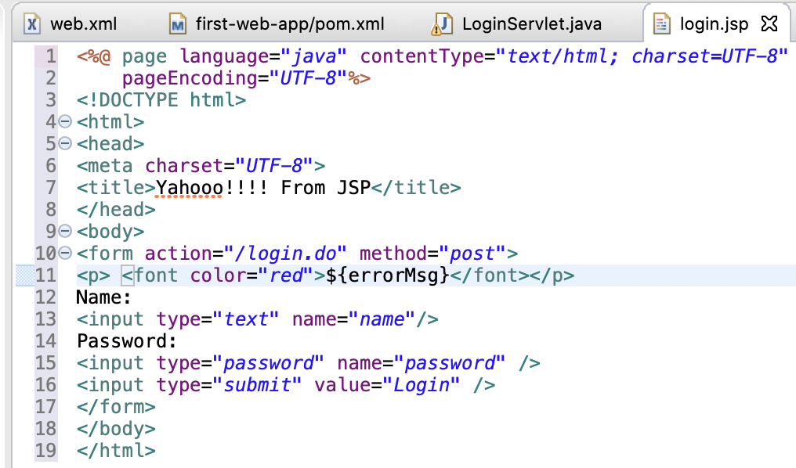

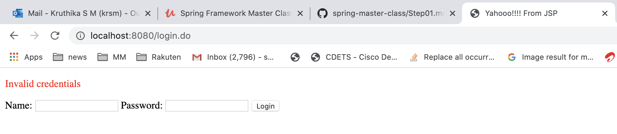

We see the web application that we already have. We want to enhance it to use spring MVC.

1)Add Spring mvc jar as dependency in maven

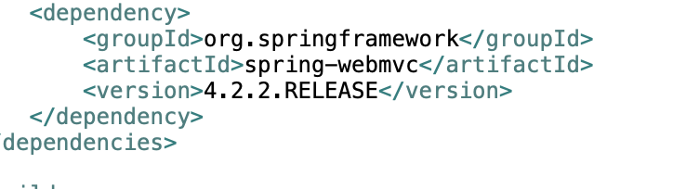

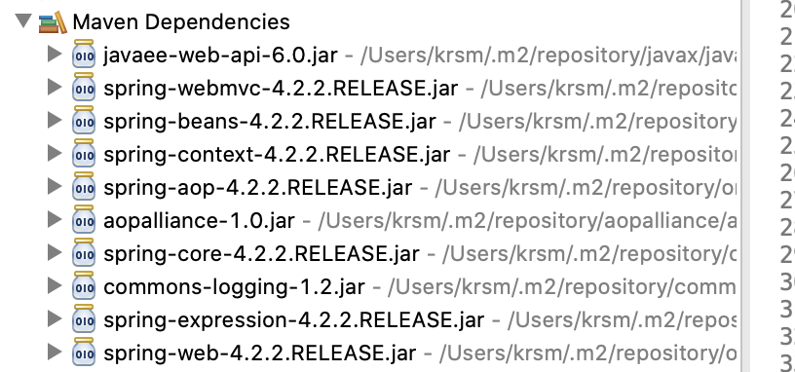

2)Spring mvc uses a front Controller pattern which is the dispatcher servlet which also needs to be added to web.xml.

Front controller it is basically something where all the requests go .

So whenever I come from browser to a web application all the requests would first go to this controller.

So anything would first go to the dispatcher sublet and only then the dispatcher would send it to a controller or a JSP or anything else.

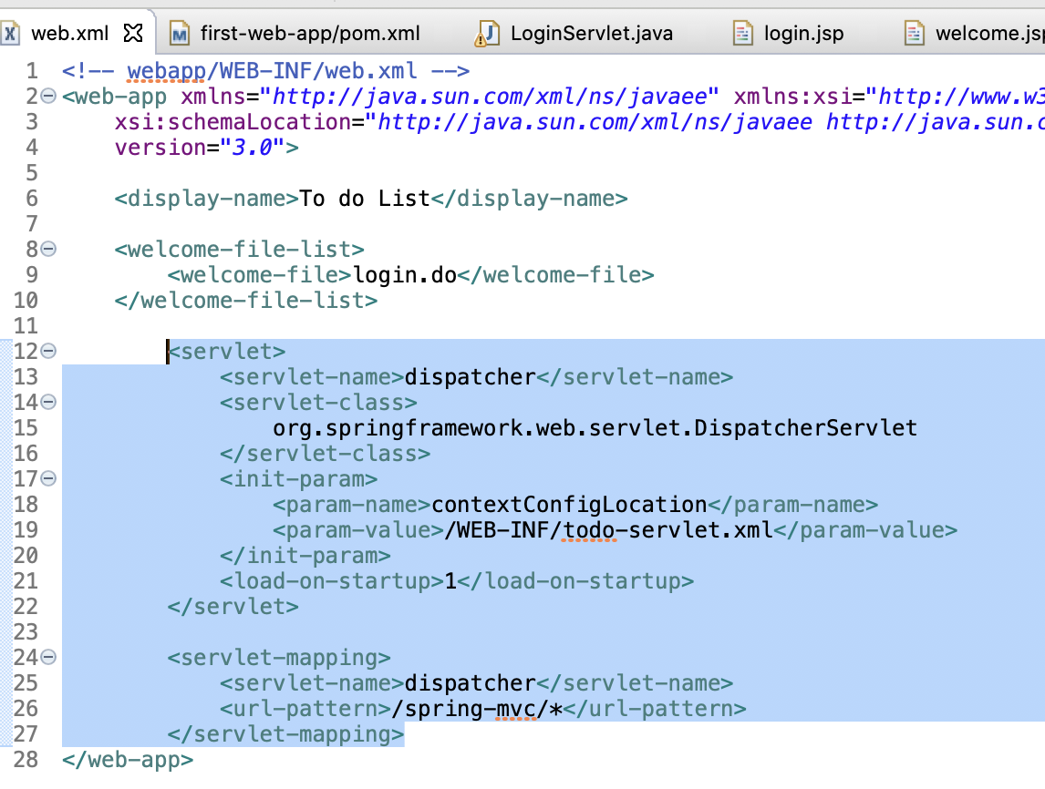

1)This is to say where dispatched is configured - /WEB-INF/todo-servlet.xml

<servlet>

<servlet-name>dispatcher</servlet-name>

<servlet-class>

org.springframework.web.servlet.DispatcherServlet

</servlet-class>

<init-param>

<param-name>contextConfigLocation</param-name>

<param-value>/WEB-INF/todo-servlet.xml</param-value>

</init-param>

<load-on-startup>1</load-on-startup>

</servlet>

1. This is to say that when we do localhost:8080/spring-mvc/*,control goes to dispatcher

<servlet-mapping>

<servlet-name>dispatcher</servlet-name>

<url-pattern>/spring-mvc/*</url-pattern>

</servlet-mapping>

3) dispatcher servlet needs an Spring Application Context to launch. WE will create /WEB-IN/todo-servlet.xml

<beans xmlns="http://www.springframework.org/schema/beans"

xmlns:context="http://www.springframework.org/schema/context"

xmlns:mvc="http://www.springframework.org/schema/mvc"

xmlns:xsi="http://www.w3.org/2001/XMLSchema-instance"

xsi:schemaLocation="http://www.springframework.org/schema/beans http://www.springframework.org/schema/beans/spring-beans.xsd

http://www.springframework.org/schema/mvc http://www.springframework.org/schema/mvc/spring-mvc.xsd

http://www.springframework.org/schema/context http://www.springframework.org/schema/context/spring-context.xsd">

<context:component-scan base-package="com.kru" />

<mvc:annotation-driven />

</beans>

1)Lets create spring mvc controller

a)Use @Controller

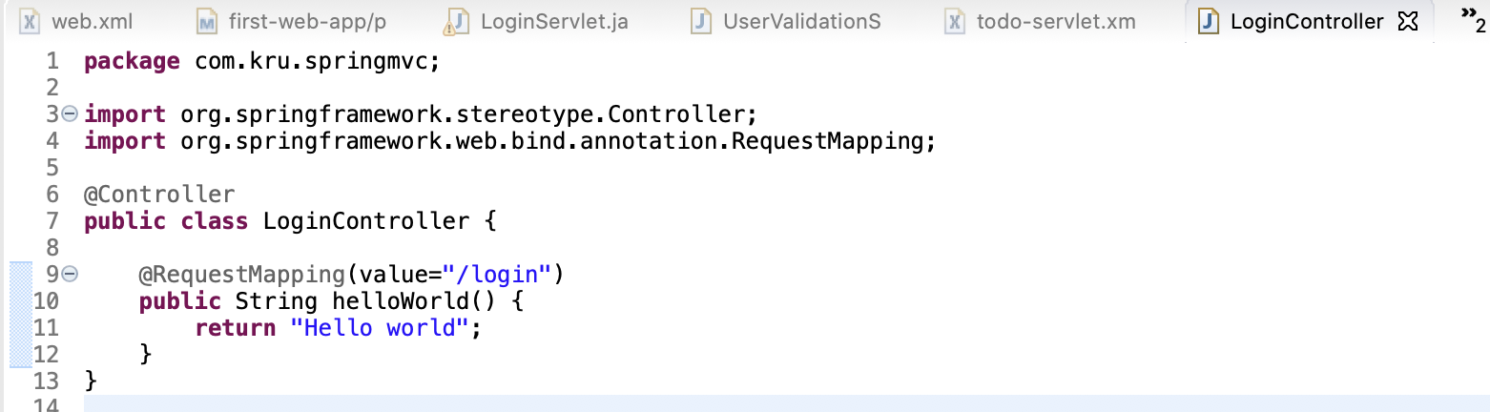

Run app

But we get 404 . Why ????

Lets understand this:

What we have is a dispatcher servlet and a LoginController.

When we say <http://localhost:8080/spring-mvc/login>

This request will be sent to dispatcher servlet as we have specified in web.xml that all url /spring-mvc/* must to go to dispatcher servlet

Once dispatcher servlet gets the url ,it knows that /login is handled by LoginController. So it sends request to LoginController which will return Hello World and it comes back to dispatcher servlet. Now dispatcher servlet tries searching for url /Hello World but infact we wanted to show Hello World in browser. So we need to tell dispatcher servlet that it needs to return Hello World as body to browser and not think of it as url . So how to do that? We can do that by using @ResponseBody as follows

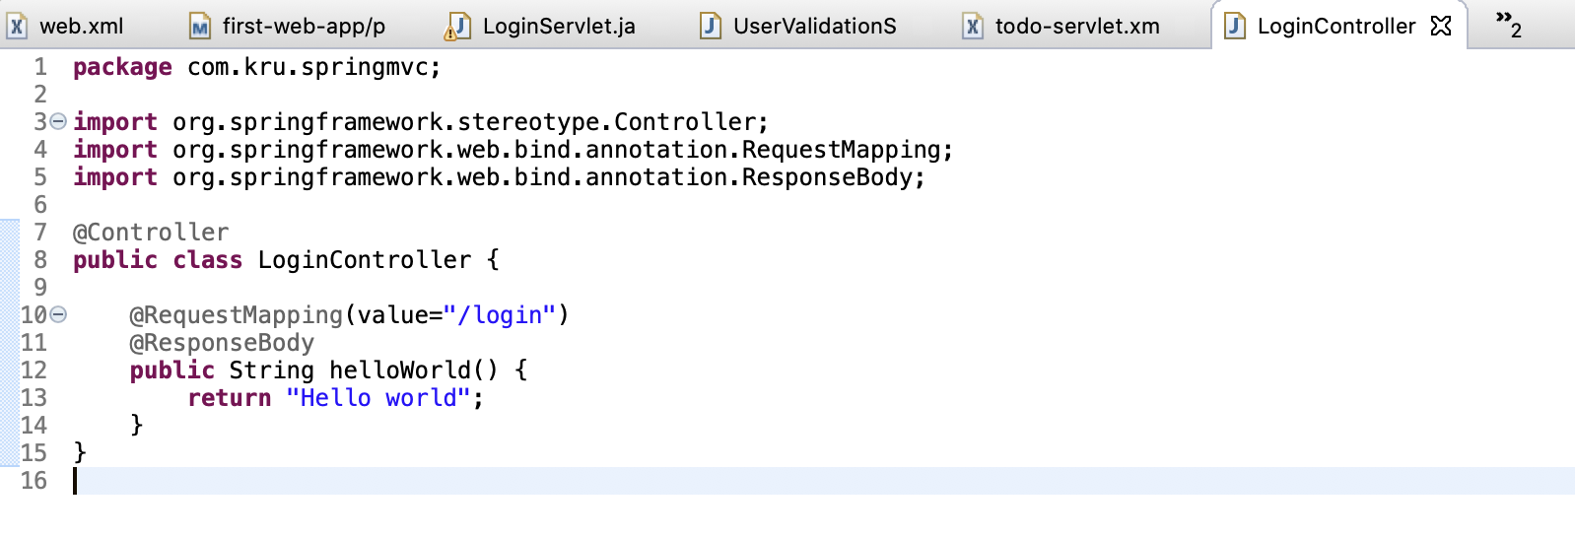

Now it is successful

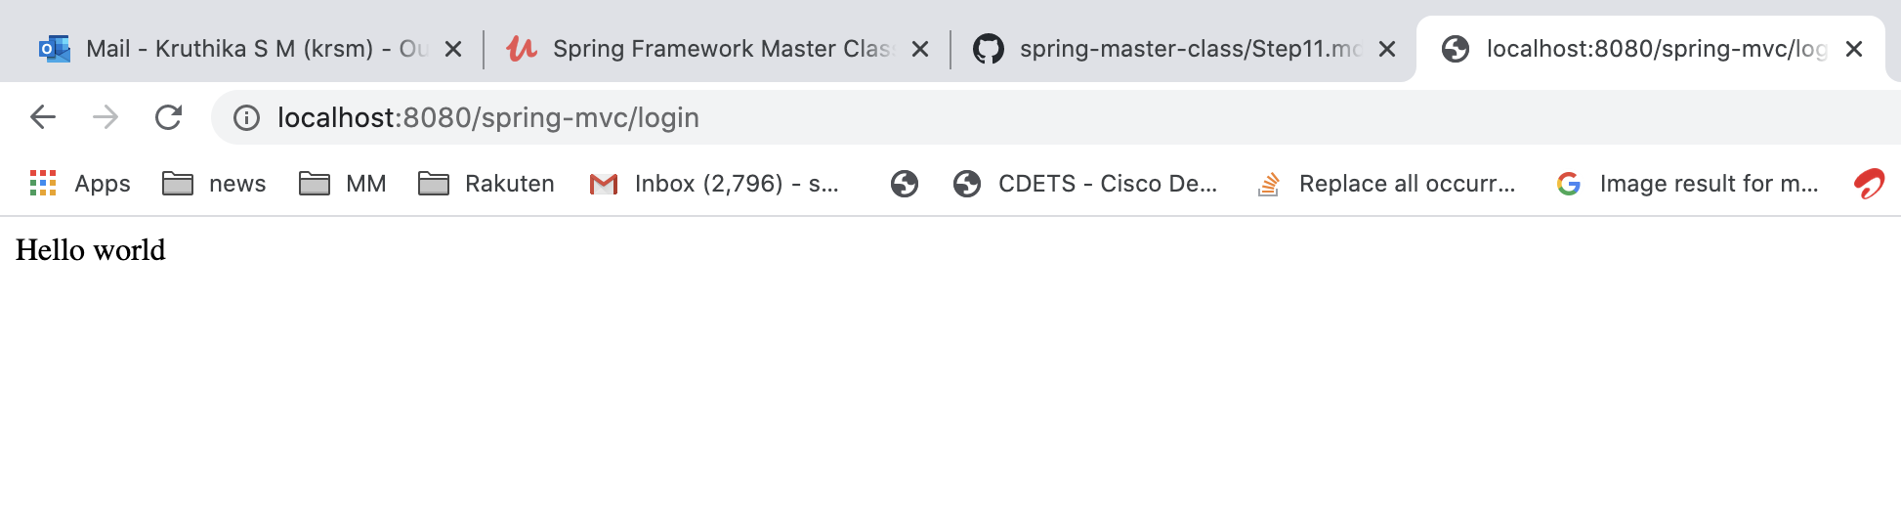

So that's basically how the requests work in spring mvc and you see everything goes through dispatches later.

it goes through the special servlet displeasures servlet looked at the controllers and tries to find the appropriate controller because returns the result back to it.

And based on the result the dispatcher servlet would either redirect it to another view or another controller or if there is a response body in addition it directly returns that response back to the browser.

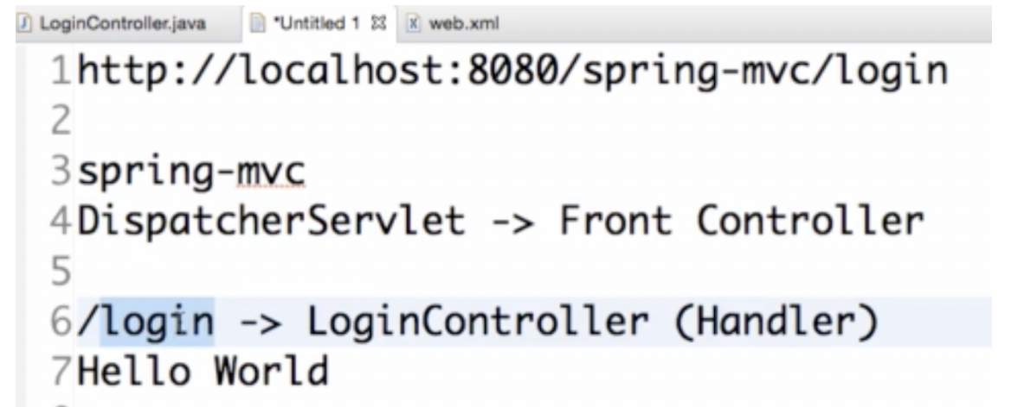

2)Lets configure a View

Instead of sending output to browser, we now want dispatcher servlet to send to view which is done by ViewResolver by using following

<bean

class="org.springframework.web.servlet.view.InternalResourceViewResolver">

<property name="prefix">

<value>/WEB-INF/views/</value>

</property>

<property name="suffix">

<value>.jsp</value>

</property>

</bean>

What this means is whatever string is passed to you, prefix it with /WEB-INF/views and suffix it with .jsp

Say it get string”login” => it should rsolve it to /WEB-INF/views/login.jsp

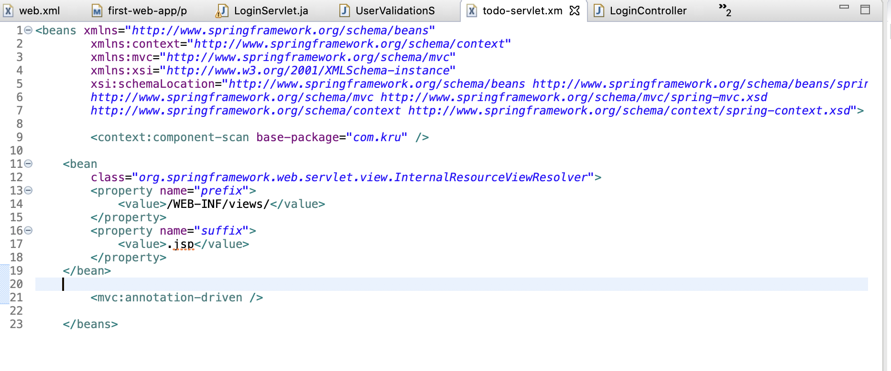

For this to work, we should not use @ResponseBody

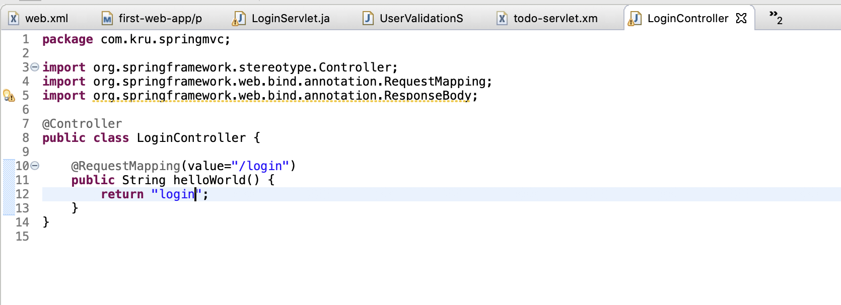

Now try it => we are redirected to /WEB-INF/views/login.jsp

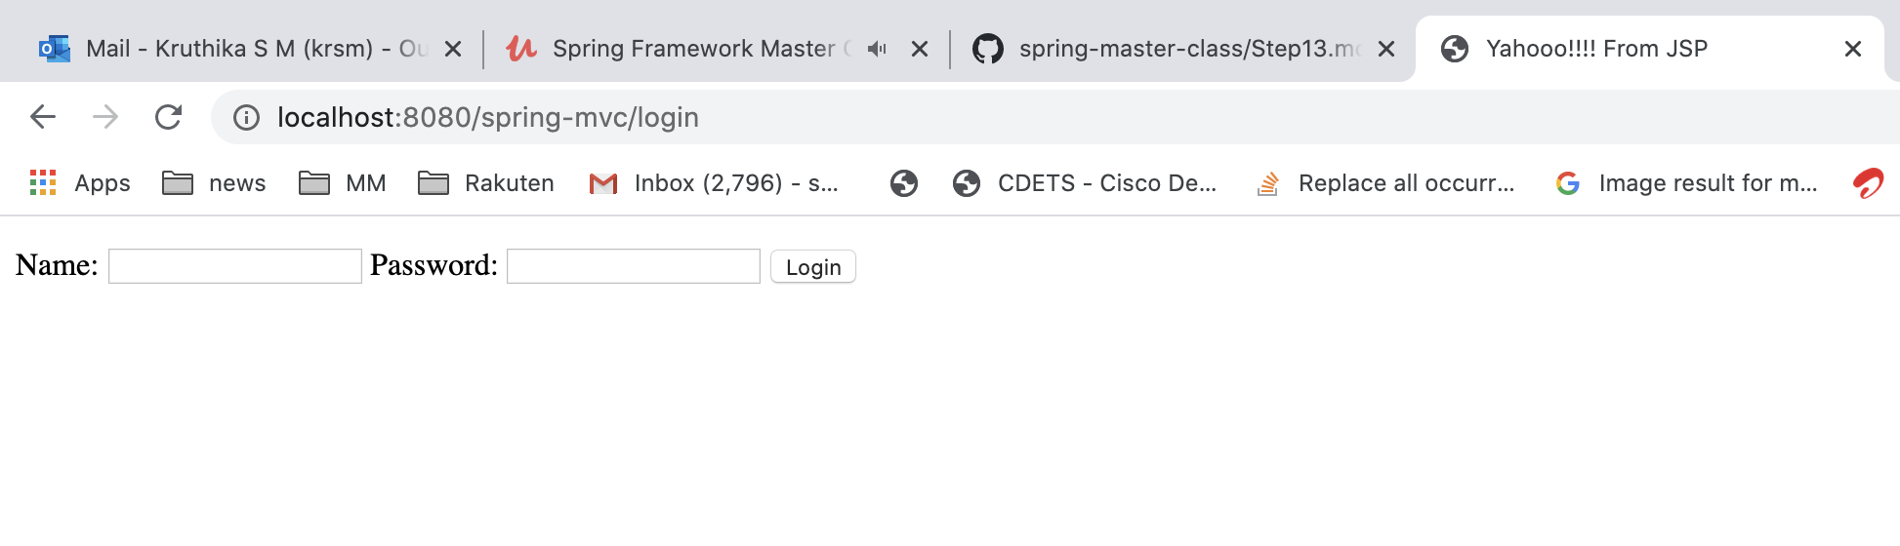

What is happening???

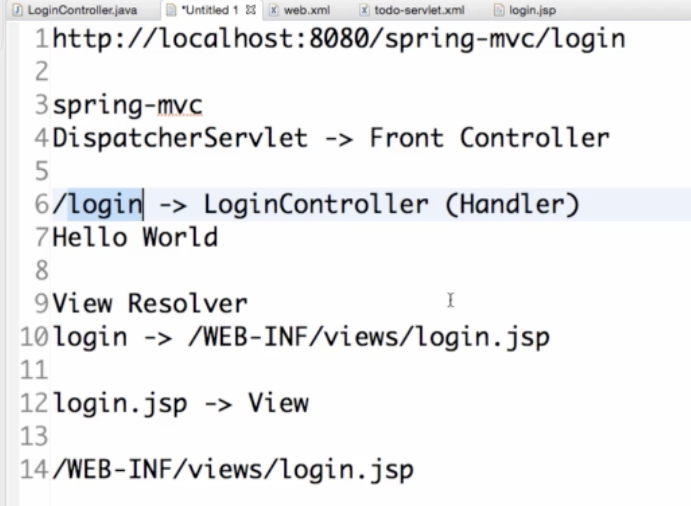

Spring MVC Architecture

Front controller – Dispatcher servlet

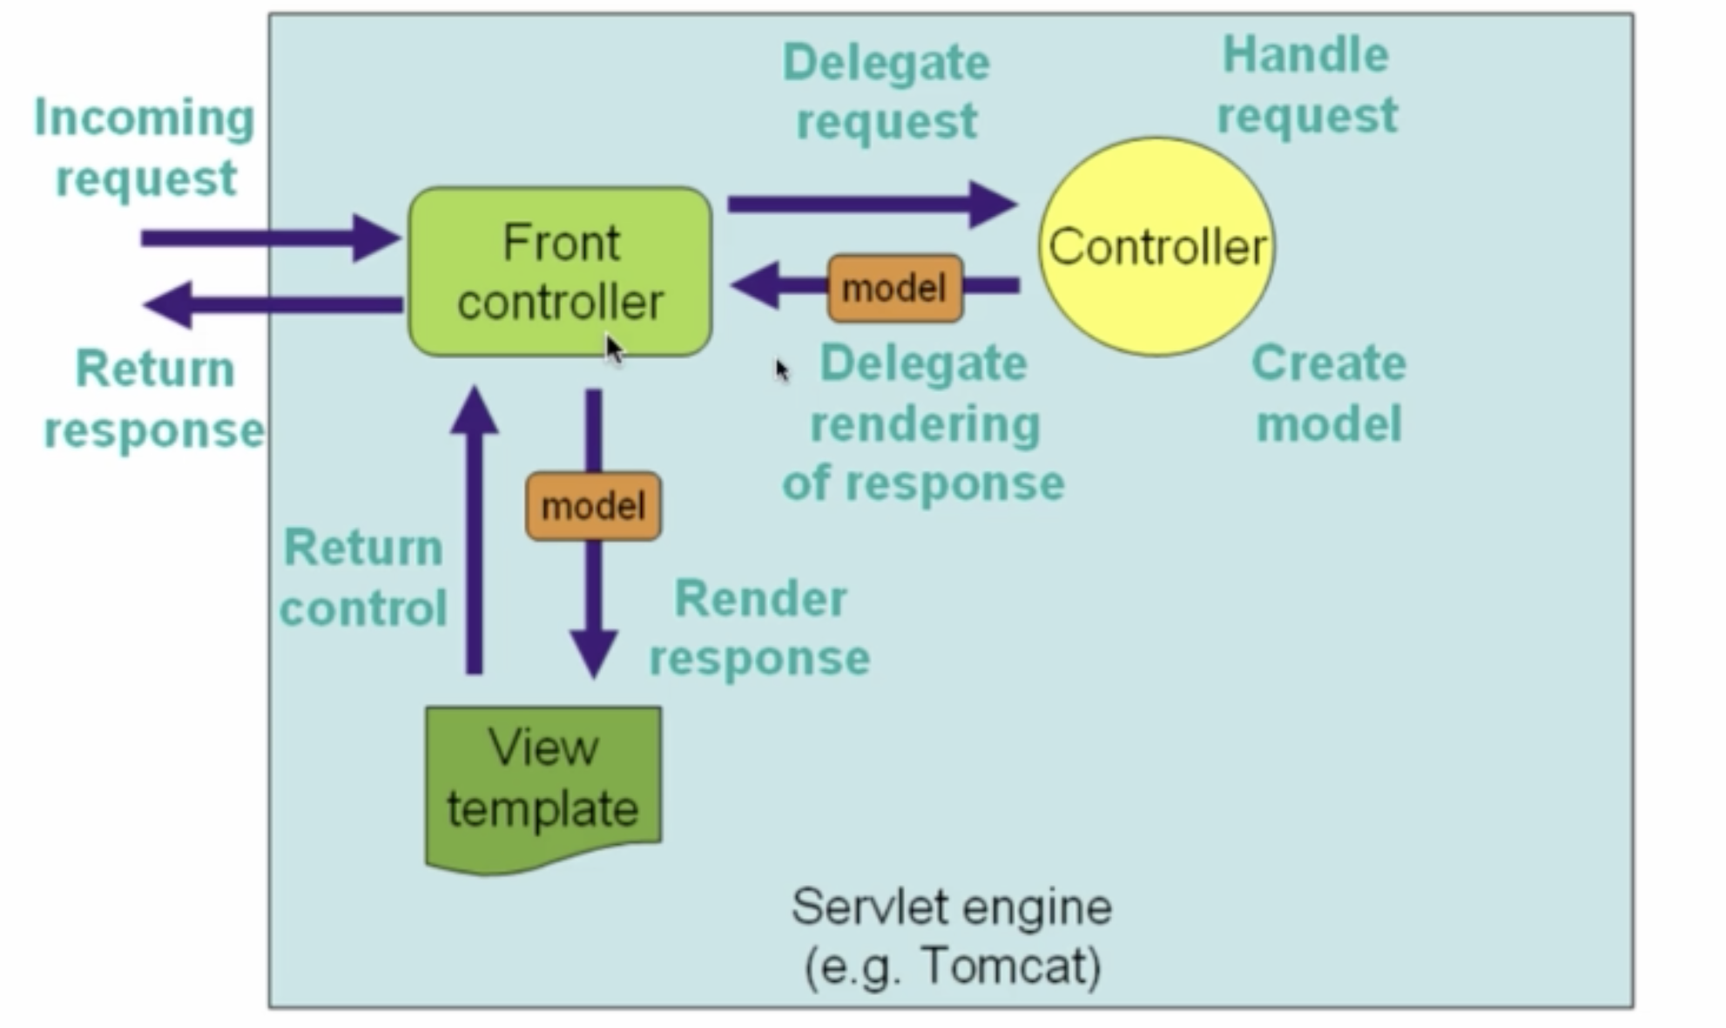

Add logging framework to spring mvc

<dependency>

<groupId>log4j</groupId>

<artifactId>log4j</artifactId>

<version>1.2.17</version>

</dependency>

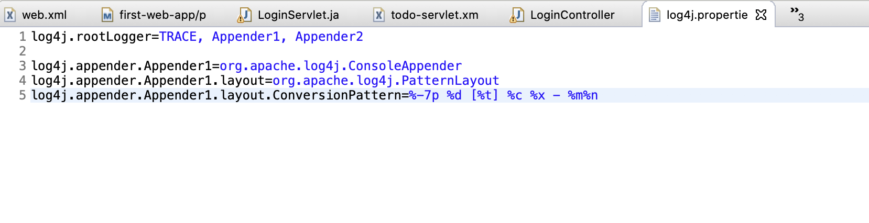

Trace includes all logs

Debug will have all from debug, info, warn, error

Info => info, warn, erorr

Warn => warn, error

Error=>only error

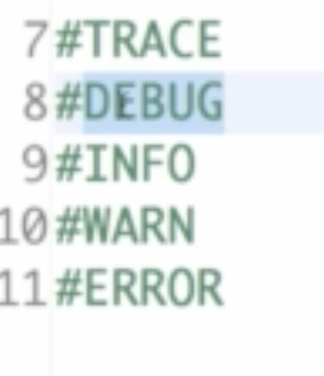

Welcome page using spring mvc using ModelMap and @RequestParam

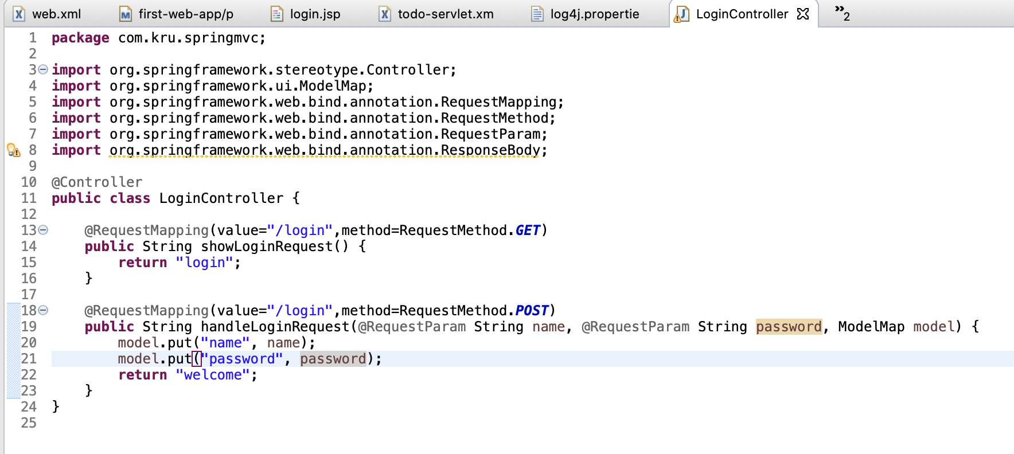

ModelMap is like make ur params available to views. So put ur params to it and its now readily available for view

Authenticate the user

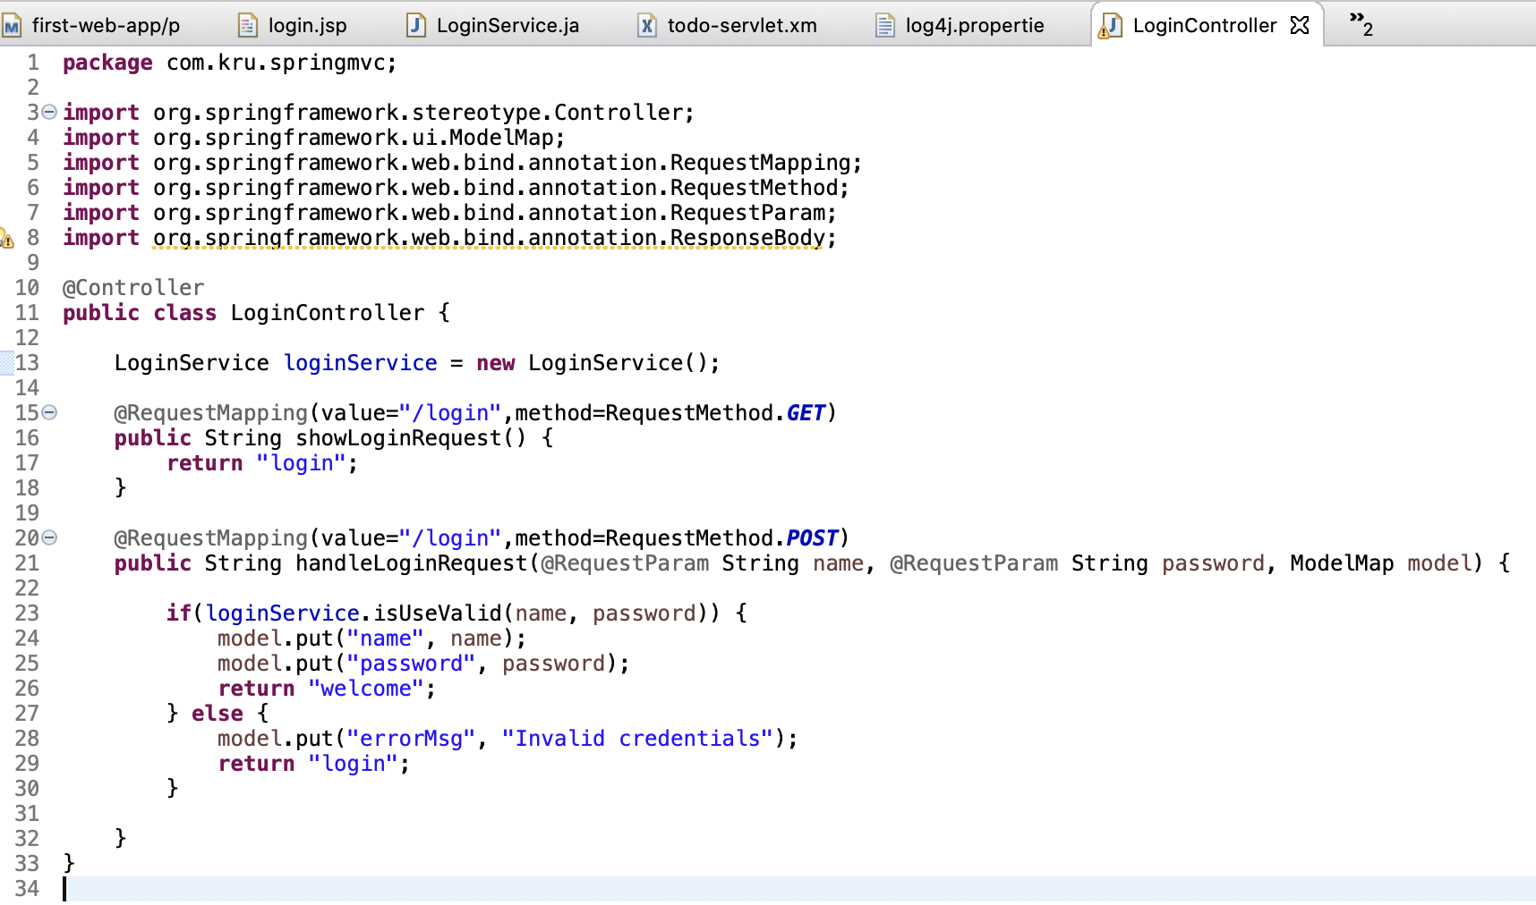

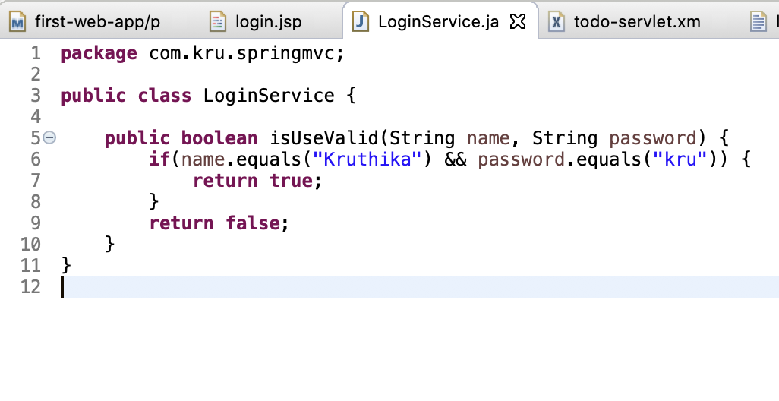

Lets now use Spring to do Autowiring and dependency mgmt.

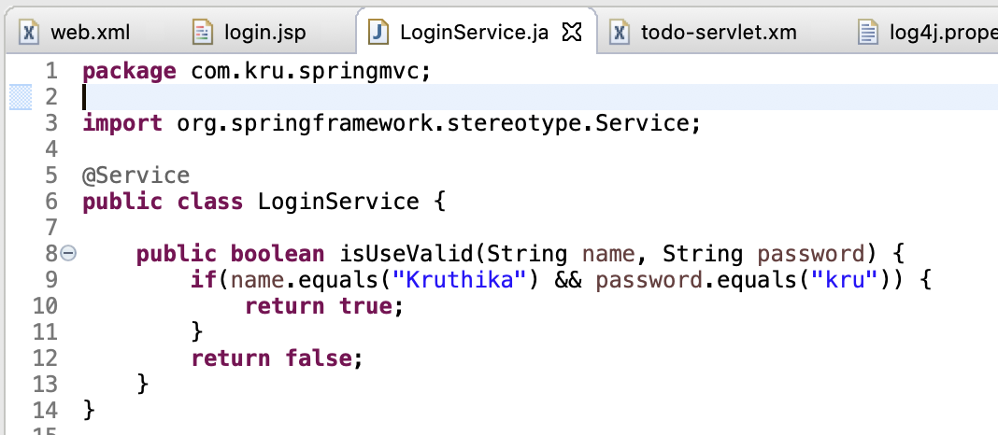

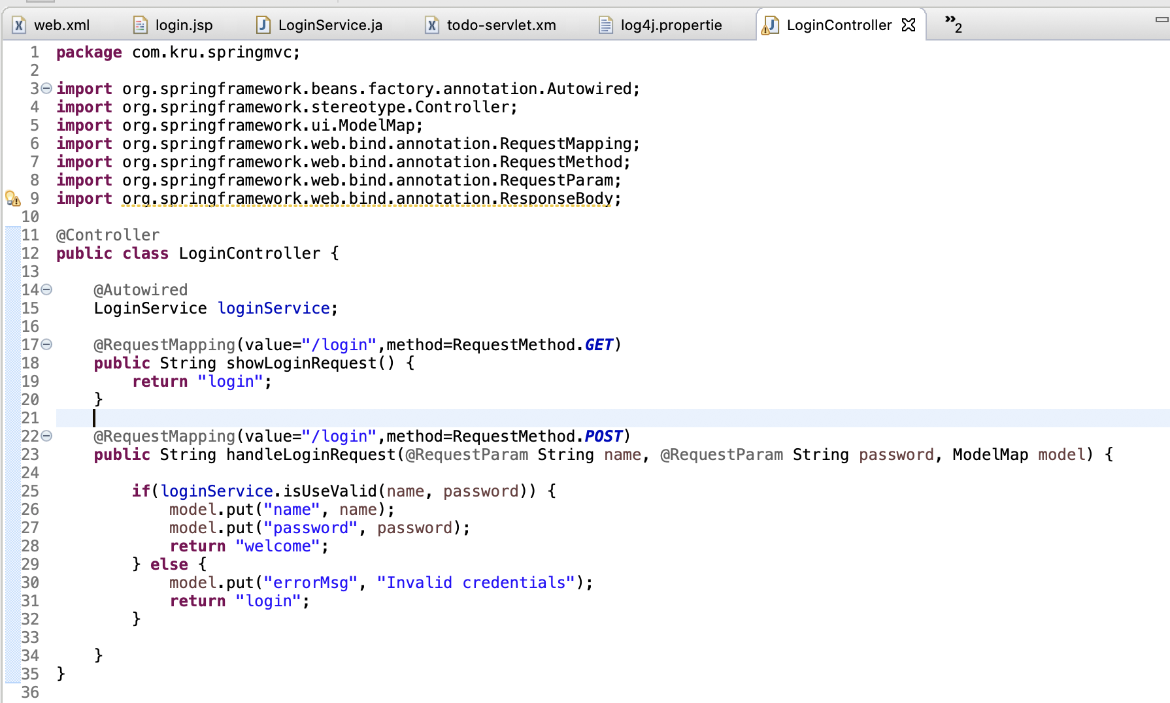

Maven

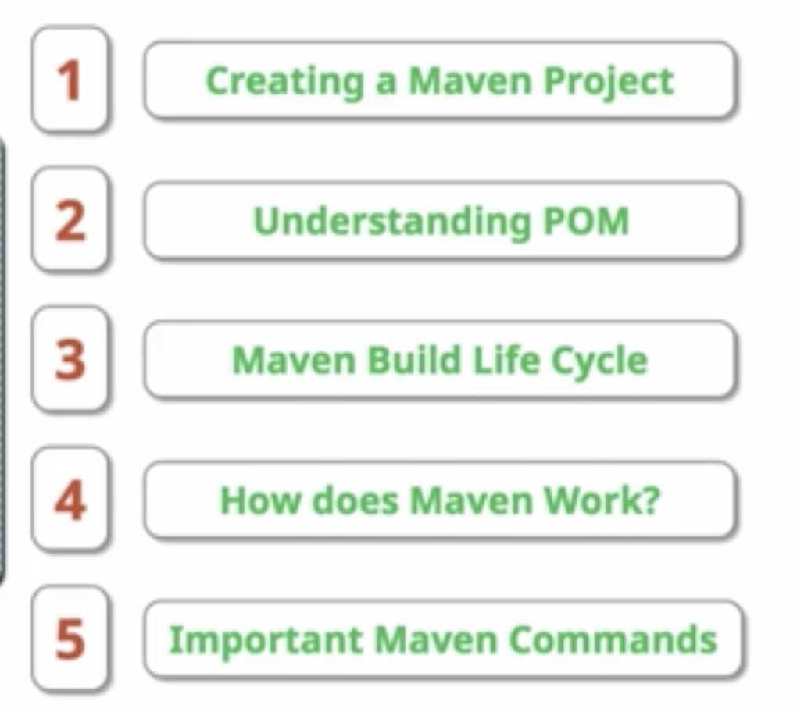

Pom- Project Object Model

1)can inherit from parent =>

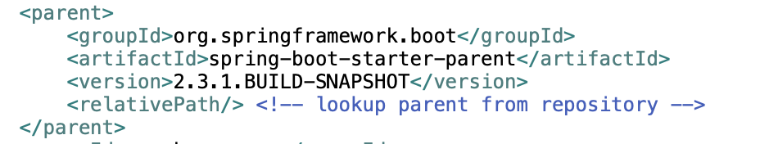

2)has dependencies

3)has repositories

Maven build life cycle

Build LifeCycle - Validate, Compile, Test, Package, Integration Test, Verify, Install, Deploy

1)validates project

2)compiles source code, test code

3)all UT are run, if successful go to package

4)Builds jar

5)Run integration test

6)Verify stage

7)Install – taking your artefact generated and putting to local repo

8)Deploy - taking your artefact generated and deploy to a remote maven repo

run "mvn clean install" => does all above steps

How does maven work ?

Maven downloads dependencies from different repo. Where are these repos present ?

* Local Repository – in ur local system
* Maven repository – central repo
  + stores all the versions of all dependencies.eg: JUnit 4.2,4.3,4.4
  + from here, its copied into ur local repo
  + mvn install - copies the created jar to local maven repository - a temp folder on my machine where maven stores the files.

### Important Maven Commands

* mvn --version
* mvn compile (compiles source files)
* mvn test-compile (compiles test files) - one thing to observe is this also compiles source files
* mvn clean - deletes target directory
* mvn test - run unit tests
* mvn package - creates the jar
* help:effective-settings
* help:effective-pom
* dependency:tree
* dependency:sources
* --debug